# Conservation area land preparedness and condition requirements under the Melbourne Strategic Assessment

December 2024

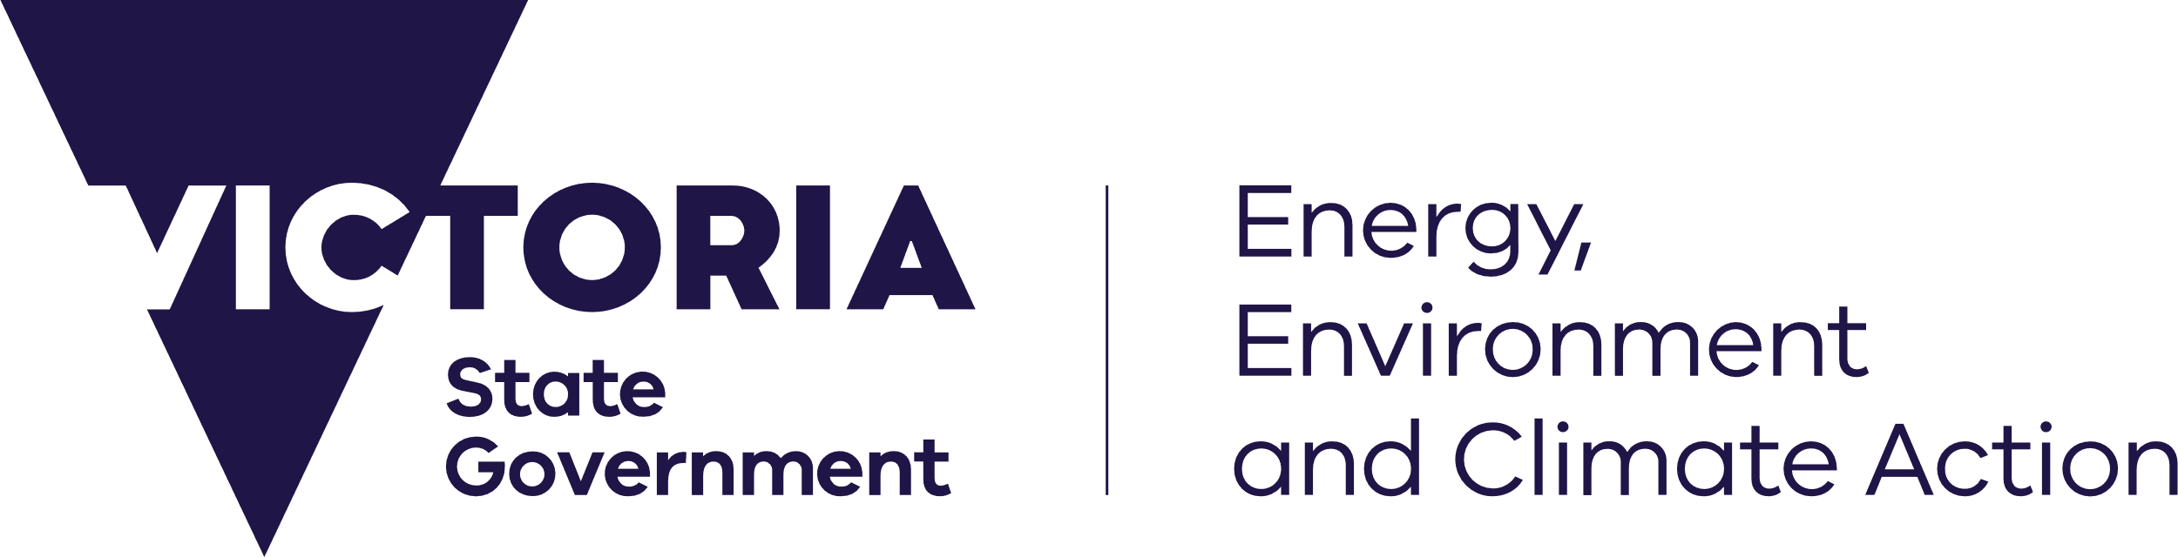

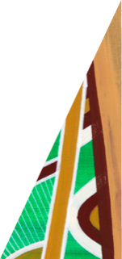This guideline is designed to assist developers and/or contractors engaged in preparing Conservation Area land for transfer to Department of Energy, Environment and Climate Action (DEECA). Once the requirements of this guideline are met to the satisfaction of DEECA, conservation area land can be transferred to the Crown in accordance with the relevant land security planning permit condition.

[deeca.vic.gov.au](https://delwpvicgovau.sharepoint.com/Users/fionadurante/Downloads/deeca.vic.gov.au)

**Early and regular consultation with DEECA during your development will ensure that land condition requirements are met, and that DEECA is able to endorse a statement of compliance for your subdivision.**

## Requirements

### 1. Conservation area interface

To minimise the impacts to the conservation area following transfer, all civil construction immediately adjacent to the conservation area must have achieved practical completion under the relevant authority. A permanent fence (or other DEECA-approved treatment) constructed along the boundary of the conservation area is an interface requirement that must be fully compliant with DEECA’s requirements. This includes ensuring access gates are safely accessible by a formed public road and accompanied by heavy-duty crossovers.

DEECA’s requirements for conservation area fencing can be accessed at the Melbourne Strategic Assessment (MSA) Program website at [Develop a fencing plan](https://www.msa.vic.gov.au/for-developers/planning-requirements-for-conservation-areas).

### 2. Landscape works and constructed assets on conservation area land

Assets such as paths, crossings, drainage infrastructure, wetland habitat and landscaping, etc., can only be constructed within a conservation area under a [Works in a Conservation Area (WICA)](https://www.msa.vic.gov.au/for-developers/conservation-area-works) approval. For further information please visit the MSA Program website at [Conservation area works](https://www.msa.vic.gov.au/for-developers/conservation-area-works). Constructed assets in conservation areas must have achieved practical completion under the relevant authority before the land can be transferred.

In exceptional circumstances, where landscape works must be delivered after a statement of compliance has been issued, the landowner must provide DEECA with evidence that these works have a security bond in place (including any maintenance periods) with the relevant authority before the land transfer can be accepted.

### 3. Existing internal boundary fencing

Conservation areas can be established progressively as development in urban precincts is completed. Conservation area land that is ready to be transferred must be appropriately distinguished and protected from adjacent properties.

Existing internal boundary fencing between the conservation area land to be transferred and an adjacent property must:

* provide clear delineation along the registered title boundary of the conservation area land and the adjacent property
* be in a suitable condition to discourage access
* protect the conservation area from the adjacent land use (e.g. stock grazing)
* not contain barbed wire unless it is required for stock management.

Where there is no existing boundary fencing, DEECA may require a temporary boundary fence to be constructed. Landowners should confirm this requirement with DEECA early in the conservation area planning process.

### 4. Conservation area land condition

**A conservation area Land Management Plan, in accordance with the relevant planning permit condition, must be prepared in consultation with DEECA. This will address site-specific land condition requirements.**

**If your conservation area land is not subject to a Land Management Plan condition, you must consult with DEECA early in your development planning to ensure the conservation area land condition requirements can be met prior to land security.**

**Landowners can refer to DEECA’s** [[***Land Management Plan Guidance Note***](https://www.msa.vic.gov.au/__data/assets/pdf_file/0031/715990/MSA-planning-guidance-note-Meeting-the-condition-Land-Management-Plans.pdf)](https://www.msa.vic.gov.au/for-developers/planning-requirements-for-conservation-areas) **for further information on preparing conservation area land to meet the land condition requirements.**

* **Weed control**

The landowner is responsible for weed management on their property until the land is transferred to DEECA. They must provide evidence of sustained weed control in accordance with their statutory obligations to control declared noxious weeds under the *Catchment and Land Protection Act 1994* (CaLP Act). Environmental weeds rated as high and very high risk on the [advisory list of environmental weeds in Victoria](https://www.environment.vic.gov.au/invasive-plants-and-animals/weed-risk-ratings) that are directly threatening conservation area values must be targeted by experienced and qualified persons. For more information please see DEECA’s [Weed risk ratings](https://www.environment.vic.gov.au/invasive-plants-and-animals/weed-risk-ratings) website page.

The landowner must engage with DEECA early in their development planning to discuss conservation area weed management. This will involve clearly outlining the current composition and cover of weeds across the conservation area and identifying clear and achievable weed cover targets to be met before the landowner plans to transfer the land. The treatment of new and emerging weeds over the management period and targeted revegetation to support weed control where needed and practical will also need to be covered.

* **Pest animal control**

The landowner must manage pest animals on the conservation area in accordance with their obligations under the Catchment and Land Protection Act 1994. Pest animal control must be sensitive to the biodiversity and cultural values of the conservation area land.

* **Removal of rubbish**

The entire conservation area must be free of all rubbish and waste.

* **Removal of materials/structures not required for conservation**

Stockpiles and structures not fixed to the property that are not required for the purpose of a conservation must be removed.

* **Hazard control**

In consultation with DEECA, hazards identified in the conservation area that pose risks to the public and land management personnel must be assessed and removed or managed if removal is not feasible. Examples include steep batters, water bodies, deep pits and holes (including where fence posts have been removed). Slashing of conservation areas may be required to manage hazards and identify rubbish. Where slashing is necessary, works must consider native vegetation patches, areas of sensitivity (e.g. cultural heritage sites, high biodiversity values, existing wetlands/waterbodies, etc.).

* **Domestic animals including livestock**

Domestic animals, including livestock, are not permitted on conservation area land unless they are appropriately managed through a DEECA-approved Land Management Plan to avoid impacts to natural values.

* **Compliance with existing plans**

All conservation area land that is subject to an environmental management plan, land rehabilitation plan, and/or any similar plan, must be fully compliant with the requirements of that plan. In addition, all conservation area land must be fully compliant with any site-specific remediation requirements as determined by DEECA, where impacts to the conservation area have been identified prior to the land having transferred to DEECA.

* **Contaminated land assessment**

An assessment of contaminated land in accordance with the [*Victorian Government Land Transactions Policy*](https://www.land.vic.gov.au/government-land/victorian-government-land-monitor/policy) will be completed by DEECA before any land is accepted by government. Where contamination assessments recommend the implementation of remediation works or risk mitigation measures, these measures must be completed prior to transfer. For more information please visit the Department of Transport and Planning’s [Victorian Government Land Transactions Policy and Guidelines website page](https://www.land.vic.gov.au/government-land/victorian-government-land-monitor/policy).

## Timing and confirmation

It is the landowner’s responsibility to meet these conservation area condition and security requirements and ensure that the schedule for implementation supports timing for land transfer.

When a landowner indicates that they are ready to transfer conservation area land, DEECA will arrange a site inspection to ensure that all land management requirements have been met. Follow-up inspections may be required where outstanding actions are identified.

## Land transfer process

Land transfer may take at least three months to complete. Landowners should consider this timing in their development planning.

## Further information

For further information on conservation area land condition requirements and the land transfer process, please email the [Conservation Areas Program team](mailto:msa.bioconservation@deeca.vic.gov.au).

For further information, visit DEECA’s [MSA Program website](https://www.msa.vic.gov.au/home).



We acknowledge Victorian Traditional Owners and their Elders past and present as the original custodians of Victoria’s land and waters and commit to genuinely partnering with them and Victoria’s Aboriginal community to progress their aspirations.

© The State of Victoria Department of Energy, Environment and Climate Action December 2024.

Creative Commons

This work is licensed under a Creative Commons Attribution 4.0 International licence, visit the [Creative Commons website](http://creativecommons.org/licenses/by/4.0/) (<http://creativecommons.org/licenses/by/4.0/>).

You are free to re-use the work under that licence, on the condition that you credit the State of Victoria as author. The licence does not apply to any images, photographs or branding, including the Victorian Coat of Arms, and the Victorian Government and Department logos.

ISBN 978-1-76176-247-5 (print) ISBN 978-1-76176-247-5 (pdf)

Disclaimer

This publication may be of assistance to you but the State of Victoria and its employees do not guarantee that the publication is without flaw of any kind or is wholly appropriate for your particular purposes and therefore disclaims all liability for any error, loss or other consequence which may arise from you relying on any information in this publication.

Accessibility

To receive this document in an alternative format, phone the Customer Service Centre on 136 186, email [customer.service@deeca.vic.gov.au](mailto:customer.service@deeca.vic.gov.au), or contact National Relay Service on 133 677. Available at [DEECA website](http://www.deeca.vic.gov.au/) (www.deeca.vic.gov.au).