www.delwp.vic.gov.au

Matt Bruce, Khorloo Batpurev, David Bryant, Steve Sinclair & Michele Kohout

Melbourne Strategic Assessment

Ecological Outcomes Report 2014-15 to 2019-20

© The State of Victoria Department of Environment, Land, Water and Planning 2020
This work is licensed under a Creative Commons Attribution 4.0 International licence. You are free to re-use the work under that licence, on the condition that you credit the State of Victoria as author. The licence does not apply to any images, photographs or branding, including the Victorian Coat of Arms, the Victorian Government logo and the Department of Environment, Land, Water and Planning (DELWP) logo. To view a copy of this licence, visit http://creativecommons.org/licenses/by/4.0/
ISBN 978-1-76105-400-6 (pdf/online/MS word)
Citation
Bruce M, Batpurev K, Bryant D. Sinclair S and Kohout M (2020) Melbourne Strategic Assessment: Ecological Outcomes Report 2014-15 to 2019-20. Department of Environment, Land, Water and Planning, Heidelberg, Victoria.
Disclaimer
This publication may be of assistance to you but the State of Victoria and its employees do not guarantee that the publication is without flaw of any kind or is wholly appropriate for your particular purposes and therefore disclaims all liability for any error, loss or other consequence which may arise from you relying on any information in this publication.
Cover photo
Cover photo: Southern Brown Bandicoot, Chinaman Island (remote camera).

Photo credits
Summary: Growling Grass Frog and Striped Legless Lizard by Geoff Heard; Southern Brown Bandicoot by Peter Menkhorst.
All other photos credit the authors.
Accessibility
If you would like to receive this publication in an alternative format, please telephone the DELWP Customer Service Centre on 136186, email customer.service@delwp.vic.gov.au, or via the National Relay Service on 133 677 www.relayservice.com.au. This document is also available on the internet at www.delwp.vic.gov.au.

Acknowledgment
We acknowledge and respect Victorian Traditional Owners as the original custodians of Victoria's land and waters, their unique ability to care for Country and deep spiritual connection to it. We honour Elders past and present whose knowledge and wisdom has ensured the continuation of culture and traditional practices.
We are committed to genuinely partner, and meaningfully engage, with Victoria's Traditional Owners and Aboriginal communities to support the protection of Country, the maintenance of spiritual and cultural practices and their broader aspirations in the 21st century and beyond.

Contents
Summary 5
Context: 5
Aims: 5
Methods: 5
Results: 5
Conclusions and implications: 5
Introduction 7
Background 7
Adaptive management 7
Definition of the desired outcomes 8
Outcome statements (‘goals’) 8
Forms and structure of the key performance indicators 9
Targets, baselines and continual improvement 10
Stratification of reporting 10
Other measures 11
Scope of application 11
Geographic 11
Temporal 11
Treatment of species re-introductions, and population augmentations and colonisation of restored habitats 12
How to read this report 13
Changes to the Monitoring and Reporting Framework 13
Natural Temperate Grasslands 15
Introduction 15
The ecological community 15
Goals and performance indicators 15
Monitored areas 15
Summary of monitoring methods 15
State mapping 15
Intensive point intercept plots 16
Rapid plots 17
Results: KPIs 19
KPI 1: Hectares making transition between states 19
KPI 2: Cover of native perennial forbs 20
KPI 3: Richness of native perennial forbs 21
KPI 4: Cover of Kangaroo Grass (Themeda triandra) 22
KPI 5: Cover of any native perennial grasses (excluding Kangaroo Grass) 23
KPI 6: Percent of plots that have bare ground cover between 25 – 75% 24
KPI 7: Percent cover of all perennial vegetation comprised of weeds 25
Results: Other measures 26
Overall NTG quality 26
Annual native forb cover 26
Annual weed cover 27
Cover of C3 and C4 grasses 28
Cover of organic litter, moss and rock 29
Soil chemical composition 30
Change in perennial weed cover 31
Kangaroo and pest animal abundance 31
Changes to the MRF 32
Grassy Eucalypt Woodland 33
Seasonal Herbaceous Wetlands 34
Introduction 34
The ecological community 34
Goals and performance indicators 34
Monitored areas 34
Summary of monitoring methods 35
Timing of sampling 35
Sampling with point intercept plots 36
Assessing the diversity of native forbs 37
Results: KPIs 37
KPI 1: Richness of native perennial forbs during spring-summer 38
KPI 2: Richness of all native forbs during drawdown 39
KPI 3: Percent cover of all perennial vegetation comprised of weeds during Spring-Summer 40
KPI 4: Percent cover of all perennial vegetation comprised of weeds during drawdown 41
Results: Other measures 42
Overall SHW quality 42
Annual weeds 42
Soil phosphorous and nitrate levels 43
Hydrological phases and dates of filling and draining 43
‘High quality’ indicator species 44
Woody shrubs 44
Changes to the MRF 45
Button Wrinklewort 46
Introduction 46
The species 46
Goals and performance indicators 46
Monitored populations 46
Summary of monitoring methods 46
Population census 46
Habitat measurements 46
Results: KPI 47
KPI 1: Population count 47
Results: Other measures 48
Weeds and bare ground 48
Reproductive effort 48
Previous monitoring data 49
Changes to the MRF 49
Large-fruit Groundsel 50
Introduction 50
The species 50
Goals and performance indicators 50
Monitored populations 50
Summary of monitoring methods 50
Population census 50
Other measures 51
Results: KPI 51
KPI 1: Population count 51
Results: Other measures 52
Cover of bare ground and weeds 52
Number of stems, flower heads and seed heads per plant 52
Census of re-introduced populations 53
Changes to the MRF 53
Matted Flax-lily 54
Introduction 54
The species 54
Goals and performance indicators 54
Monitored populations 55
Summary of monitoring method 55
KPI: Detection of plants 55
Other measures 55
Results: KPI 56
KPI 1: Percentage of plants detected each year 56
Results: Other measures 56
Changes to the MRF 57
Small Golden Moths Orchid 58
Spiny Rice-flower 59
Introduction 59
The species 59
Goals and performance indicators 59
Monitored populations 60
Monitoring method 60
Population census 60
Vegetation measures 61
Results: KPIs 61
KPI 1: Population count 61
KPI 2: Number of years that recruits form over 10% of the population over a ten-year period 62
Results: Other measures 63
Scattered plants 63
Vegetation cover 64
Identity of associated species 64
Changes to MRF 64
Golden Sun Moth 66
Introduction 66
The species 66
Goals and performance indicators 66
Monitored populations 66
Monitoring method 67
KPI 1: Detection of moths 67
Other measures 67
Results: KPI 68
KPI 1: Proportion of monitoring sites that are occupied 68
Results: Other measures 68
Cover of bare ground, weeds and overall biomass 68
Weather conditions during survey 69
Cover of C3 and C4 grasses 70
Abundance of Golden Sun Moth 70
Changes to the MRF 71
Growling Grass Frog 72
Introduction 72
The species 72
Goals and performance indicators 72
Monitored populations 72
Suggested changes to the MRF 72
Southern Brown Bandicoot 73
Introduction 73
The species 73
Goals and performance indicators 73
Monitored populations 73
Monitoring method 73
Site selection 73
Camera setup 74
Data analysis 74
Results: KPI 75
KPI 1: Proportion of monitored sites that are occupied 75
Results: Other measures 76
Detection probability 76
Fox occupancy 77
Extent of native vegetation 77
Fire history 78
Changes to the MRF 79
Striped Legless Lizard 80
Introduction 80
The species 80
Goals and performance indicators 80
Monitored populations 80
Monitoring method 80
General protocol 80
Identification of permanent monitoring locations 81
Ongoing monitoring of known populations 81
Monitoring to date 81
Other measures 81
Results: KPI 82
Identification of permanent monitoring locations 82
KPI 1: Proportion of monitoring sites that are occupied 82
Results: Other measures 83
Cover of bare ground and weeds 83
Weather conditions during survey 83
Reptiles and frogs detected under tile grids 84
Changes to the MRF 85
Acknowledgements 86
References 87

Summary

Context:
Under the Melbourne Strategic Assessment (MSA), the Victorian Government has committed to the protection and management of threatened ecological communities, plants and animals in the Melbourne region. The commitments include regular reporting on ecological outcomes. The Monitoring and Reporting Framework (MRF; DELWP 2015a) mandates annual data collection to evaluate/ track the set of measurable Key Performance Indicators (KPIs) underlying ecological outcomes. Additionally, the MRF mandates that ecological outcomes be reported every five years to provide the Australian Government and the public with the data required to evaluate whether Victoria is achieving its obligations under the MSA. This document is the report of annual data collection for the 2019-20 financial year.

Aims:
This report aims to assess the ecological outcomes for three communities, five plant species and four animal species on land that is currently protected under the MSA against KPIs set by the MRF (DELWP 2015a).

Methods:
Field surveys tailored to the characteristics of each species and community are used to measure progress towards the KPIs, as detailed in the MRF (DELWP 2015a) and summarised here. KPIs for species include measures relating to population counts, detection rates, recruitment and occupancy. KPIs for communities include measures relating to plant species richness and cover of weed and native species, state change and spatial heterogeneity. This report incorporates recommendations for minor changes to the MRF, resulting from practical experience of the first five years of its implementation. These changes were recommended in the first five-year report (Sinclair et al. 2019a).

Results:
The results are summarised graphically below. For each species and community, the progress towards each KPI is summarised by a coloured bar. Results for Natural Temperate Grassland, Seasonal Herbaceous Wetland, Golden Sun Moth and Striped Legless Lizard KPIs have all been reported where they have been able to be assessed. For other species and communities, many KPIs are shown as “KPI cannot yet be assessed”. Reasons for a KPI to not have been assessed include that the Matter of National Environmental Significance (MNES) is not currently protected (or too few locations are protected), too few years have elapsed for the KPI to be assessed (e.g. the baseline is not set) or the KPI is only assessed after a particular event which has not occurred in the relevant period (e.g. wetland flooding).

Conclusions and implications:
Of the KPIs that could be assessed against a baseline, all were assessed as “KPI met”. For several KPIs, there is now sufficient data to set the baseline due to a sufficient area of land being protected and/or sufficient time elapsed since protection, and these are reported here. This reflects the fact that MSA land protection commenced in 2013 and currently a limited area has been protected.

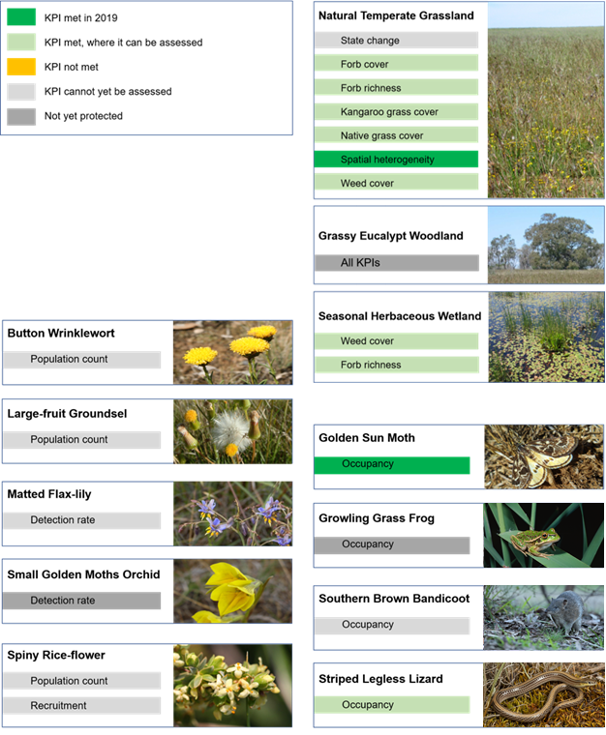

Introduction

Background
The Victorian Government has committed to the protection and management of threatened ecological communities, plants and animals in the Melbourne region. These commitments include the establishment of a network of new Conservation Areas on Melbourne’s fringes.
These commitments are part of the Melbourne Strategic Assessment (MSA). The MSA is the Victorian Government’s response to Melbourne’s urban growth, which impacts on species and communities listed under the Australian Environment Protection and Biodiversity Conservation (EPBC) Act 1999. The Victorian Government has assumed the role of the proponent of development on behalf of property developers, using the ‘strategic assessment’ provision of the EPBC Act (DPCD 2009). Approval was given by the Australian Government for the expansion of Melbourne’s Urban Growth boundary and the removal of EPBC listed species and communities, provided adequate mitigation measures were put in place. Such a strategic assessment (as opposed to a series of approvals by individual developers) allows an integrated mitigation plan to be implemented. For the MSA, this includes the collection of fees from developers to fund the acquisition and management of a series of reserves which are designed to protect many of the best remaining small areas of habitat and create a large protected landscape reserve by aggregating acquisitions into the Western Grassland Reserve. These conservation measures are detailed in the Biodiversity Conservation Strategy for Melbourne’s Growth Corridors (DEPI 2013a).
The MSA commitments include regular reporting on ecological outcomes. The ‘Monitoring and Reporting Framework’ (MRF; DELWP 2015a) provides the logic and basis for monitoring and reporting; it defines clear quantitative outcomes (i.e. ‘goals and performance indicators’) for management and outlines a program of monitoring that has since been implemented.
For many of these outcomes the MRF (DELWP 2015a) mandates annual data collection. Additionally, the MRF mandates that ecological outcomes be reported every five years to provide the Australian Government and the public with the data required to judge whether Victoria is achieving its obligations under the MSA.
This document reports the monitoring data for the six-year period from 2014-15 to 2019-20. It details all measured outcomes for the current period and provides a summary of all monitoring activities from their commencement. This report summarises the data with the aim of clearly representing the main patterns. All raw data for all measures required in the MRF is held securely by the Department of Environment, Land, Water and Planning (DELWP).

Adaptive management
From its inception (DSE 2009), the MSA has committed to applying a meaningful ‘adaptive management’ approach to conservation management. Adaptive management may take different forms (Walters 1986, Lee 1999, Schrieber et al. 2004, McCarthy and Possingham 2007, Duncan and Wintle 2008), but it is generally agreed that adaptive management involves a program of management that is adjusted over time as understanding of the system’s response to management improves through regular monitoring.
Monitoring plays a central role in adaptive management. Monitoring is how the consequences of management or disturbance are recorded and fed back to the knowledge base, allowing land managers and stakeholders to learn how to repeat successes (changes that advance towards the stated goals) and avoid repeating mistakes (changes that are regressive).
For adaptive management to be effective, there needs to be appropriate structures in place: Clear goals, a credible monitoring program, a coherent knowledge base (model) that can be updated, flexible and competent managers, and good communication between field staff, managers and decision makers. The current document is one part of this larger set of structures. It contributes to adaptive management in several ways:
- It presents the raw data that drives the community (ecosystem) management models (DELWP, unpublished; currently only the model for the ‘Natural Temperate Grasslands’ community has sufficient data to be operational). These models use the data reported here, alongside records of management and the weather, to make predictions about the outcomes of potential future management regimes. The model predictions can be evaluated against the Key Performance Indicators (KPIs).
- It presents some of the raw data that inform the management response models that have been created for each species (Regan et al. 2020). These models, like their ecosystem counterparts, make predictions about species outcomes under different management scenarios. For most species these models are population viability analysis models (PVAs), for Growling Grass Frog a stochastic patch occupancy model (SPOM) is used (Heard et al. 2013, Scroggie et al. 2019a). These models also require other data that is not collected via routine monitoring.
- It presents data that forms a narrative of change that can be used in the management discussion that takes place between managers, decision makers, funders, scientists and other stakeholders.
Given there are modelling processes designed to integrate the data into an overall understanding of change and management (e.g. Regan et al. 2020), this document does not present detailed analyses or interpretation of the monitoring results. Instead, it offers only a statement of whether each KPI is met, and a brief qualitative discussion of obvious trends.

Definition of the desired outcomes

Outcome statements (‘goals’)
The MRF (DELWP 2015a) defines the Program Outcomes. These are structured as a simple two-tier ‘objectives hierarchy’ (Keeney 1992, Biggs and Rogers 2003), with a single overarching ‘desired outcome’ for each species and community, each with an underlying set of measurable KPIs.
The following single outcome statements, one for each species or community, form the structure of the current document.
- The composition, structure and function of Natural Temperate Grassland of the Victorian Volcanic Plain improves
- The composition, structure and function of Grassy Eucalypt Woodland of the Victorian Volcanic Plain improves
- The composition, structure and function of Seasonal Herbaceous Wetlands (Freshwater) of the Temperate Lowland Plains improves
- No substantial negative change to populations of Button Wrinklewort
- No substantial negative change to populations of Large-fruit Groundsel
- No substantial negative change to populations of Maroon Leek-orchid
- No substantial negative change to Small Golden Moths Orchid
- Matted Flax-lily persists
- No substantial negative change to the population of Spiny Rice-flower, and the population is self-sustaining
- Golden Sun Moth persists
- Growling Grass Frog persists
- Southern Brown Bandicoot persists
- Striped Legless Lizard persists
The MRF treats each of these as independent outcomes, all of which must be achieved for the MSA to be fulfilling its obligations. They are not afforded different levels of importance or integrated into any system which permits trade-offs between them (e.g. Marttunen et al. 2018).

Forms and structure of the key performance indicators
Each species has one or more KPI. These sit beneath the outcome statements (above). The KPIs are intended, collectively, to assess whether the outcome is being achieved. The choice of KPIs is determined by the form of the outcome, the ecological characteristics of the species or vegetation communities (mobility, detectability, temporal variation, etc.), the feasibility and cost of measurement, and the spatial distribution of the species or vegetation community.
For species, each KPI is conceived in one of three ways:
- Abundance – the number of individuals in an area. Counts of an entire population can be conducted for some plant species that are relatively easily detected and occur in small areas (e.g. Button Wrinklewort). As these data relate to real numbers of individuals any change represents a real change in the population of that area (Elzinga et al. 2001). In other cases, full counts are impractical, and samples are taken to estimate changes in abundance of the total population.
- Occupancy – the presence or absence of the species in a defined area (or across a set of defined areas). Occupancy is determined by searching until the species is found or sufficient search effort (time) has been used such that the chance of a false absence (Type II error) is acceptable (here generally 5%). Occupancy is applied to species which are mobile or difficult to detect. There are established analytical techniques for analysing occupancy data which take into account imperfect detection (false absences) and express a probability that a site is occupied (MacKenzie et al. 2005). To allow reporting with appropriate thresholds, this measurement variable requires an a priori determination of the search effort required to reduce the probability of false absences to an acceptable level (Garrard 2009; Garrard et al. 2008), which is available from the literature for most species considered here. In the case of Southern Brown Bandicoot, the occupancy is estimated using an occupancy model (MacKenzie et al. 2005). This is appropriate for this species as it is mobile, spread over a large area and the whole population can be suveyed at the same time (i.e. it is not subject to the constraints of reserve acquisition). Occupancy modelling also allows for an estimate of uncertaity which is used to assess whether on not the KPI has been met. This approach may be approriate for Striped Legless Lizard and Golden Sun Moth when sufficient land is acquired. For Growling Grass Frog, occupancy will be assesed by taking advantage of an existing modelling approach (a stochastic patch occupancy model) which takes into account the population dynamics of the species (Heard et al. 2013).
For vegetation communities, each KPI is conceived in one of the following four ways:
- Cover of selected plants – the proportion of the ground covered by the species (or group of species) in a defined plot, as defined by Wilson (2011). Cover is a measure of the 2-dimensional quantity of the species, reflecting its competitive success, and not necessarily a measure of its numerical abundance. Cover is derived either from a point-intercept plot, or from visual estimation.
- Richness of plant species within selected groups – the count of species in a defined area. Usually, richness is confined to a species group (such as forbs). Richness is one measure of the species diversity of an ecosystem.
- Heterogeneity – the variability in structure of the community across space, measured by the proportion of area (i.e. plots) in different structural categories (Benton et al. 2003, Tews et al. 2004, Tilman 1994, Tilman and Pacala 1993).
- Proportion of community undergoing undesirable changes between states – the number of hectares detected through mapping that has undergone an undesirable transition between states (i.e. a change representing degradation), defined by an appropriate state-and-transition model (currently only relevant for ‘Natural Temperate Grasslands’; Sinclair et al. 2019b).

Targets, baselines and continual improvement
To clearly assess compliance with the KPIs, it is necessary to specify a target. Targets ensure that the intentions of management are clearly recorded at the outset, so that managers can be held accountable over long periods of time. Compliance against targets also allows the complex ecological outcomes of the MSA to be evaluated at a glance. Nonetheless, it is necessary to remember that KPIs and targets are ultimately filters for interpretation and that the raw data records a richer narrative of change.
The form of the target varies according to the characteristics of the species or community, but there are several consistent themes .
- Most KPIs are assessed against a baseline, which sets the target that the relevant attribute must remain above (for desirable attributes such as populations of threatened species) or below (for undesirable attributes such as weeds). In all such cases, the KPI is not met once the 95% confidence interval on the measure falls on the wrong side of the baseline.
- All baseline values that are derived from means (for percentage cover and species counts) are rounded to the nearest whole number.
- In most cases, baselines are set by the conditions at the commencement of monitoring. This means that the target is to maintain or improve on what was present when MSA management commenced. In these cases, the baseline is calculated not from the first survey, but from the mean of the first 5 years of monitoring data. This approach is intended to dampen fluctuations between monitoring periods that are not related to management or long-term success (e.g. fluctuations in vegetation cover due to recent fires, or responses by animals to weather conditions).
- A continuous improvement approach applies to some KPIs. In these cases, if the measured mean in a five yearly reporting cycle is an improvement from the baseline, the measured mean sets a new target for the next five-year reporting period. This is beneficial for measures where the most desirable outcome is always ‘complete removal’ (e.g. weeds) or ‘as high as possible’ (e.g. abundance of a listed species). For example, fewer weeds are always more desirable, and it is considered sensible to maintain gains, and not merely settle for keeping weed levels below an arbitrary baseline. For other KPIs, the baseline is set and does not change, regardless of the results. Such set baselines are appropriate in cases where the attribute is desired at moderate levels. For example, it is desirable for the cover of Kangaroo Grass in Natural Temperate Grasslands to be maintained at an appropriate level (neither 100% nor 0%), so a continuous improvement model is not appropriate.
There are exceptions to these general approaches, which are based on considerations of the ecology and survey techniques applicable to the measure in question. These are described and explained in the MRF.

Stratification of reporting
For most species, the KPIs are reported separately for different locations. This is intended to reveal whether progress is consistent or mixed, and whether different places under different management regimes are tracking differently.
For two of the three vegetation communities (Natural Temperate Grassland and Grassy Eucalypt Woodland), the KPIs are reported separately according to ‘states’. These are defined by a state-and-transition model. State-and-transition models (STM) present alternative ‘states’ of species assemblages (or profiles, groups) that could occur at a given site. Which of these occurs depends on management and natural events at the site (Westoby et al. 1989). The assemblage may change from one state to another – it may undergo a desirable or undesirable ‘transition’– if a threshold is crossed. Assigning a state to a site is effectively a shorthand summary of what has happened to that site, what its current ecological status is, what the possibilities are for the site for improvement, and what management tools might be available. The STM approach taken here is endorsed by the Threatened Species Scientific Committee (TSSC) under the EPBC Act (Beeton and McGrath 2009).
The STM for Natural Temperate Grassland is described in Sinclair et al. (2019b). The STM for Grassy Eucalypt Woodland is unpublished. States are not used for reporting on Seasonal Herbaceous Wetlands, because this community is instead reported on at discrete wetland sites.

Other measures
Some additional parameters are monitored that do not contribute to the KPIs. These measures were not selected as KPIs because they are highly labile, highly correlated to the KPIs, or because they have an uncertain relationship to the desired outcomes. They are, however, measured because they may assist in the interpretation of the KPIs, inform species and community models, or reveal other changes of interest in the ecosystem. In most cases these additional variables can be collected with little or no additional effort when the monitoring protocols for the KPIs are implemented. The other measures include all the types of measure described above, and three additional categories:
- Ecosystem quality – (or ‘condition’) a measure that assesses whether the combination of attributes of an ecosystem are more or less desirable (Sinclair et al. 2015). The measurement of quality requires a metric which takes multiple relevant measures and reduces them to a single dimension. Here, this is used to make sense of the multiple KPIs and express them as a single quality score.
- Soil nutrient levels – the concentration of various nutrients in the soil surface, which may relate to ecological function.
- Landscape level patterns in disturbance and land use – the mapped native vegetation extent, fire history and extent of development within the Southern Brown Bandicoot (SBB) management area are included as other measures for SBB. These may help explain changes in Southern Brown Bandicoot populations over time.

Scope of application

Geographic
Monitoring applies to all known natural populations of relevant species and vegetation communities on land within the Conservation Areas described in the Biodiversity Conservation Strategy for Melbourne’s Growth Corridors (DEPI 2013a), the Western Grassland Reserve, the Grassy Eucalypt Woodland Reserve, the Southern Brown Bandicoot management area and any other parcels of land acquired under the MSA.
Any newly discovered natural populations of EPBC-listed species will be monitored, and their outcomes evaluated against the KPIs.

Temporal
Monitoring commences at a given location only once that site is secured, or the regional implementation program has commenced in that area (for Growling Grass Frog, and Southern Brown Bandicoot only). This approach was a basic assumption in the design and costing of the MSA. This has several implications.
First, it means that the monitoring does not include counterfactuals that are not part of MSA management. This limits the ability to compare and evaluate MSA management against other management or neglect scenarios.
Second, the progressive addition of sites means that the statistical power to detect changes or management effects will initially be low. For example, in 2019, only approximately 10% of the Natural Temperate Grassland that will be protected by the MSA is being monitored. Conclusions cannot be drawn about the remaining 90%.
Third, it means that newly secured sites can influence the apparent progress towards the outcomes; not because of changes brought about by management, but simply due to their addition to the dataset. The KPIs have been designed in various ways to counter such effects. For example, some KPIs are assessed for a given site only from when it is secured, and some baselines are re-balanced to account for new sites.

Treatment of species re-introductions, and population augmentations and colonisation of restored habitats
For several plant species, new populations may be created, or existing populations augmented, with the establishment of new individuals by seeding or planting. Button Wrinklewort and Large-fruit Groundsel are known to establish well from direct seeding (e.g. Gibson-Roy 2010). Both Matted Flax-lily and Spiny Rice-flower have been previously translocated from cleared sites to recipient sites, with a mixed record of success and failure (e.g. Mueck 2000). For the Growling Grass Frog new wetlands will be created to compensate for losses due to development (DELWP 2017). It is important that the Monitoring and Reporting Framework deals appropriately with these situations.
The following principles which are introduced here will be applied, and were not explicit in the MRF (DELWP 2015a):
- Any plants that are planted or translocated within an existing population will be marked and monitored but will only contribute to the KPI targets in the fifth year after their introduction, when they are assumed to be established within the population. This decision reflects the fact that planted or translocated plants suffer high mortality rates (Godefroid et al. 2011). If they are counted before they are truly established, the population will be falsely inflated early on, then a decline will later be recorded which does not reflect the decline of the wild population.
- Any progeny resulting from direct seeding at monitored sites will be counted as part of the monitored population and will contribute to the KPI targets. This recognises the fact that direct seeding is likely to be an important management action for some populations of some species. It also recognises that individuals emerging from direct-sowing are often indistinguishable from those derived from wild seed, and that any plants which are detected by the monitoring protocols have gone through stringent selection as germinants, and probably have a similar survival probability to wild plants.
- Spatially-discrete new plant populations created by any means will not be assessed with relation to their KPIs. Instead, new populations will be monitored and reported as “other measures”. The decision to exclude such populations from evaluation against KPIs considers the clearly defined commitment to protect particular assets under the MSA (not new assets), the unknown survival probabilities in new populations, and the fact that most translocation projects are expected to be conducted under non-MSA projects with their own monitoring requirements. It is acknowledged that new populations are often valuable for the conservation of species, as they boost the numbers of individuals, provide insurance populations, and may facilitate gene flow, and should be monitored.
- It is expected that new wetlands created for Growling Grass Frog will be colonised from adjacent habitiat, this created habitat will be monitored and will contribute towards KPI targets.
- Spatially-discrete new populations created on MSA properties by non-MSA projects which are covered by their own monitoring programs will not be monitored at all under the MSA (e.g. several translocations were undertaken under the Regional Rail Link project).

How to read this report
This report is separated into chapters by Matter of National Environmental Significance (i.e. communities and species). For each, there are one or more KPIs and one or more “other measures”. For each KPI there is a summary table at the beginning of the relevant section. This table is a quick guide to the status of a KPI for the current reporting period (Figure 1). It shows the relevant reporting unit (location, population or state) and indicates if the KPI was achieved, not achieved or not assessed. Reasons for it to not have been assessed include that the Matter of National Environmenatl Significance (MNES) is not currently protected (or too few locations are protected), too few years have elapsed for the KPI to be assessed (e.g. the baseline is not set) or the KPI is only assessed after a particular event which has not occurred in the relevant period (e.g. wetland flooding).
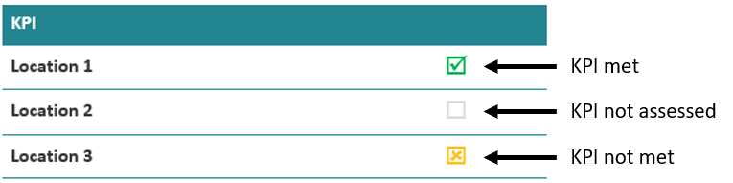
Figure 1. Example of a KPI summary table.
Also included are charts or tables that show annual data relevant to the KPI. The most common of these is a chart showing the temporal trend in the indicator (shown as a faded line), a baseline (shown as horizontal dashed line) and the relevant mean used for assessing performance against the KPIs (typically a five-year rolling mean) with 95% confidence intervals (Figure 2).
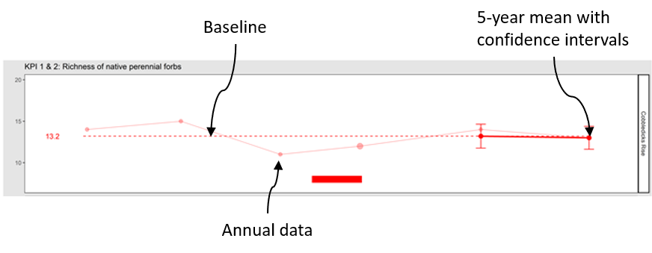
Figure 2. Example of a KPI indicator chart, in this case the KPI was recorded as achieved.
Other measures are reported as charts, tables or lists depending on the type of data captured. Typically, charts will show annual trends and therefore look similar to those used for KPIs without the baseline.

Changes to the Monitoring and Reporting Framework
The MRF (DEPI 2015) was produced before most of the field-based monitoring commenced. The subsequent application of the monitoring and reporting regime has revealed several areas where the MRF can be improved. In this report, we recommend changes to improve the MRF, document them, and implement them. All such changes are intended to strengthen the conservation outcomes or clarify ambiguities; none are intended to weaken the KPIs or the reporting requirements. A separate section on any changes is included in each chapter so that all changes are clearly documented.

Natural Temperate Grasslands

Introduction

The ecological community
‘Natural Temperate Grassland of the Victorian Volcanic Plains’ (hereafter NTG) is an ecological community listed as Critically Endangered (CE) under the EPBC Act. It is dominated by native tussock grasses and contains a variety of native forbs. The community is described in detail in the Commonwealth listing advice (TSSC 2008, DSEWPAC 2011). It formerly covered much of the Victorian Volcanic Plain bioregion, but is now restricted to small, scattered remnants throughout its former range.

Goals and performance indicators
Under the MSA, the Victorian Government has committed to ensuring that ‘the composition, structure and function of Natural Temperate Grassland of the Victorian Volcanic Plains improves within the program area’.
Progress towards this goal is measured using seven KPIs:
- Hectares making transition between states (defined by a state-and-transition model, Sinclair et al. 2019b).
- Cover of native perennial forbs, which must remain above a baseline (see below).
- Richness of native perennial forbs, which must remain above a baseline (see below).
- Cover of Kangaroo Grass (Themeda triandra), which must remain above a baseline (see below).
- Cover of native perennial grass (excluding Themeda triandra), which must remain above a baseline (see below).
- Percent of plots that have bare ground cover between 25 – 75%.
- Cover of perennial weeds, which must remain below a baseline (see below).
For KPIs 2, 3, 4, 5 and 7, each state will have a separate baseline, which will apply across all patches of that state. For each state, that baseline will be calculated using the data collected in the first five years after the first acquisition of a substantial representation of that state. A ‘substantial representation’ is considered to be three different patches of vegetation in that state, spread over three different parcels of land.

Monitored areas
NTG is only monitored on properties protected under the MSA. Properties are protected each year, so that the area covered by the monitoring increases year-on-year. Over time, the number of plots will increase, and the ability to detect changes and infer relationships between management and ecological outcomes will increase. The current monitoring program is somewhat less than 15% of the scale of the monitoring program expected in the final years of the MSA, when all properties are protected (in terms of area monitored and number of sampling plots).

Summary of monitoring methods
Three sampling methods are employed to monitor NTG, each described below.

State mapping
This method addresses the following KPI:
- Hectares making transition between states
Every new parcel of land is inspected upon acquisition, and any NTG is mapped according to the method described in the Conservation Area Inventory Guidelines (DELWP 2015b), and assigned to a state using the NTG state-and-transition model and the accompanying state key (Sinclair et al. 2019b). Every property is remapped periodically, and any changes in state are recorded. These changes are reported on in five-year blocks and any changes are evaluated as being positive, neutral or negative, according to Sinclair et al. (2019b). The first five-year period for reporting has been identified as 2015-2020.

Intensive point intercept plots
This sampling method addresses the following KPIs:
- Cover of perennial native herbs
- Diversity of perennial native herbs
- Cover of Kangaroo Grass (Themeda triandra)
- Cover of any native perennial grass (excluding Themeda triandra)
- Cover of perennial weeds
The plots are stratified across the states, with a higher density of plots in the more intact states which are rarer in the MSA area and more highly valued (Herb-rich grassland, Themeda grassland), and a lower density in the less intact states which are more widespread (C3 grassland, Nutrient-enriched Grassland, De-rocked grassland) (The MRF (DELWP, 2015a) provides density guidelines, and Table 1 shows the plot allocations by state).
Approximately 75% of the plots in each state are permanent (and marked), and 25% re-allocated annually (and not marked). This mix of plots was selected to gain the benefits of learning about change with repeat measures (permanent plots), and to partly avoid the danger of biasing management towards the plot locations (DELWP, 2015; Vos et al. 2000; Lindenmayer et al. 2012). Table 1 summarises how the plots have been deployed over multiple years of sampling as new properties have been protected, and new plots introduced and re-randomised.
Within the stratification by state the plots are located randomly, with the exception that additional permanent plots are located on Spiny Rice-flower clusters (See Spiny Rice-flower section). All such Spiny Rice-flower plots fall in Herb-rich grassland, such that this state experiences some bias towards sites occupied by Spiny Rice-flower. In 2019, 3 of 14 permanent plots are allocated to Spiny Rice-flower clusters.
Each plot is a square 400 m² in area (20 x 20 m), aligned north-south. Within each plot, five 20 m lines are laid out across the plot, running east-west (at 2, 6, 10, 14 and 18 m along the north-south axis). Each line defines a set of 50 sampling points, located 40 cm apart, such that the plot contains 250 sampling points. At each point, a narrow pin is held vertically and any vascular plant species, exposed rock, detached plant litter, bare ground or moss intersecting the pin is recorded. Every item or species is recorded only once per pin, but multiple items are recorded at a single point (including multiple plant species, rock and plants), meaning that when the values for all plants are summed, the total cover may exceed 100%. Every data point for plant species is recorded as ‘basal area’ (a point where the plant contacts the ground; i.e. a stem- or tiller-base), or ‘aerial cover’ (a point where any other plant part touches the pin). The total cover for any species is the sum of basal and aerial cover.
After the point intercept measurements are completed, an unstructured three-minute search of the plot is undertaken by a single experienced botanist, to record all native perennial forb species not detected by pointing. Native perennial forbs are defined in the MRF as any native perennial species not in the families Poaceae, Juncaceae or Cyperaceae (DELWP 2015a).
Figure 3 shows an example of a point intercept plot in NTG.
Soil samples are taken from all permanent plots when they are newly established, and every five years thereafter.
Intensive point intercept plots were first established in 2013, before the MRF was drafted (DELWP 2015a). The monitoring methods were slightly different in 2013 to the following years, such that some measures cannot be served by the data from 2013.

Rapid plots
This sampling method addresses the following KPI:
- Percent of plots that have bare ground cover between 25 – 75%
It also provides data to characterise the grassland habitat of Golden Sun Moth and Striped Legless Lizard (see below).
Numerous small ‘rapid plots’ are randomly positioned across the protected area of NTG without stratification by state. The MRF does not specify the density of such plots, but this has been gradually raised from one plot per 18.3 ha in 2014 (51 plots) to 1 plot per 7 ha in 2018 (145 plots). Table 1 summarises how the rapid plots have been deployed over multiple years of sampling, as new properties have been protected and new plots introduced. Each rapid plot is a square 1 m² in area. Within each plot, visual estimates are made of the cover of the following important elements:
- Themeda triandra
- Native forbs (as defined in DELWP 2015a)
- C4 native grasses
- C3 native grasses
- Exotic perennial monocots
- Exotic perennial dicots
- Exotic annual dicots
- Exotic annual monocots
- Bare ground
- Litter
- Exposed rock.
The biomass assessment method of Schultz et al. (2017) is also applied at each plot. This data is used to characterise habitat for Golden Sun Moth.
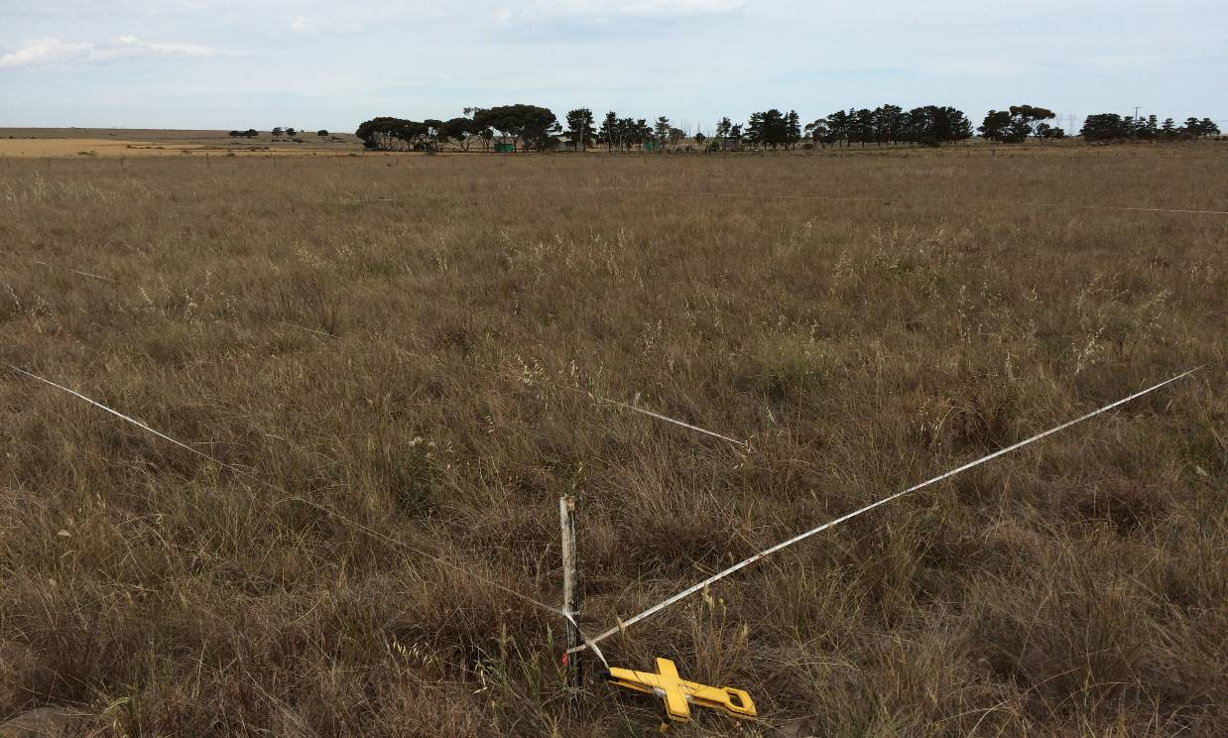
Figure 3. A point-intercept plot used to sample Natural Temperate Grassland.
Table 1. Sampling intensity for Natural Temperate grassland, showing how the different plot types have been dispersed across the states in different years.
Plot type (and state) | Number of plots
 | 2013 | 2014 | 2015 | 2016 | 2017 | 2018 | 2019
Rapid plots (all states, no strata) | - | 47 | 69 | 93 | 124 | 145 | 224
Allpoint intercept plots | 16 | 23 | 32 | 33 | 32 | 36 | 53
Permanent point intercept plots | 10 | 18 | 24 | 24 | 24 | 27 | 39
- Herb-rich grassland (HG) | 5 | 7 | 10 | 10 | 10 | 10 | 14
- Themeda grassland (TG) | 0 | 3 | 5 | 5 | 5 | 8 | 11
- C3 grassland (C3G) | 0 | 2 | 3 | 3 | 3 | 3 | 5
- Nutrient-enriched grassland (NG) | 5 | 6 | 6 | 6 | 6 | 6 | 6
- De-rocked grassland (DG) | 0 | 0 | 0 | 0 | 0 | 3 | 3
Re-allocated point-intercept plots | 6 | 5 | 8 | 9 | 8 | 9 | 14
- Herb-rich grassland (HG) | 3 | 2 | 4 | 4 | 3 | 1 | 6
- Themeda grassland (TG) | 0 | 1 | 1 | 2 | 1 | 4 | 5
- C3 grassland (C3G) | 1 | 0 | 0 | 0 | 1 | 1 | 0
- Nutrient-enriched grassland (NG) | 2 | 2 | 3 | 3 | 3 | 3 | 3
- De-rocked grassland (DG) | 0 | 0 | 0 | 0 | 0 | 0 | 0

Results: KPIs

KPI 1: Hectares making transition between states
Hectares making transition between states
Herb-rich grassland | ◻
Themeda grassland | ◻
C3 grassland | ◻
Nutrient-enriched grassland | ◻
De-rocked grassland | ◻

This KPI compares the results from vegetation mapping completed at five-yearly intervals (with the first interval set to conclude in 2020, covering all areas protected and mapped by 2016 – an arbitrary commencement date when several properties were protected). It refers to states defined by the NTG state-and-transition model (Sinclair et al. 2019b), where some states are more desirable than others. The KPI is designed to ensure that any transitions between states are positive transitions, and that negative transitions are avoided. Table 2 shows the hectares of NTG assigned to each state. The figures include areas assigned to states which are no longer NTG (due to their levels of weed invasion).
It is not yet possible to state whether the KPI has been met, as the first reporting period does not conclude until 2020.
Table 2. Baseline areas of each state. The states are listed from most- to least-desirable.
NTG state | Area (ha) first assessed by 2016  (Baseline 2016 - 2019)
Herb-rich grassland (HG) | 24
Themeda grassland (TG) | 12
C3 grassland (C3G) | 23
Nutrient-enriched grassland (NG) | 899
De-rocked grassland (DG) | 0
De-rocked nutrient-enriched pasture (DNP) | Not NTG

KPI 2: Cover of native perennial forbs
Cover of native perennial forbs
Herb-rich grassland | ☑
Themeda grassland | ☑
C3 grassland | ◻
Nutrient-enriched grassland | ◻
De-rocked grassland | ◻

This KPI measures the cover of the valuable and diverse native perennial forb component, which includes many rare species (Stuwe 1986; Sinclair et al. 2015). The point intercept plots (permanent and re-allocated) provide an estimate of the cover of native perennial herbs in each state in each year, as shown in Figure 4. Forb cover is relatively low across all states.
This KPI was met in the two states for which assessment is possible: Herb-rich grassland and Themeda grassland. The baseline for C3 grassland was set in this monitoring period at 1.7% cover. The baseline has not yet been set for the other states because these states are not yet sufficiently protected.
This KPI will be assessed using a ‘continuous improvement’ approach, where any increase over the baseline in a five-year reporting period will lead to the calculation of a new baseline for subsequent reporting periods.
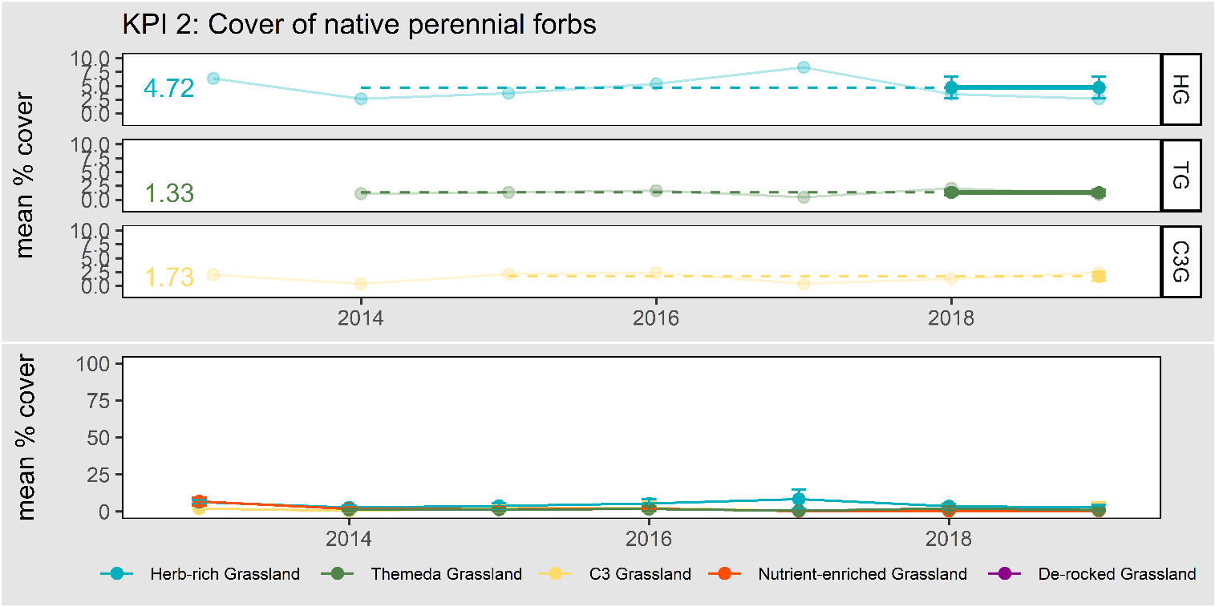
Figure 4. Cover of native perennial forbs in NTG, displayed by state. The error bars represent 95% confidence intervals. The baselines are shown for those states which have had baselines set.

KPI 3: Richness of native perennial forbs
Richness of native perennial forbs
Herb-rich grassland | ☑
Themeda grassland | ☑
C3 grassland | ◻
Nutrient-enriched grassland | ◻
De-rocked grassland | ◻

This KPI measures the richness of the native perennial forb component (explicitly at the scale of the 400 m² plot). The point intercept plots (permanent and re-allocated) provide an estimate of the richness of native perennial herbs per plot, in each state, in each year, as shown in Figure 5. It is notable that imperfect detectability of sparse or cryptic species (due to seasonal conditions and human error) inevitably leads to fluctuations in the data.
This KPI was met in the two states for which assessment is possible: Herb-rich grassland and Themeda grassland. The baseline for C3 grassland was set in this monitoring period at 3.9. The baseline has not yet been set for the other states because these states are not yet sufficiently protected.
This KPI will be assessed using a ‘continuous improvement’ approach, where any increase over the baseline in a five-year reporting period will lead to the calculation of a new baseline for subsequent reporting periods.
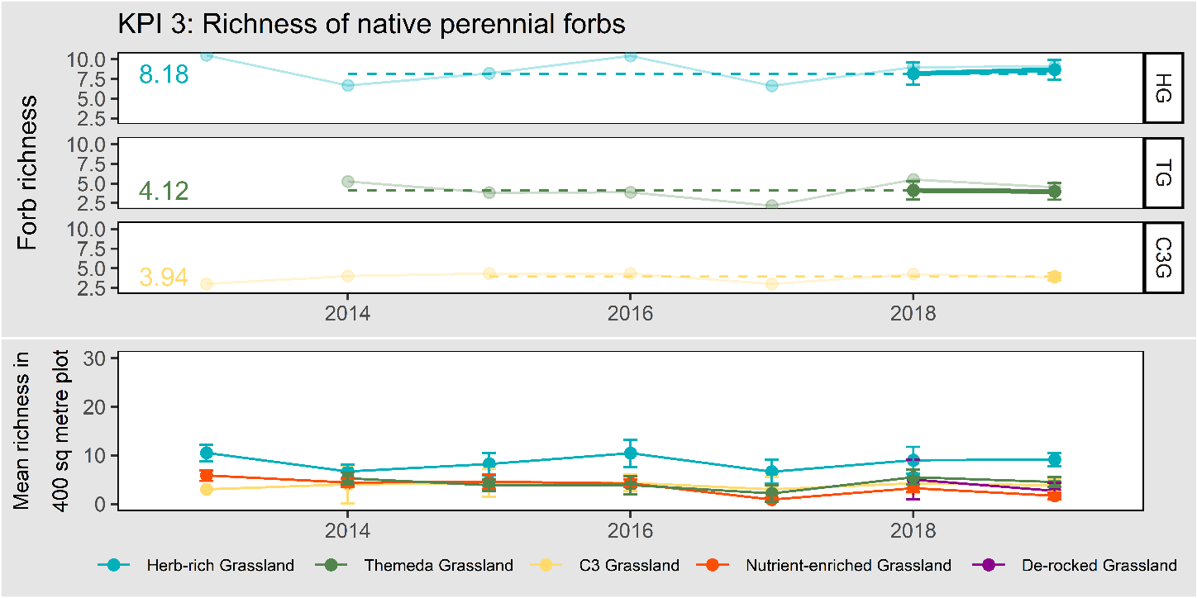
Figure 5. Richness of native perennial forbs in NTG, displayed by state. The error bars represent 95% confidence intervals. The upper panel shows the annual data (faint line), five-year rolling mean (heavy line) and the baseline (dashed line) for those states which have had baselines set. The lower panel shows the annual data for all states.

KPI 4: Cover of Kangaroo Grass (Themeda triandra)
Cover of Kangaroo Grass
Herb-rich grassland | ☑
Themeda grassland | ☑
C3 grassland | ◻
Nutrient-enriched grassland | ◻
De-rocked grassland | ◻

This KPI measures the cover of Kangaroo Grass (Themeda triandra), which was the natural dominant of NTG, and can be considered a foundational species that regulates nutrient dynamics and species competition in the community (Prober and Lunt 2009; Prober et al. 2009). The point intercept plots (permanent and re-allocated) provide an estimate of the cover of this species in each state in each year, as shown in Figure 6.
This KPI was met in the two states for which assessment is possible: Herb-rich grassland and Themeda grassland. The baseline for C3 grassland was set in this monitoring period at 0.5% cover. The baseline has not yet been set for the other states because these states are not yet sufficiently protected.
For the most intact state, Herb-rich grassland) this KPI will be assessed using a set baseline approach (rather than a ‘continuous improvement’ approach), where the baseline will remain perpetually at 29%. this reflects the fact that Kangaroo Grass is valuable but can become over-abundant (Stuwe and Parsons 1977; Lunt and Morgan 1999). It is assumed that the intact Herb-rich grasslands have an acceptable level of Kangaroo Grass cover.
For all other states, a continuous improvement approach will be taken, where any increase over the baseline in a five-year reporting period will lead to the calculation of a new baseline for subsequent reporting periods until a cover of 29% is reached, when the baseline will become fixed.

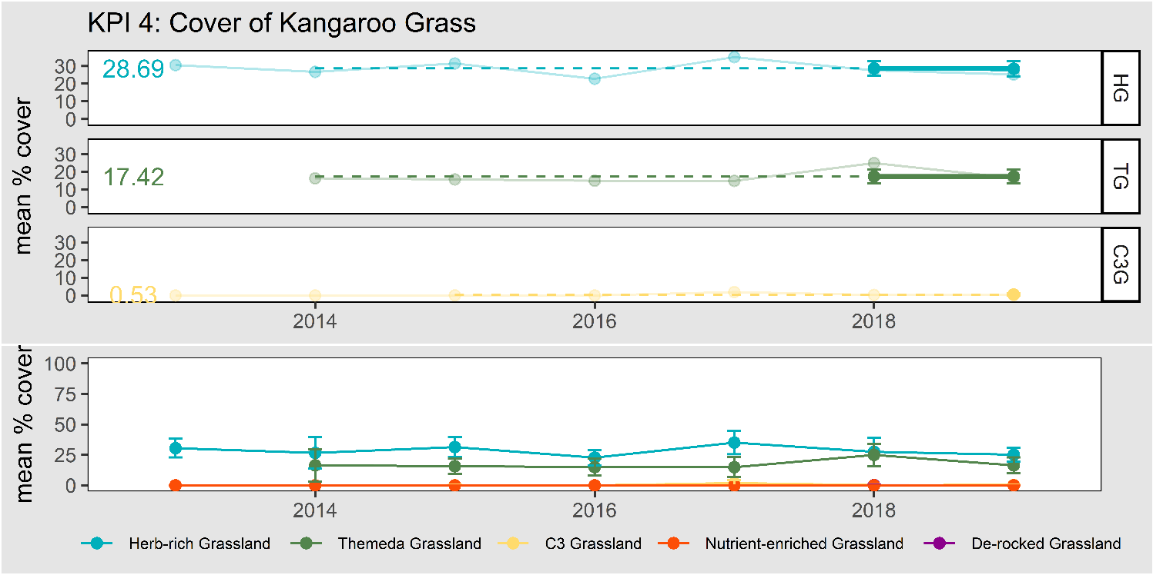
Figure 6. Richness of native perennial forbs in NTG, displayed by state. The error bars represent 95% confidence intervals. The upper panel shows the annual data (faint line), five-year rolling mean (heavy line) and the baseline (dashed line) for those states which have had baselines set. The lower panel shows the annual data for all states.

KPI 5: Cover of any native perennial grasses (excluding Kangaroo Grass)
Cover of any native perennial grass (ex. Kangaroo Grass)
Herb-rich grassland | ☑
Themeda grassland | ☑
C3 grassland | ◻
Nutrient-enriched grassland | ◻
De-rocked grassland | ◻

This KPI measures the cover of native perennial grasses (other than Kangaroo Grass, which was dealt with in the preceding KPI). The point intercept plots (permanent and re-allocated) provide an estimate of the cover of these species in each state in each year, as shown in Figure 5.
This KPI was met in the two states for which assessment is possible: Herb-rich grassland and Themeda grassland. The baseline for C3 grassland was set in this monitoring period at 40.7% cover. The baseline has not yet been set for the other states because these states are not yet sufficiently protected.
This KPI will be assessed using a set baseline approach (rather than a ‘continuous improvement’ approach), where the baseline will remain at the value defined in the first monitoring period, reflecting the fact that moderate levels of native grass cover must be maintained, and that loss of cover and over-growth may both be problematic.
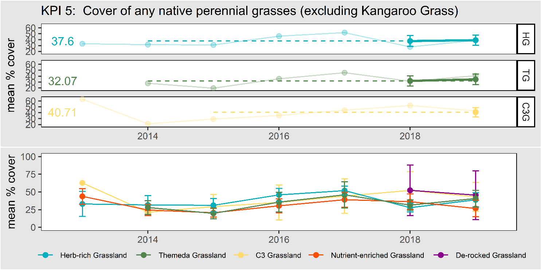
Figure 7. Cover of perennial native grasses (excluding Themeda triandra) in NTG, displayed by state. The error bars represent 95% confidence intervals. The upper panel shows the annual data (faint line), five-year rolling mean (heavy line) and the baseline (dashed line) for those states which have had baselines set. The lower panel shows the annual data for all states.

KPI 6: Percent of plots that have bare ground cover between 25 – 75%
Percentage of plots that have bare ground between 25 – 75%
All states | ☑

This KPI is a measure of habitat structural heterogeneity. It requires that NTG exists in a range of structural types each year (no single type is always preferred), to allow a range of animals to meet their habitat requirements (e.g. Baker-Gabb et al. 1990). The KPI requires a certain percentage (5 - 30%) of plots to fall within a bare ground cover category (25 – 75% bare ground), and consequently requires a proportion to fall outside that category. The rapid plots provide the data for this KPI.
This KPI does not refer to a baseline. Rather, the KPI is met, or not, in each year.
Table 3 shows performance against this KPI over multiple years. It records the numbers of plots that fell into different bare ground categories, along with a measure of what percentage of plots fall within the range specified by the KPI. It shows that this KPI was met in 2017, 2018 and 2019 after having not been met in 2014, 2015 or 2016.
Table 3. The distribution of all plots according to bare ground categories. All figures are numbers of rapid plots.
Year | 0 – 24%  bare ground | 25 – 75%  bare ground | 76 – 100%  bare ground | Total number of plots | Percent of plots with 25 - 75% bare ground cover | KPI met?
2013 | No rapid plots were implemented in 2013.
2014 | 45 | 1 | 1 | 47 | 2% | No
2015 | 37 | 31 | 1 | 69 | 45% | No
2016 | 57 | 36 | 0 | 93 | 39% | No
2017 | 113 | 11 | 0 | 124 | 9% | Yes
2018 | 139 | 21 | 0 | 160 | 13% | Yes
2019 | 154 | 67 | 3 | 224 | 30% | Yes

KPI 7: Percent cover of all perennial vegetation comprised of weeds
Percentage cover of all perennial vegetation comprised of weeds
Herb-rich grassland | ☑
Themeda grassland | ☑
C3 grassland | ◻
Nutrient-enriched grassland | ◻
De-rocked grassland | ◻

This KPI measures the percent of all perennial vegetation cover that is comprised of weeds (introduced species). Weeds are considered undesirable (Sinclair et al. 2015). The point intercept data from the permanent and re-randomised plots provide the relevant data in each state in each year.
This KPI was met in both Herb-rich grassland and Themeda grassland, the two states for which assessment is possible (Figure 8). The baseline for C3 grassland was set in this monitoring period at 44.8%. The baseline has not yet been set for the other states because these states are not yet sufficiently protected. This KPI will be assessed using a ‘continuous improvement’ approach, where any increase over the baseline in a five-year reporting period will lead to the calculation of a new baseline for subsequent reporting periods.
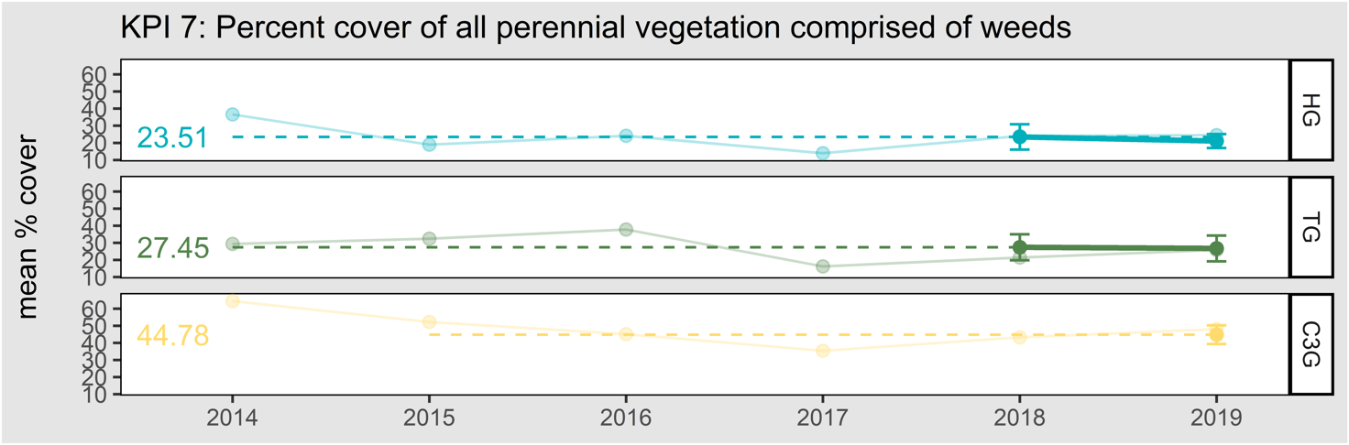Figure 8. The percentage of all perennial vegetation cover comprised of weeds, displayed by state. The error bars represent 95% confidence intervals. The upper panel shows the annual data from permanent and re-allocated plots (faint line), five-year rolling mean (heavy line), and the baseline (dashed line) for those states which have had baselines set.

Results: Other measures

Overall NTG quality
The KPIs described above provide good indications of NTG change, but they address separate aspects of the community. No single KPI is a direct and all-encompassing measure of the “composition, structure and function” for the community, which is the way improvement is framed in the MRF (DELWP 2015a).
To partially address this, overall NTG ‘quality’ is determined using the algorithm described in Sinclair et al. (2015). The quality algorithm combines eight measurable on-ground variables into a single value. These eight variables correspond closely with the KPI variables. The algorithm makes sense of changes among the multiple KPIs, by providing a single quality score between 100 (a ‘pristine’ site) and 0 (where no value remains). The score is calculated from all permanent and re-allocated point-intercept plots in each year and reported by state.
The quality of all sites, reported by state and year, is shown in Figure 9. Overall, the quality of Natural Temperate Grassland remains relatively steady over the monitoring period.

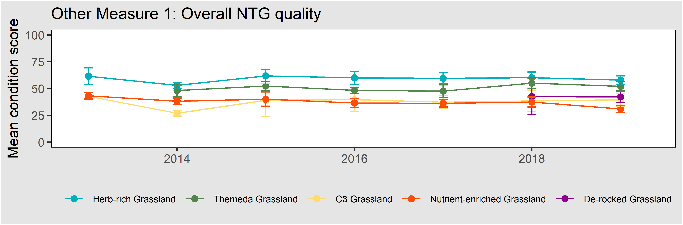
Figure 9. Change in the overall quality of the permanent NTG monitoring plots, showing changes over multiple years by grassland state. Error bars are 95% confidence intervals.

Annual native forb cover
In intact NTG, annual native forbs formed an appreciable component of the species richness and cover (Sutton 1916, 1917). This group of species is, however, now greatly depleted. It is also highly variable in cover due to rainfall variation between years. For these reasons, annual forbs are excluded from the KPIs that deal with native forb richness and cover.
The point-intercept plots can detect annual forbs, and their covers are shown in Figure 10. Annual native forbs generally have negligible cover (often zero), except in wet years when they may proliferate (e.g. 2016).
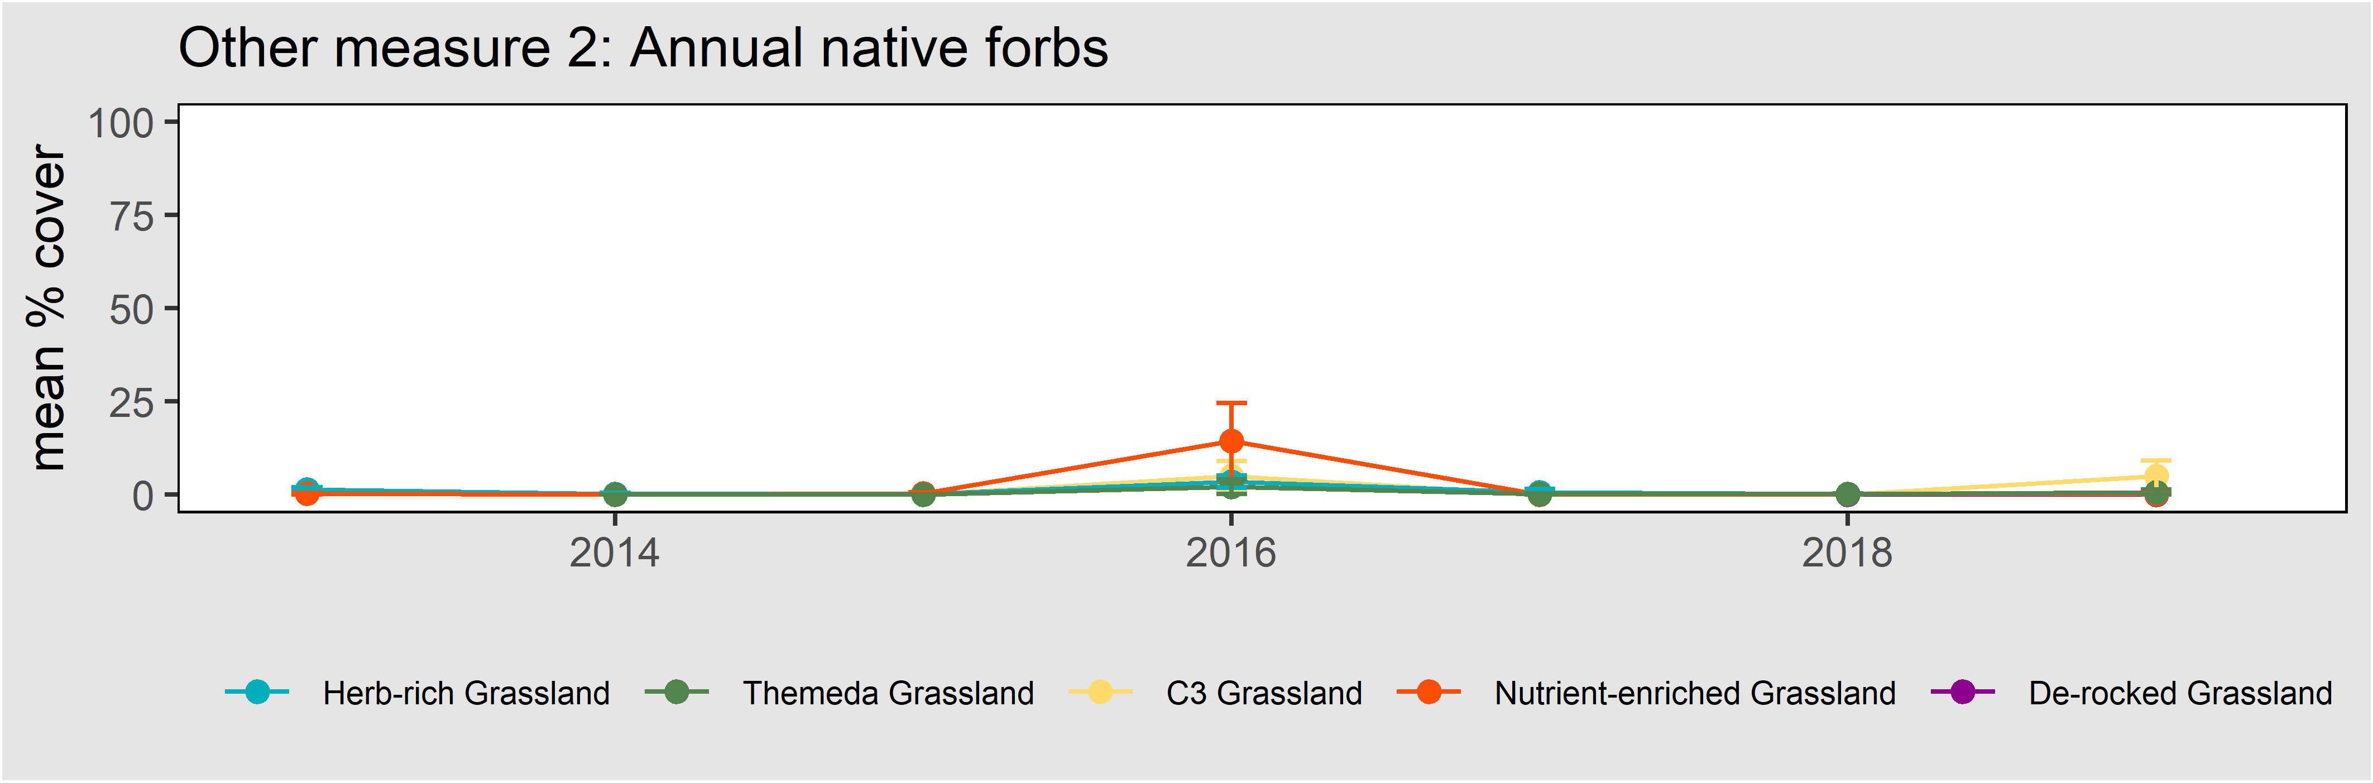
Figure 10. Change in the overall quality of the permanent NTG monitoring plots, showing changes over multiple years by grassland state. Error bars are 95% confidence intervals.

Annual weed cover
The cover of annual weeds is closely linked to the levels of nitrate in the surface soil, and higher annual weed levels often indicate more degraded sites (Prober et al. 2009; Chisholm et al. 2015). Annual weeds are measured each year, but their volatility between seasons makes them unsuited to monitoring purposes.
Figure 11 shows the total cover of annual weeds. The top two panels show data taken from all point intercept plots (permanent and re-allocated). Monocot (largely grasses) and dicot (largely forbs) annual weeds are shown separately. Annual grasses make up the bulk of annual weed cover. The lower panel shows the cover of annual weeds as measured by the rapid plots (where monocots and dicots are not distinguished). The trends captured by the two sampling methods are consistent, with a large peak in annual weeds in 2017.

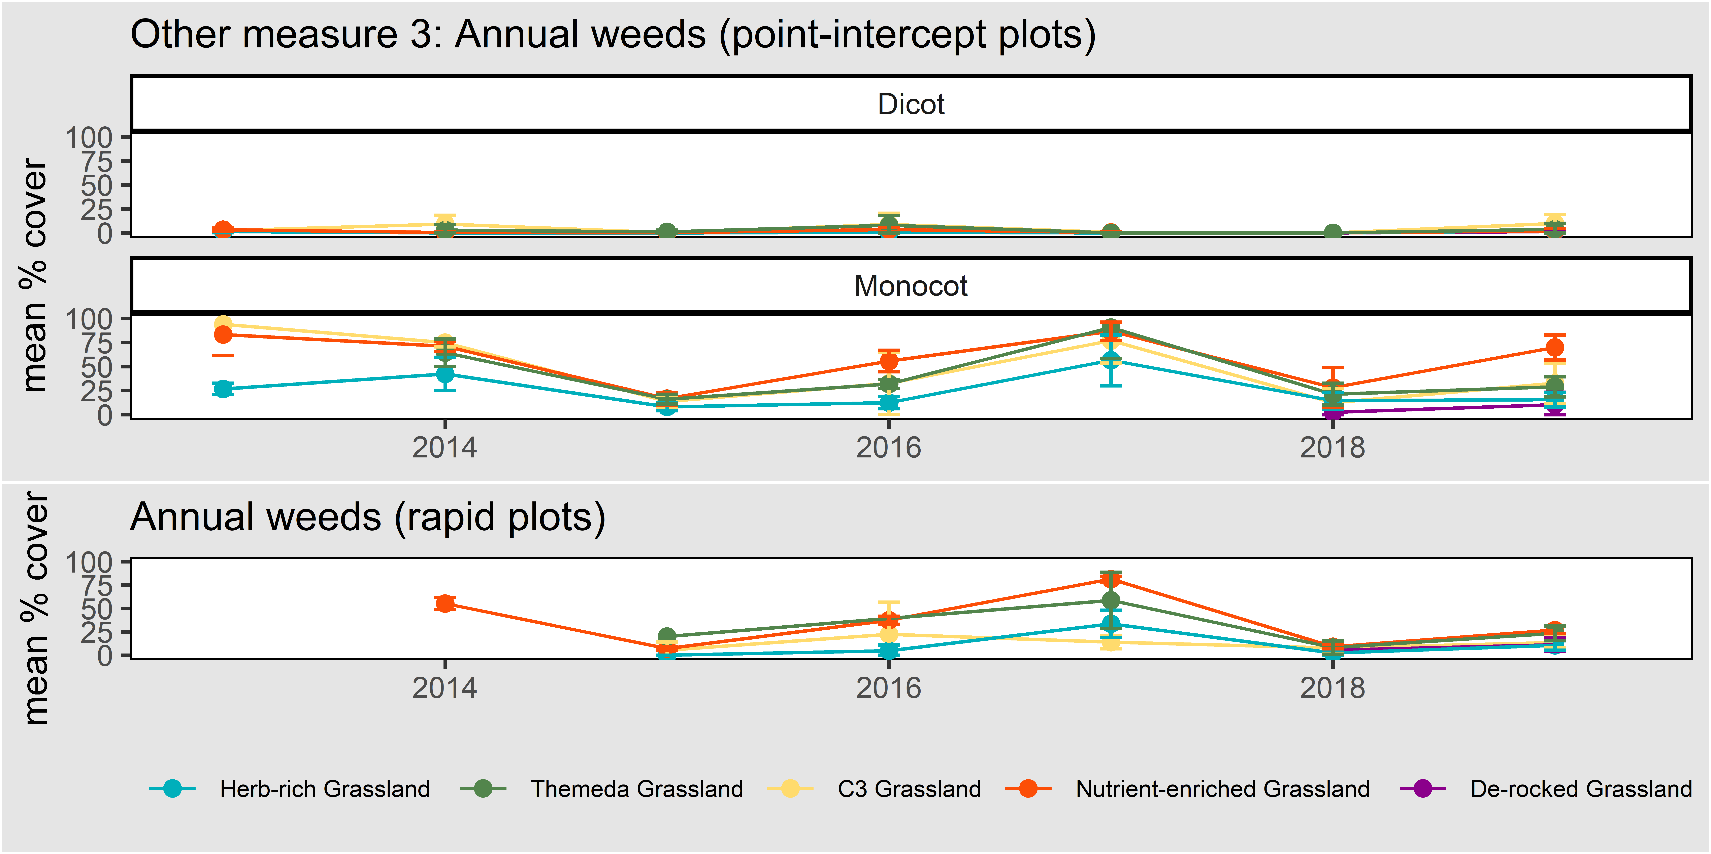
Figure 11. The cover of annual weeds as measured in point-intercept plots (upper panels) and rapid plots (lower panel). Error bars are 95% confidence intervals.

Cover of C3 and C4 grasses
Long-term grazing causes a shift from summer-active (C4) to cool-season active (C3) grasses in NTG (Moore 1970; McIntyre and Lavorel 2007). Since this shift alters the timing of growth and competition between the grass and dicot components (virtually all dicot forbs are C3) and may alter the grassland’s response to disturbance such as fire (Sinclair et al. 2014), it represents an important transition in function.
Figure 12 shows the cover of all native grasses that are C4 or C3 by state, as measured by the point intercept plots (upper panels) and the rapid plots (lower panels). Kangaroo-grass was the most abundant C4 grass (with minor contributions to cover by Windmill Grass [Chloris truncata] and Red-leg Grass [Bothriochloa macra]). C3 grasses include many Wallaby-grass (Rytidosperma spp.) and Spear-grass (Austrostipa spp.) species, among many other genera.

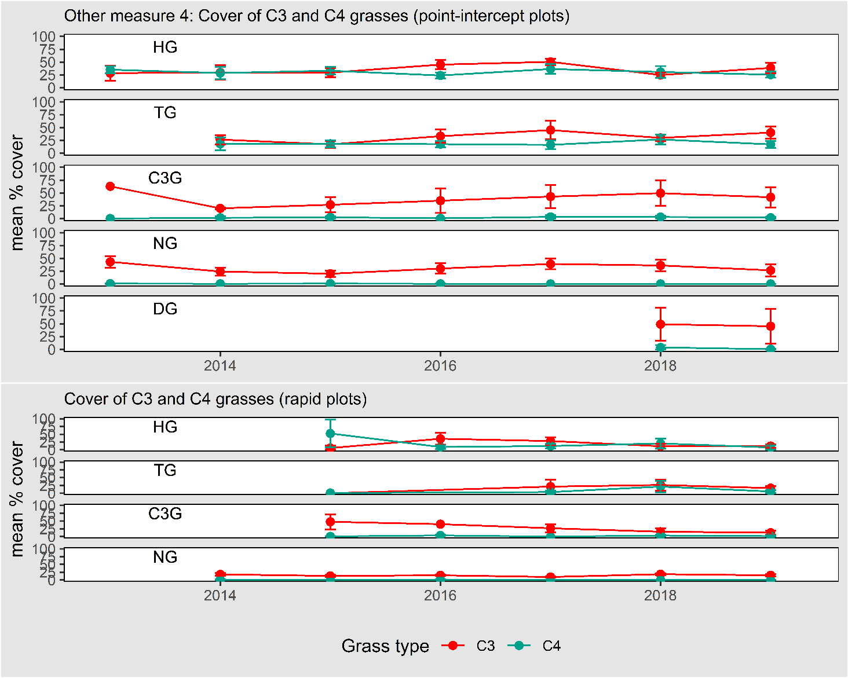
Figure 12. The cover of native C3 and C4 as measured in point-intercept plots (upper panels) and rapid plots (lower panels). Error bars are 95% confidence intervals.

Cover of organic litter, moss and rock
The soil substrate, with its impermeable rock, its surface soil, and the variable covering of litter and moss, plays important ecological roles; it fosters or inhibits seed germination, and allows animals to thermo-regulate, hunt and hide.
Figure 13 shows the measured covers of moss, rock and litter as measured by the point intercept plots (upper panels) and the rapid plots (lower panels).
Moss is universally of low cover. Organic litter fluctuates, as would be expected given it accumulates from plant growth and decay and is largely cleared away by fire. Given that the cover of rock is constant over long periods and does not vary with seasonal weather or management, it is expected to remain a stable measure. Any changes recorded are due to the re-allocation of some point intercept plots (to rockier or less rocky sites), and measurement error.
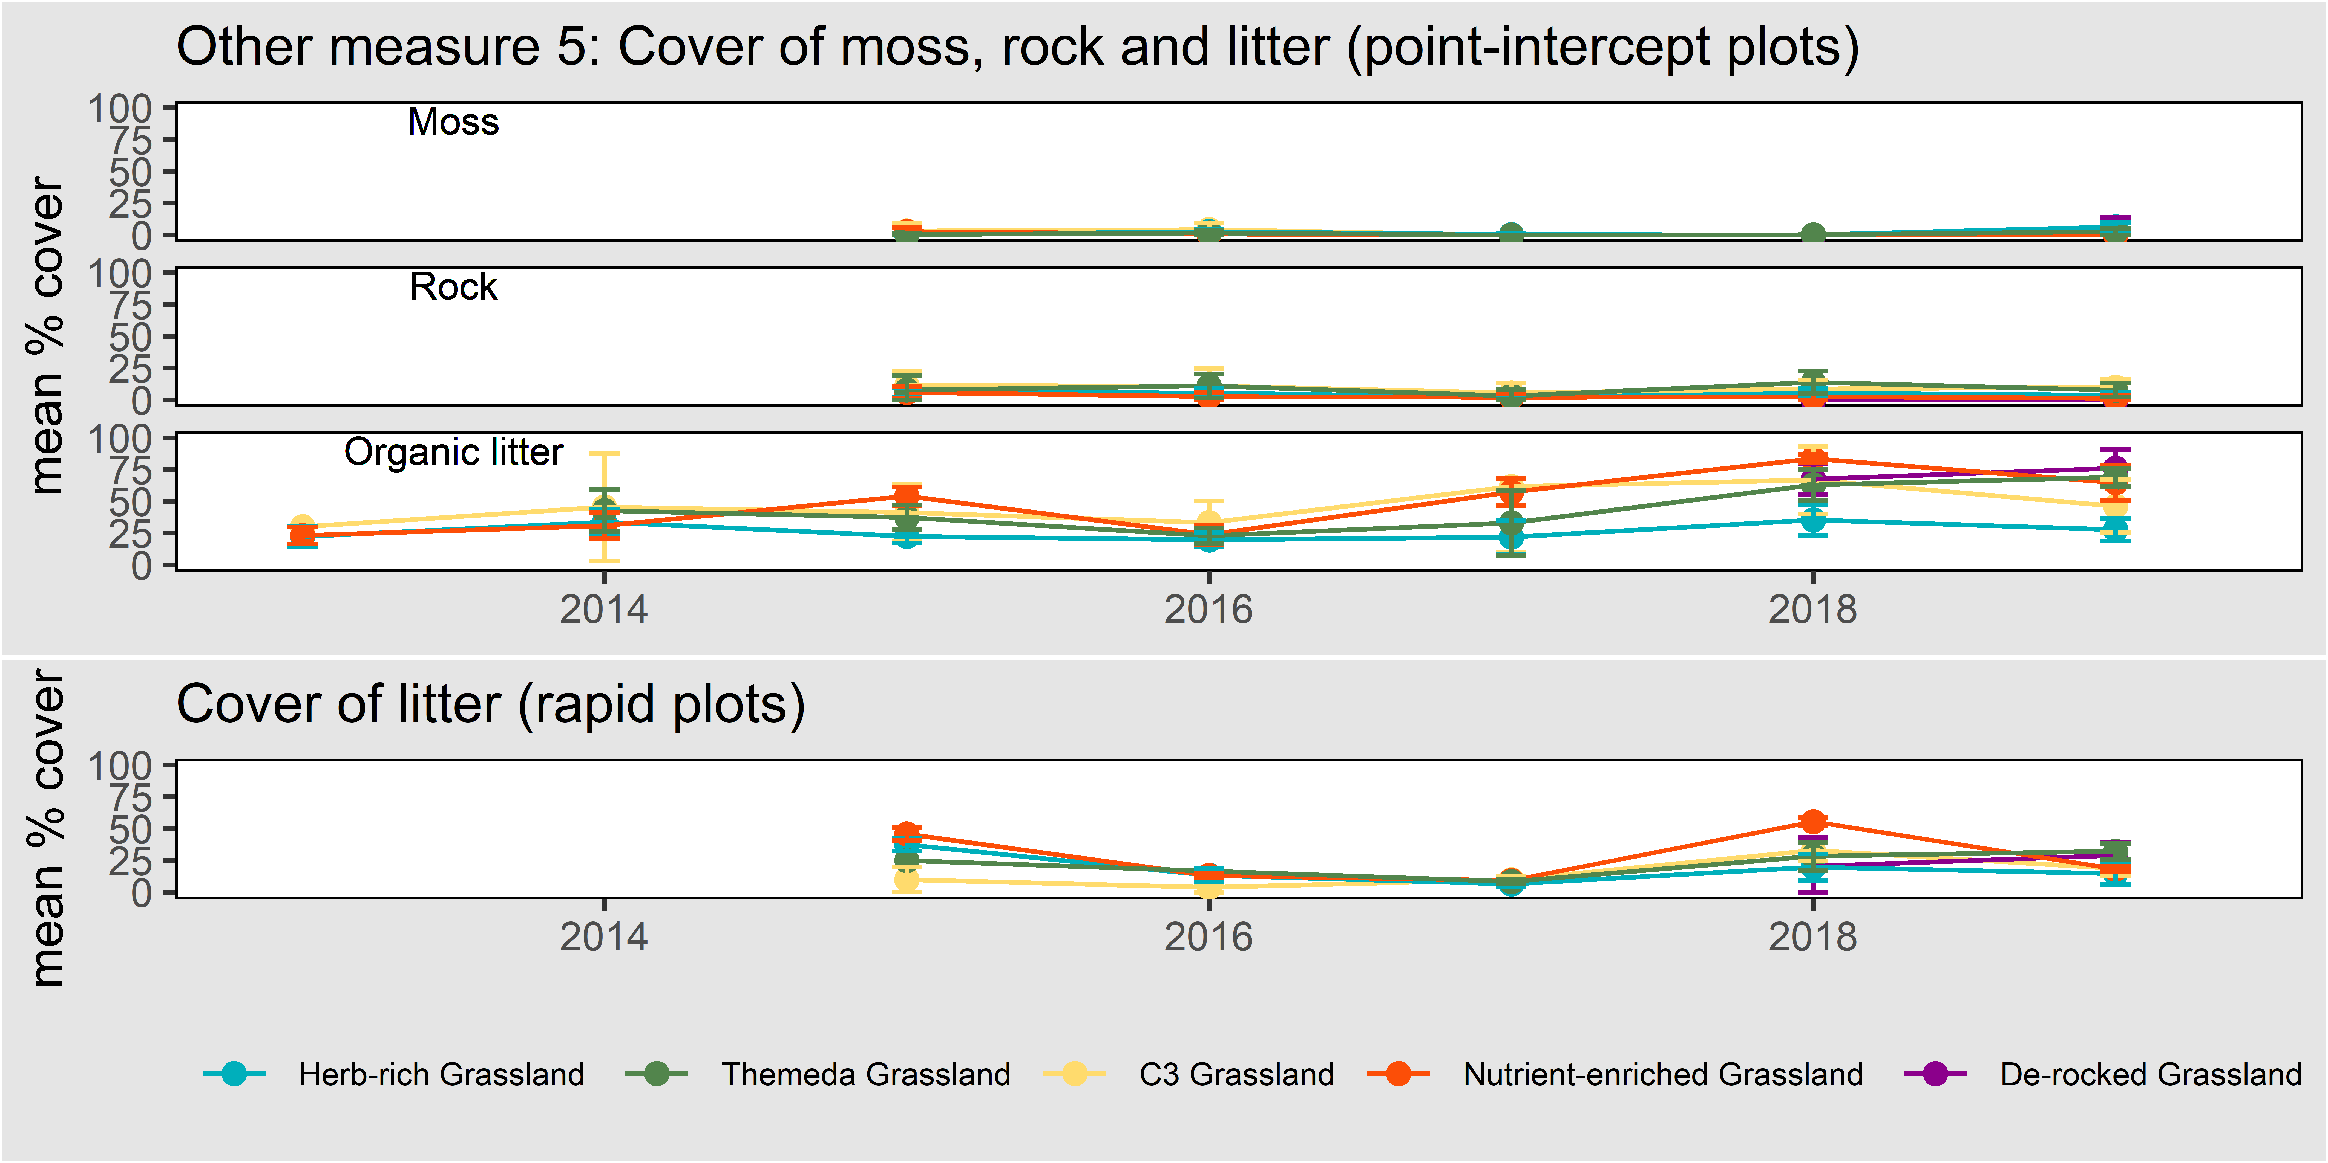
Figure 13. The cover of moss, rock and organic litter as measured in point-intercept plots (upper panels) and litter as measured in rapid plots (lower panel). Error bars are 95% confidence intervals.

Soil chemical composition
Soil chemistry has significant impacts on vegetation. It may alter the competitive dynamics of native and exotic species, and soil chemistry measures may be used as indicators of degradation and recovery potential (Dorrough and Scroggie 2008; Prober et al. 2005; McIntyre 2008). Nitrate and Phosphorous are well known to be ecologically relevant, and closely tied to vegetation parameters (Sinclair et al. 2019b).
Figure 14 shows the measured nitrate and Phosphorus levels in the top 5 cm of soil at all permanent point-intercept plots. Nitrate is temporally variable, while Phosphorous is more stable.
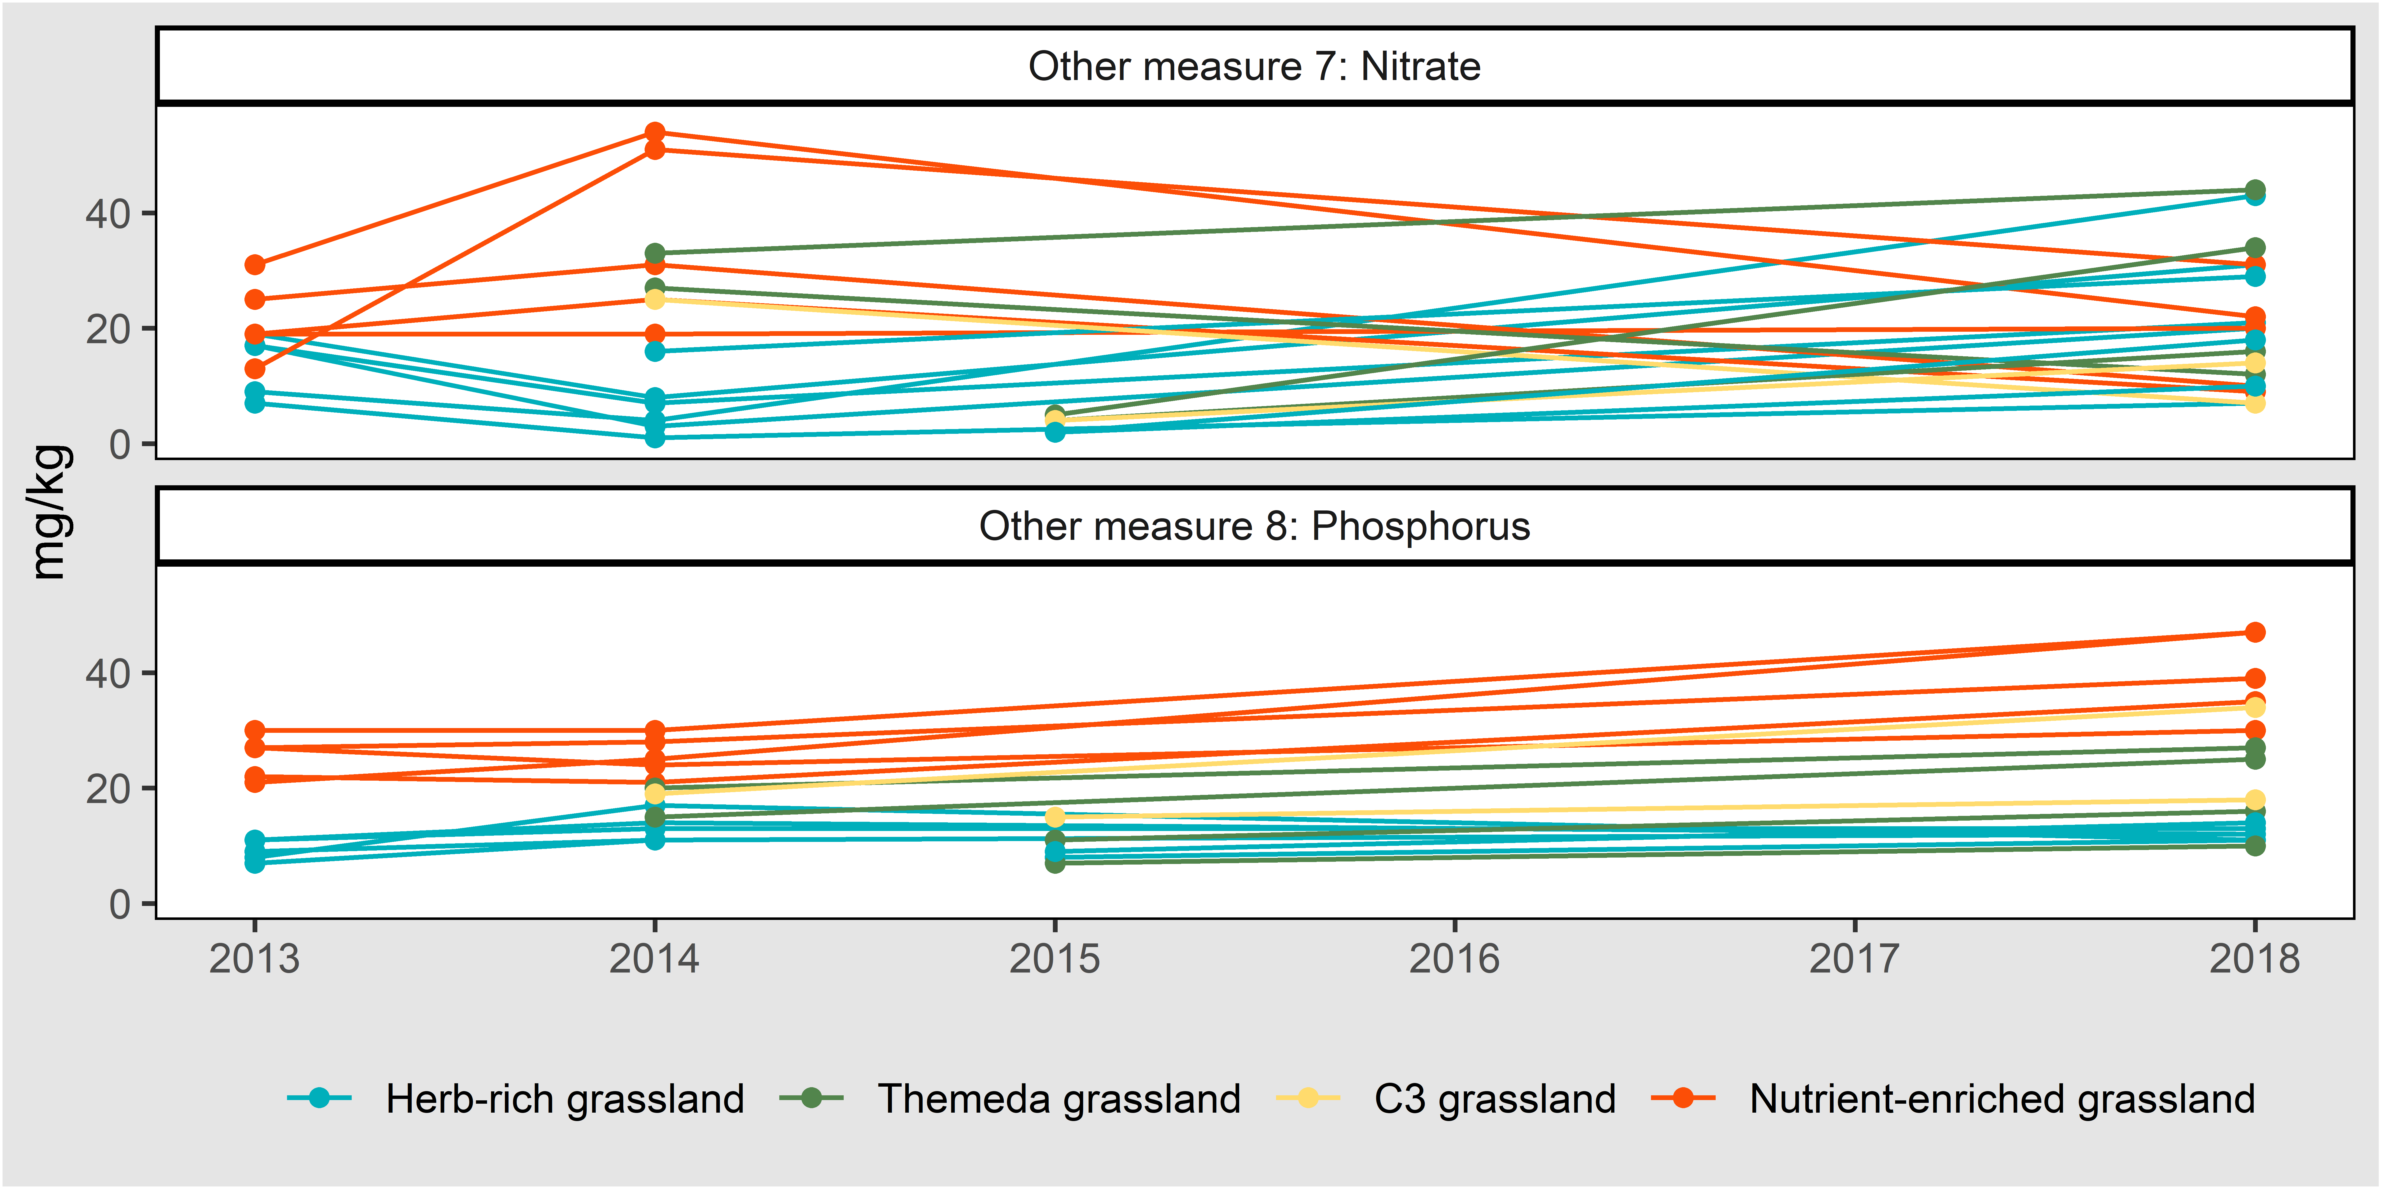
Figure 14. Soil surface Nitrate and Phosphorous (Colwell extraction). Each individual plot is shown as a separate set of points connected by a line.

Change in perennial weed cover
This measure is intended as a companion to KPI 7. It shows the trend in perennial weeds for permanent point-intercept plots (unlike KPI 7 which uses all plots) from the time a plot was first surveyed by state (i.e. the mean difference between the cover in a given year and the first year). Controlling perennial weeds is one of the main management actions in MSA grassland reserves and presenting the data this way may show trends related to management at these locations. Figure 15 shows that perennial weed cover fluctuates at permanent monitoring locations and is higher in 2019 than it was in 2018.
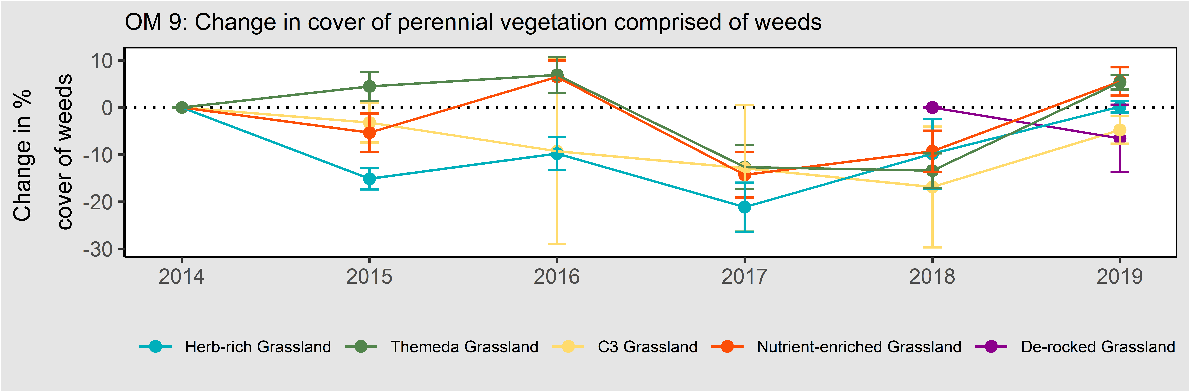
Figure 15. The mean change in perennial weed cover in permanent plots only for each state compared to year one of monitoring in that plot. In this chart, each plot is set to zero in its first year of sampling, to provide a clear view of proportional changes over time, relative to year 1. Error bars are 95% confidence intervals.

Kangaroo and pest animal abundance
Kangaroo and pest animal abundance has not been quantified to date. Monitoring of these animals will commence when a larger aggregation of parcels is protected in the Western Grassland Reserve (>5000 ha of connected land), or if kangaroo or pest management issues become a known problem on smaller Conservation Areas.

Changes to the MRF
This section details the ways in which the approach taken here differs from the MRF (DELWP 2015a).
- All KPIs have been numbered, 1-7.
- The formulation of baselines and targets was clarified to clearly indicate which KPIs are assessed against static baselines, and which are assessed using a continual improvement model.
- All references to “native herbs” have been changed to “native forbs”, in line with accepted usage.
- In KPI 3, the term ‘diversity’ has been changed to ‘richness’, in line with accepted usage.
- The measurement of KPI 7 has been changed so that it includes all plots and is calculated in the same way as other KPIs which measure vegetation cover. The baseline for KPI 7 is now set after the first 5 years and reported by state. This KPI will be assessed using a continuous improvement approach, whereby the baseline will be updated after five years if an improvement has occurred. The trend in perennial weeds is presented as another measure (Other measure 9).
- All reference to flora and fauna inventories has been removed. Inventories are instead done as part of the management preparations for individual parcels, as once-off activities, and not as part of the five-yearly reporting under the MRF. They are lengthy and would be a distraction in the five-yearly reporting against KPIs.
- The ‘other measure’ that tracks the covers of C3 and C4 grasses has been changed to report simple cover measures for each, rather than a combined proportional measure.
- The stipulation that monitoring of kangaroo abundance and pest animal abundance is to commence in the Western Grassland Reserve only when a large aggregation of parcels is protected (>5000 ha of connected land). In the smaller Conservation Areas these animals may be monitored on a case by case basis, if they are perceived to be problematic.

Grassy Eucalypt Woodland
‘Grassy Eucalypt Woodland of the Victorian Volcanic Plain’ (hereafter GEW) is an ecological community listed as Critically Endangered (CE) under the EPBC Act (TSSC 2012). The community is described in detail in the Commonwealth listing advice (TSSC 2008).
Under the ‘Melbourne Strategic Assessment’, the Victorian Government has committed to ensure that “the composition, structure and function of Grassy Eucalypt Woodland of the Victorian Volcanic Plain improves” in all areas where it is protected (DELWP 2015a). Further details of how this commitment is interpreted, and how this community will be monitored are provided in the Monitoring and Reporting Framework (DELWP 2015a).
GEW have yet been sufficiently protected, and no areas of this community are monitored. Therefore, this community will not be dealt with further here.

Seasonal Herbaceous Wetlands

Introduction

The ecological community
‘Seasonal Herbaceous Wetlands (Freshwater) of the Temperate Lowland Plains’ (hereafter SHW) are a class of wetlands listed as Critically Endangered (CE) under EPBC Act (TSSC 2012). The wetlands occur on fertile clay soils. They are inundated after rains but may remain dry for long periods. Their vegetation is low and open, composed mostly of grasses, sedges, herbs and ferns. The community is described in detail in the Commonwealth listing advice (TSSC 2012). This community was formerly scattered in large and small patches across the lowland plains of south-eastern Australia. It is now restricted to small, scattered remnants throughout its former range (TSSC 2012).

Goals and performance indicators
Under the ‘Melbourne Strategic Assessment’, the Victorian Government has committed to ensure that “the composition, structure and function of Seasonal Herbaceous Wetlands (Freshwater) of the Temperate Lowland Plains improves” in all areas where it is protected (DELWP 2015a).
Progress towards this goal is measured using four KPIs, with the following targets:
- Richness of native perennial forbs during spring-summer, which must remain above the baseline
- Richness of all native forbs during drawdown, which must remain above the baseline
- Percent of all perennial vegetation during spring-summer composed of weeds, which must remain below the baseline
- Percent of all perennial vegetation during drawdown composed of weeds, which must remain below the baseline

Monitored areas
SHW is monitored as a set of discrete wetlands. Each wetland is reported separately. All SHW sites exceeding 3 ha in area are monitored.
The first parcels of land supporting SHW were acquired in 2012. These areas contained three wetlands greater than 3 ha. As of 2019, no further examples of SHW have been protected which meet this criterion. All monitored wetlands are in the Western Grassland Reserve. They are:
- Cobbledicks Rise Wetland (5.1 ha, part of the Cobbledicks cluster noted in DEPI (2013b))
- One Tree Rise Wetland (3.1 ha)
- Windmill Wetland (4.3 ha, part of the Cobbledicks cluster noted in DEPI (2013b))
Their locations are shown in Figure 16.

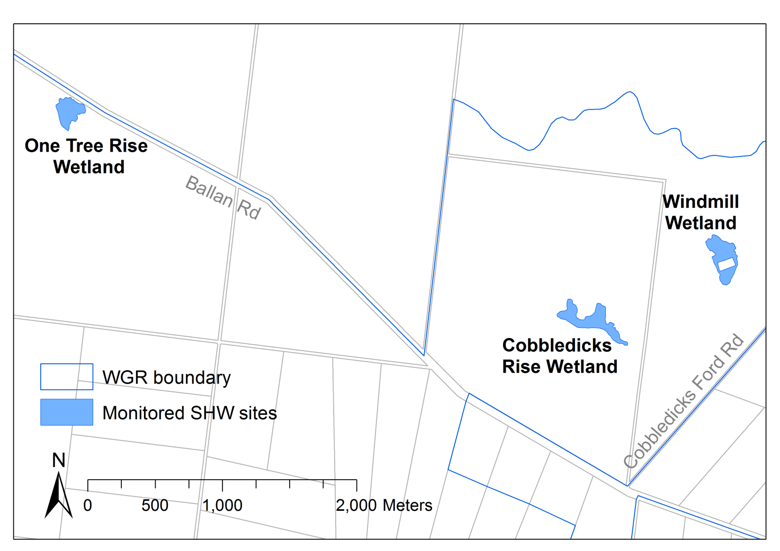
Figure 16. The locations of the subject wetlands within the protected Western Grassland Reserve (WGR).

Summary of monitoring methods

Timing of sampling
The monitoring protocol (DELWP 2015a) requires that the timing of SHW monitoring is governed by two temporal considerations. These result in two parallel lines of reporting for SHW:
- On drawdown. Wetlands must be assessed each time they draw down after filling, regardless of the date (but only once per year). Filling is here taken to be when most of the wetland area (>50%) meets the definition of ‘full’ given by Casanova and Powling (2014), that water reaches a depth of 10 cm. Filling does not occur every year.
- Annual. Wetlands must be assessed every year between September and December, regardless of their hydrological status. If the drawdown sampling happens to coincide with this period, only a single round of monitoring is required to cover both ‘on drawdown’ and ‘annual’ sampling.
At each sampling, the hydrological phase of the wetlands is recorded, using a conceptual model adapted from Bayes and Cook (2015); which categorises wetland dynamics into the following five categories:
- First fill. Water present, meets definition of ‘full’. Aquatic plants growing, but leaves not yet at the water surface. Non-aquatic species present but many drowning. Much decomposing material in the water. Aquatic fauna not yet conspicuous.
- Full. Water present, meets definition of ‘full’. Aquatic plants abundant, many emergent and flowering species are prominent on the surface, and most are flowering. Aquatic fauna can be abundant (e.g. Shield shrimp, Water Boatmen, frogs).
- Drawing down. Puddles and mud present, has recently been full, but no longer meets definition of ‘full’. Aquatic and dampland species remain prominent, many seeding. Annual or geophyte plants prominent. Aquatic fauna often present.
- Empty. No water. Soil cracks closed. Aquatic species retreated underground, dampland and semi-aquatic species abundant. Perennial native grasses, rushes and sedges actively growing. Terrestrial ruderals may be common. Aquatic fauna virtually absent.
- Dry. No water. Bare ground prominent. Soil cracks evident. Aquatic species retreated underground. Damp-land forbs low cover and stunted. Perennial grasses, sedges and rushes remain prominent, but often inactive. Terrestrial ruderals may be common.
It is acknowledged that some degree of subjectivity is involved with the assignment of a phase at the time of sampling.

Sampling with point intercept plots
Parallel line transects 25 m apart are set up at fixed locations, to cross the majority of each SHW area. Along each transect, a 1 x 1 m plot is sampled every 10 m, provided the location falls within the SHW (which is irregularly shaped and patchy). If it does not fall within the SHW, that potential sampling location is ignored, and the next sampled. Thus, the transects are of varying length for different wetlands, and have gaps where no SHW is sampled.
Within each 1 x 1 m plot, a wired frame is used to define nine points (spaced on a grid, at 10, 50, 90 cm). At every point, the identity of the vegetation (by group) intercepting the points is recorded, in the following categories:
- Persistent perennial native grasses
- Opportunistically growing native grasses
- Perennial native tussock-forming sedges and rushes (Cyperaceae or Juncaceae)
- Perennial native rhizomatous sedges
- Perennial native forbs (aquatic)
- Perennial native forbs (damp-land dependent)
- Perennial native forbs (terrestrial or ruderal)
- Annual native forbs
- Perennial dryland exotic species
- Perennial aquatic exotic species
- Annual and biennial exotic species
- Water
- Bare ground, stones or mud
Multiple categories are recorded at some points where multiple species overlapped at the point. This data is used to derive cover estimates for each category, and hence the percentage of perennial cover that is exotic, as required to address the KPIs. The data are also used to inform the ecosystem model for SHW.
An example of a plot used in sampling a wetland is shown in Figure 17.

Assessing the diversity of native forbs
All native forbs species encountered during the point-intercept sampling are recorded. One observer spends an additional 20 min/ha actively searching for forb species over the full extent of each wetland.
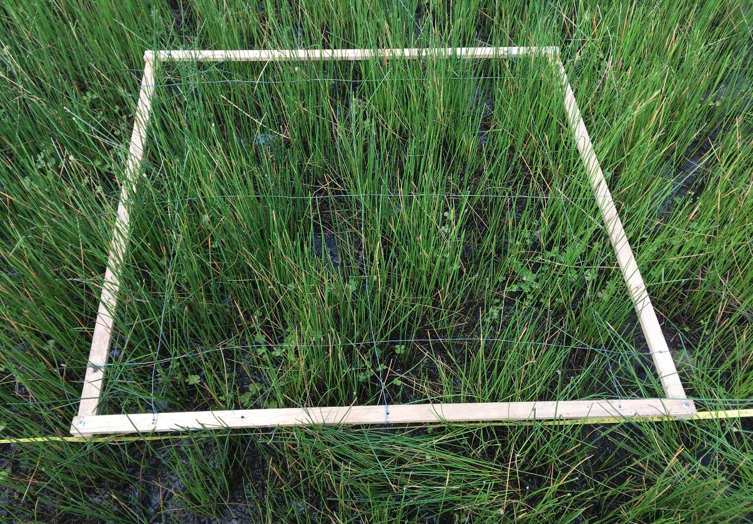
Figure 17. The small plot used to sample Seasonal Herbaceous Wetland, lying alongside the tape measure that defines the transect.

Results: KPIs
The raw data that underpins all four KPIs is shown in Figure 18 for each wetland over the period of monitoring. This data is presented alongside the rainfall data for the corresponding period. Each KPI is described in more detail below.

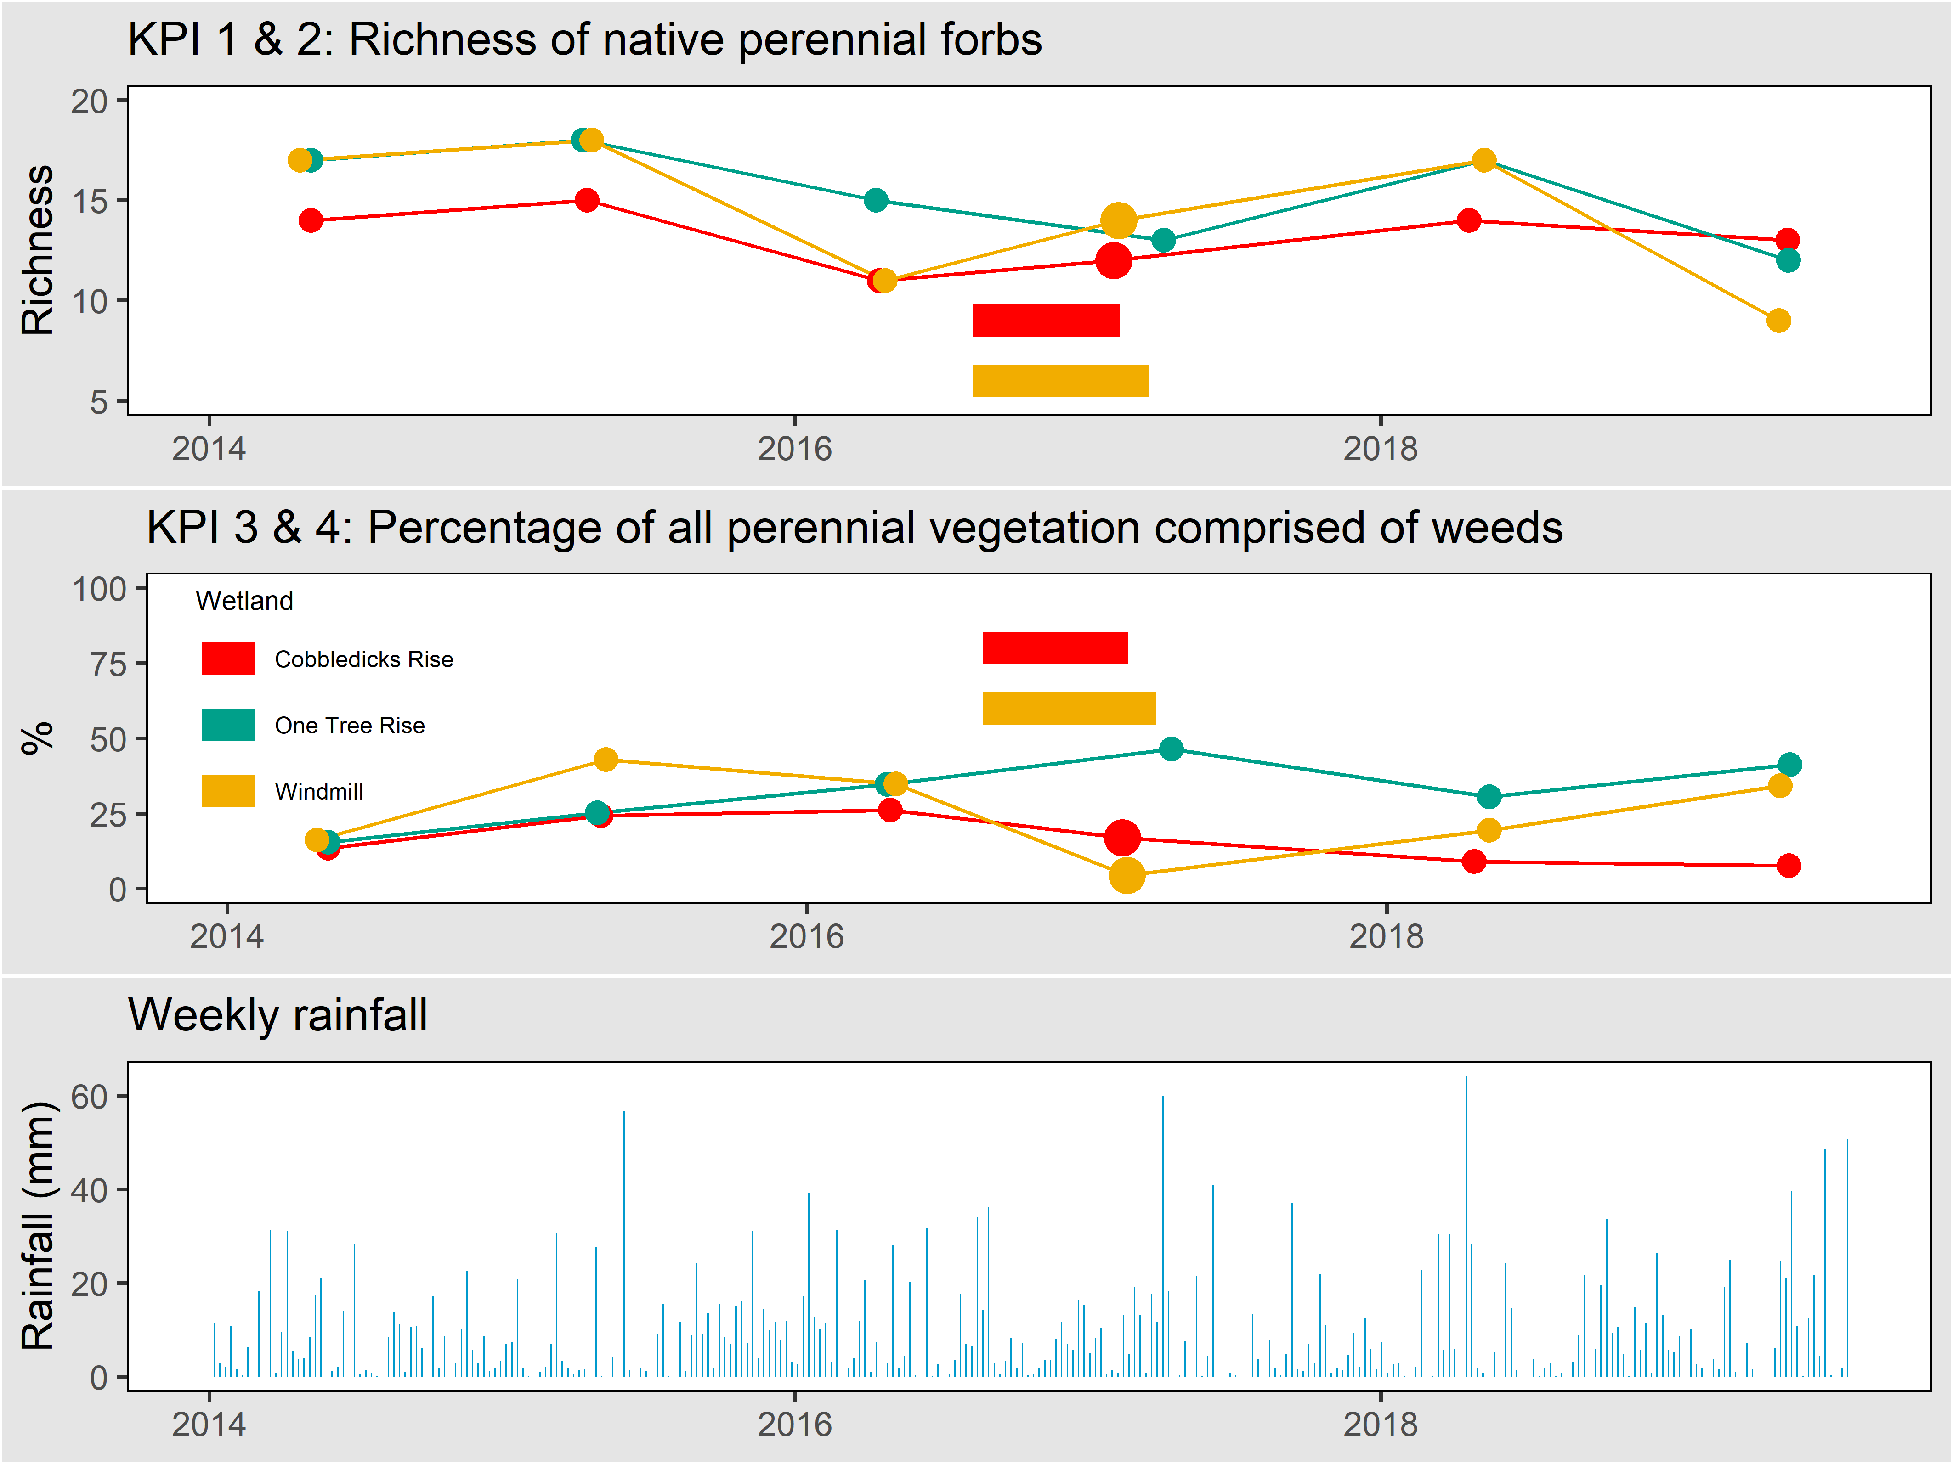
Figure 18. The diversity of native forbs (upper panel), percentage of perennial vegetation comprised of weeds (centre panel) and weekly rainfall (lower panel, data from Laverton RAAF weather station, BOM). Larger points indicate that the wetland was monitored during drawdown in that year. The horizontal bars indicate the period over which a wetland was considered filled, coded by colour. The location of the points on the x-axis indicate the date of sampling, with a sampling year (i.e. the axis marks) beginning on September 1st.

KPI 1: Richness of native perennial forbs during spring-summer
Richness of native perennial forbs during spring-summer
Cobbledicks Rise | ☑
One Tree Rise | ☑
Windmill | ☑

This KPI measures the richness of the valuable native perennial forb component (explicitly at the individual wetland scale). This KPI measures forb richness in every year, regardless of hydrological phase. Given this will include wet and dry years, this measure is expected to fluctuate over time. This KPI was met for all wetlands in 2019-20 (Figure 19).
This KPI will be assessed using a ‘continuous improvement’ approach, where any increase over the baseline in any wetland in a five-year reporting period will lead to the calculation of a new baseline for that wetland for subsequent reporting periods.
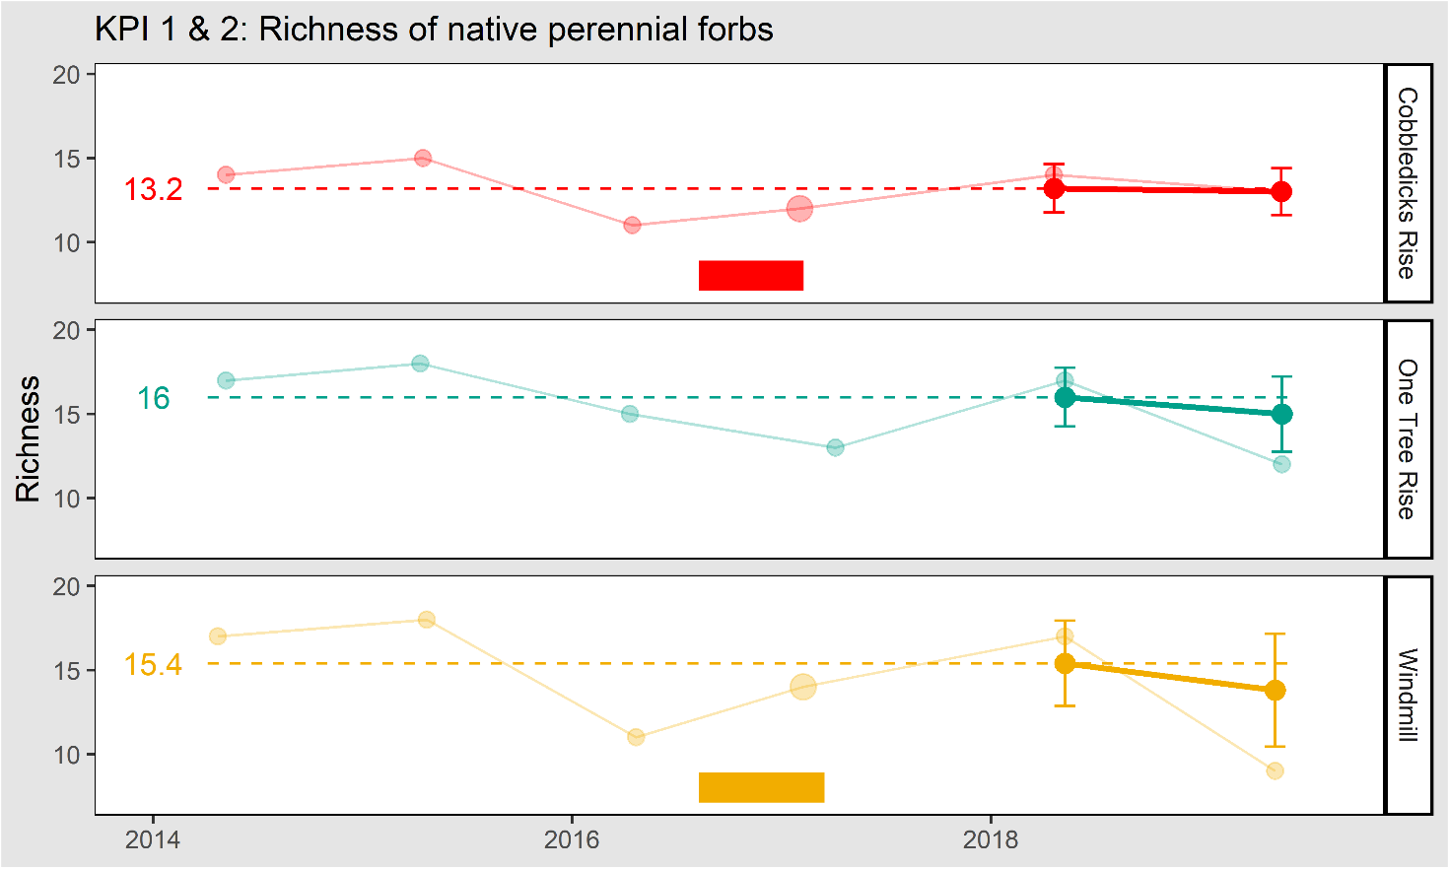
Figure 19. The richness of native forbs for each wetland. The solid lines show the five-year rolling mean (± 95% CI) and the faded lines show the annual data. The dashed line is the baseline, calculated after the first 5 years of monitoring. Larger points indicate that the wetland was monitored during drawdown in that year. The horizontal bars indicate the period over which each wetland was full. The location of the points on the x-axis indicate the date of sampling, with a sampling year (i.e. the axis marks) beginning on September 1st.

KPI 2: Richness of all native forbs during drawdown
Richness of all native forbs during drawdown
Cobbledicks Rise | ◻
One Tree Rise | ◻
Windmill Rise | ◻

This KPI measures the richness of all native forbs, including both perennial and annual species (explicitly at the individual wetland scale). It is measured only at times when a given wetland is drawing down after filling, and the maximum expression of species richness is expected. This may only happen every few years, such that this KPI will remain unassessed in many years.
This KPI is assessed against a baseline, set by the first year of monitoring at drawdown, with a unique benchmark for each wetland. Since monitoring began, drawdown has only occurred in 2017, for Windmill Wetland and Cobbledicks Rise Wetland (One Tree Rise has a smaller catchment and did not fill in 2017). This occurred during the normal Spring-Summer monitoring period, so a single monitoring event covered KPIs 1 and 2. Drawdown did not occur during 2019-20 so this KPI was not assessed this year.
For Cobbledicks Rise Wetland, the count of native forbs at drawdown in 2017 was 12 species. All were perennial, so this value is identical to that measured for KPI 1 (which only assesses perennial forb species). For Windmill Wetland, the count of native forbs at drawdown in 2017 was 17 species. Three were annual, so that this count is higher than KPI 1 measured at the same time for this wetland.
This KPI will be assessed using a ‘continuous improvement’ approach, where any increase over the baseline in any wetland in a five-year reporting period will lead to the calculation of a new baseline for that wetland for subsequent reporting periods.

KPI 3: Percent cover of all perennial vegetation comprised of weeds during Spring-Summer
Percent cover of all perennial vegetation comprised of weeds during Spring-Summer
Cobbledicks Rise | ☑
One Tree Rise | ☑
Windmill Rise | ☑

This KPI measures the percent of all perennial vegetation cover that is comprised of weeds (introduced species). Weeds are considered undesirable as they are in grasslands. This KPI is assessed against a baseline set by the first five years of monitoring. This KPI was met for all wetlands in 2019-20 (Figure 20).
This KPI will be assessed using a ‘continuous improvement’ approach, where any decrease below the baseline in any wetland in a five-year reporting period will lead to the calculation of a new baseline for that wetland for subsequent reporting periods.
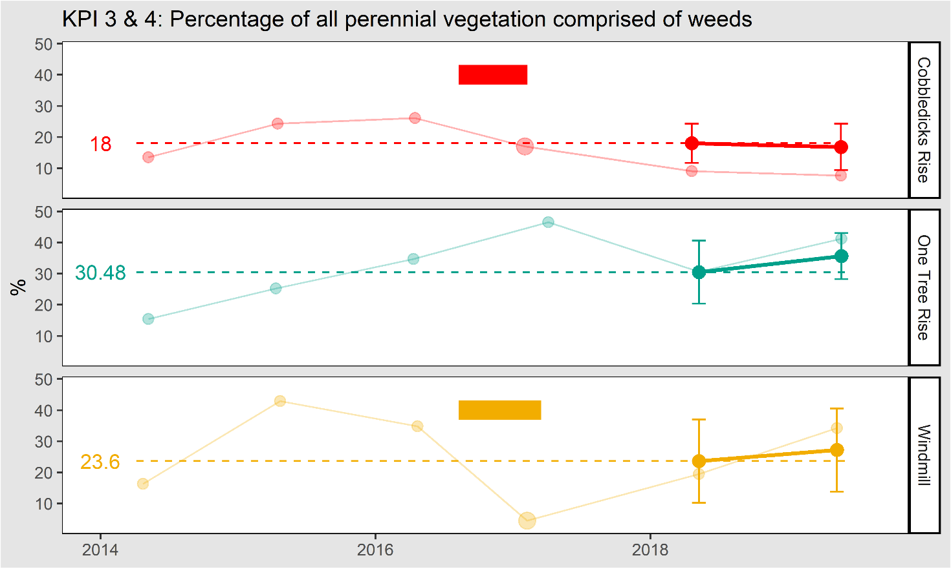
Figure 20. The percentage of all perennial vegetation comprised of weeds for each wetland. The solid lines show the five-year rolling average (± 95% CI) and the faded lines show the annual data. The dashed line is the baseline, calculated after the first 5 years of monitoring. Larger points indicate wetland was monitored during drawdown in that year. The horizontal bars indicate the period over which a wetland was considered filled. The location of the points on the x-axis indicate the date of sampling, with a sampling year (i.e. the axis marks) beginning on September 1st.

KPI 4: Percent cover of all perennial vegetation comprised of weeds during drawdown
Percent cover of all perennial vegetation comprised of weeds during drawdown
Cobbledicks Rise | ◻
One Tree Rise | ◻
Windmill Rise | ◻

Like KPI 3, this KPI measures the percent of all perennial vegetation cover that is comprised of weeds (introduced species). In this case, the KPI only applies when a wetland is drawing down, having been filled.
This KPI is assessed against a baseline, set by the first year of monitoring at drawdown, with a unique benchmark for each wetland. Since monitoring began, drawdown has only occurred in 2017, for Windmill Wetland and Cobbledicks Rise Wetland (One Tree Rise has a smaller catchment and did not fill in 2017). This occurred during the normal Spring-Summer monitoring period, so a single monitoring event covered KPIs 3 and 4, and the data for KPI 3 also cover KPI 4. Drawdown did not occur this year so this KPI cannot be assessed in 2019-20.
The baseline for Cobbledicks Rise Wetland is set at 17%, for Windmill Wetland it is set at 5%. These values are shown as large points on Figure 20.
This KPI will be assessed using a ‘continuous improvement’ approach, where any decrease below the baseline in any wetland in a five-year reporting period will lead to the calculation of a new baseline for that wetland for subsequent reporting periods.

Results: Other measures

Overall SHW quality
The KPIs described above address separate aspects of the community. No single KPI is a direct and all-encompassing measure of the “composition, structure and function” for the community, which is the way improvement is framed in the MRF (DELWP 2015a). To partially address this, overall SHW ‘quality’ is determined using the algorithm described in DELWP (2016). The quality algorithm combines 11 measurable on-ground variables into a single value. The algorithm makes sense of changes among the multiple KPIs, by providing a single quality score between 100 (a ‘pristine’ site) and 0 (where no value remains). The score is calculated for each individual wetland, each year, as shown in Figure 21. All monitored wetlands are of moderate quality, and their quality is steady over all years of monitoring.
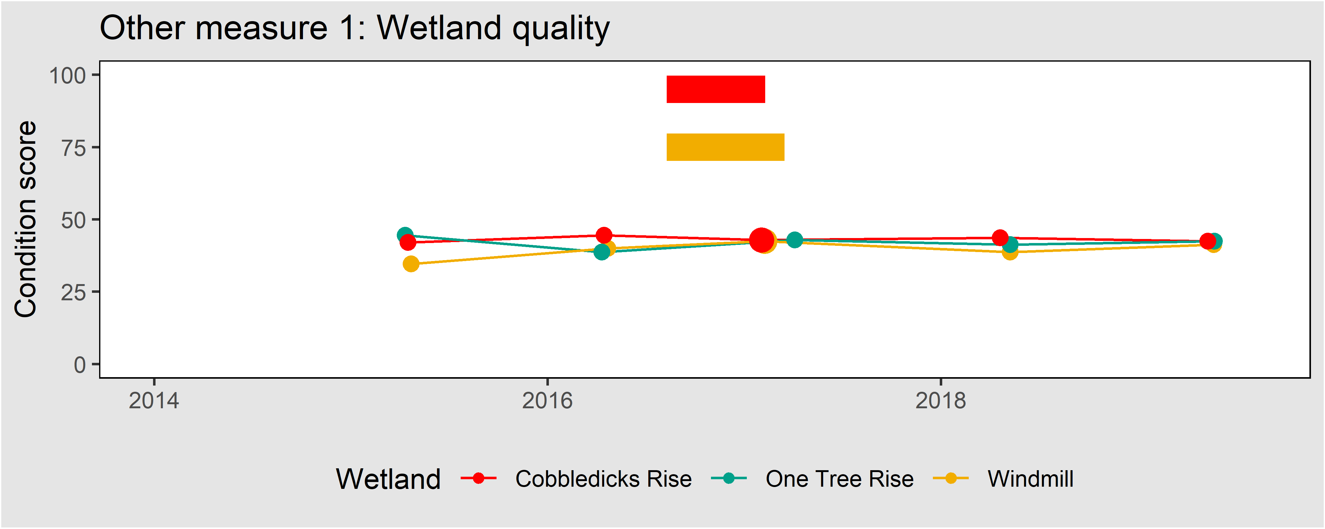
Figure 21. Wetland quality as indicated by a quality metric. Larger points indicate wetland was monitored during drawdown in that year. The horizontal bars indicate the period over which a wetland was considered filled, coded by colour. The location of the points on the x-axis indicate the date of sampling, with a sampling year (i.e. the axis marks) beginning on September 1st.

Annual weeds
Annual weeds are undesirable, but they are now a major structural component of most SHWs. They fluctuate greatly between years depending on rainfall and inundation, so they are not used to define any KPIs. The cover of annuals is shown for each wetland in Figure 22.
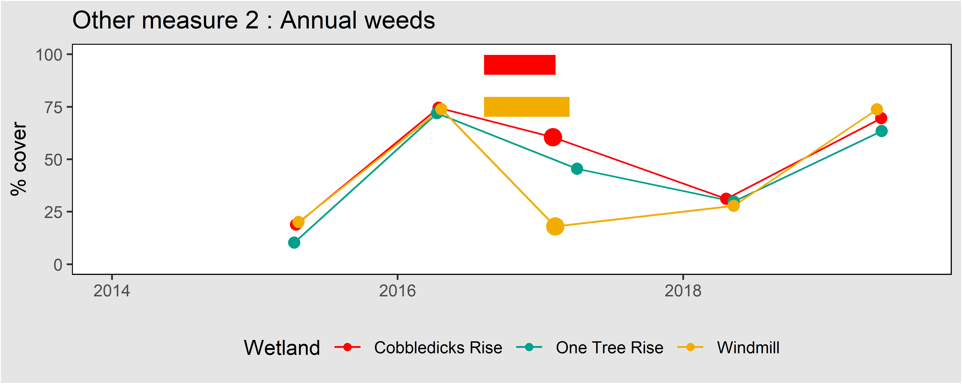
Figure 22. The cover of annual weeds. Larger points indicate wetland was monitored during drawdown in that year. The horizontal bars indicate the period over which a wetland was considered filled. The location of the points on the x-axis indicate the date of sampling with a sampling year (i.e. the axis marks) beginning on September 1st.

Soil phosphorous and nitrate levels
Little is known about the relationship between soil attributes and the function or quality of SHW. However, given the strong relationship between grassland ecological dynamics and soil phosphorous (P) and nitrate levels, the MRF (DELWP 2015a) recommends that P and nitrate data are collected for the SHW every five years. Table 4 shows the values from soil samples taken in 2014. Soil samples will be collected again in 2020.
Table 4. Soil phosphorous and nitrate levels in SHW.
Wetland | Phosphorous (Colwell extraction, mg/kg) | Nitrate (mg/kg)
Cobbledicks Rise | 37 | 10
One Tree Rise | 74 | 13
Windmill | 56 | 26

Hydrological phases and dates of filling and draining
The hydrological phase for each wetland at the time of sampling is shown in Table 5. The MRF also requires recording of the dates that filling commences and draining is complete (DELWP 2015a). Filling has only occurred once, in 2017, as shown as horizontal coloured bars on Figures 14, 15 and 16 (Filling 10th April 2017; Windmill returned to ‘Empty’ in November 2017 and Cobbledicks Rise in October 2017).
Table 5. Hydrological phases during monitoring.
Wetland | 2014 | 2015 | 2016 | 2017 | 2018 | 2019
Cobbledicks Rise | Empty | Dry | Empty | Drawing down | Empty | Dry
One Tree Rise | Empty | Dry | Empty | Empty | Empty | Dry
Windmill | Empty | Dry | Empty | Drawing down | Empty | Dry

‘High quality’ indicator species
The listing advice for SHW defines a ‘high quality site’ as one which supports three or more species from a list of indicator species (TSSC 2012). The MRF (DELWP 2015a) requires reporting on the occurrence of these indicator species in each wetland. These species are expected to be detected along with all other native forb species during point-intercept sampling and timed searches.
Table 6 summarises the detection of indicator species in the three monitored wetlands. Windmill Wetland clearly qualifies as a ‘high quality site’, while Cobbledicks Rise Wetlands and One Tree Rise Wetland sit on the borderline, and only qualify in years when three species happen to be detected by searches. This is because only two indicator species are abundant in these wetlands. In 2019, only Windmill Wetland qualified as a ‘high quality site’.
Table 6. The occurrence of ‘high quality’ indicator species in SHW. Upper rows: ‘P’ denotes a presence, ‘-‘ denotes non-detection, with the sequence of symbols showing the progression of detection across the six years of survey. Lower rows: The number of indicator species found in each wetland in each year is shown, and the cell coloured green in each year that the wetland could be classified as a ‘high quality’ site.
Species | Cobbledicks Rise | One Tree Rise | Windmill
Asperula conferta | PPPPPP | PPPPPP | PPPPPP
Bracyscome basaltica | ------ | ------ | P-----
Eryngium vesiculosum | ----- | ------ | -PPPPP
Lobelia pratioides | PP-PP- | PP—P- | PP-PP-
Marselia drummondii | PPPPPP | PPPPP | PPPPPP
Ottelia ovalifolia | ------ | ------ | ---P--
Number of indicator species
2014 | 3 | 3 | 4
2015 | 3 | 3 | 4
2016 | 2 | 2 | 3
2017 | 3 | 2 | 5
2018 | 3 | 3 | 4
2019 | 2 | 2 | 3

Woody shrubs
The MRF (DELWP 2015a) requires that the cover of woody shrubs is reported, largely because if woody shrub cover exceeds 10%, the wetlands no longer qualify as SHW (TSSC 2012). Woody shrub species are distinguished in the point-intercept sampling and are noted during the timed searches.
All wetlands contained a small number of woody species, but these are at very low abundance (all <1% every year) and are thus not well quantified by the point-intercept surveys. The occurrence of woody species is summarised as follows:
- Cobbledicks Rise Wetland contains no native woody species, but a few small African Boxthorns (Lycium ferocissimum).
- One Tree Rise Wetland contains one plant of Tangled Lignum (Duma florulenta), approximately 20 plants of Black Roly Poly (Sclerolaena muricata) and a few small introduced African Boxthorns.
- Windmill Wetland contains 10 plants of Tangled Lignum and a few Black Roly Poly plants. Between 2014 and 2015 it also contained many small African Boxthorn bushes, but these were almost entirely eradicated by weed control in 2016.

Changes to the MRF
This section details the ways in which the approach taken here differs from the MRF (DEPI 2015).
- All references to “native herbs” have been changed to “native forbs”, in line with accepted usage.
- The term ‘diversity’ has been changed to ‘richness’ in KPIs 1 and 2, in line with accepted usage.
- All KPIs have now been numbered.
- The formulation of baselines and targets was clarified to clearly indicate that all KPIs are assessed using a continual improvement model.
- The clarification has been added that if a wetland is divided into multiple management units (e.g. by a fence), then these may be reported as separate wetlands, even if they are each under 3 ha. Distinguishing wetlands with different management is important for modelling and adaptive management. This situation has not yet occurred; all wetlands are single management units.
- ‘Filling’ is now defined in the methods section, this was left undefined in the MRF.
- It is now clearly stipulated that the hydrological phase must be noted at time of monitoring, with a full definition of each phase added to the methods.
- It has been clarified that for KPIs 3 and 4, the baseline is set for a given wetland after the first year of monitoring, not after 5 years.
- The phrasing of KPIs 3 and 4 has been altered slightly to match the phrasing of the equivalent KPIs for Natural Temperate Grassland.

Button Wrinklewort

Introduction

The species
Button Wrinklewort (Rutidosis leptorhynchoides) is listed as Endangered (EN) under the EPBC Act. It is a small perennial daisy which produces multiple flowering stems with yellow flower heads. It occurs in grassy woodlands and grasslands, in places free from intense competition from other plants. It is distributed across south-western Victoria, around Melbourne and in the Canberra region (NSW OEH 2012). Button Wrinklewort is shown in Figure 23A.

Goals and performance indicators
The Victorian Government has committed to ensuring that there is no substantial negative change to the population of Button Wrinklewort within the program area.
Progress towards this goal is measured using a single KPI:
- The five-year mean population count, which must remain above a baseline set by the first five years of counts.

Monitored populations
Button Wrinklewort occurs naturally at only one location within the MSA area, the Truganina Cemetery Grassland (Conservation Area 10). Here, the entire population is contained within an area measuring 90 x 70 m. This site has been monitored under the MSA since 2015 (i.e. 2019 is the fifth year of monitoring and the population baseline is set this year).

Summary of monitoring methods

Population census
Button Wrinklewort is monitored between 1 November and 31 December, when it is flowering. A full population count is taken, using 3 m wide transects to structure systematic searches of the entire cemetery site. The transects are also used to record the location of every plant as X, Y co-ordinates (Figure 23B). The X, Y coordinates from previous years may be used to aid plant searches in subsequent years.
Recruits are identified and recorded (plants not recorded in prior years and with no evidence of previous years’ growth). Reproductive plants are also identified and recorded (plants with buds, flowers or seed heads from the current year (being careful to exclude seed heads from previous years, which are sometimes retained). On every plant, the number of stems, buds, flowers and seed heads is recorded (at least once every five years, to provide estimates of reproductive output for Population Viability Analysis models).

Habitat measurements
Several habitat parameters which are known to influence recruitment success of Button Wrinklewort are monitored: bare ground, perennial and annual weed cover (DELWP 2015a; Morgan 1997). These parameters are quantified using a single permanent point intercept plot located within the Truganina Cemetery Button Wrinklewort population, which forms part of the monitoring for Natural Temperate Grassland. This single plot (20 x 20 m) covers a substantial portion of the Button Wrinklewort population and is assumed to adequately represent the vegetation supporting the population.
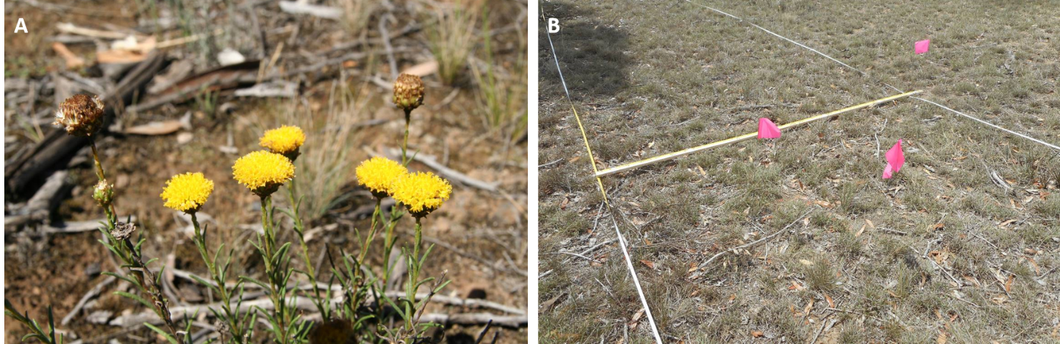
Figure 23. A) Button Wrinklewort, and B) The 3 m wide monitoring transect, at Truganina Cemetery, showing how plants (here marked with flags) can be given X, Y co-ordinates with a ruler.

Results: KPI

KPI 1: Population count
Population count
Truganina Cemetery | ◻

The number of Button Wrinklewort plants recorded at Truganina Cemetery increased very slightly from 2015 to 2018 (from 591 to 638) but declined to 593 in 2019 (Figure 24). In each year, most plants have been reproductive (between 89 and 93%). Very few recruits have been recorded in any year (between 0 and 4 individuals, with only 9 over all years).
The baseline for this species is the mean population count over the first five years of monitoring. This is set this year, at 617. Given this KPI is assessed using a total population count, no uncertainty is quantified, meaning that the actual count in every year must remain above the baseline for the target to be met (not the 95% CI as with many other KPIs).
This KPI will be assessed using a ‘continuous improvement’ approach, where any increase over the baseline in a five-year reporting period will lead to the calculation of a new baseline for subsequent reporting periods.
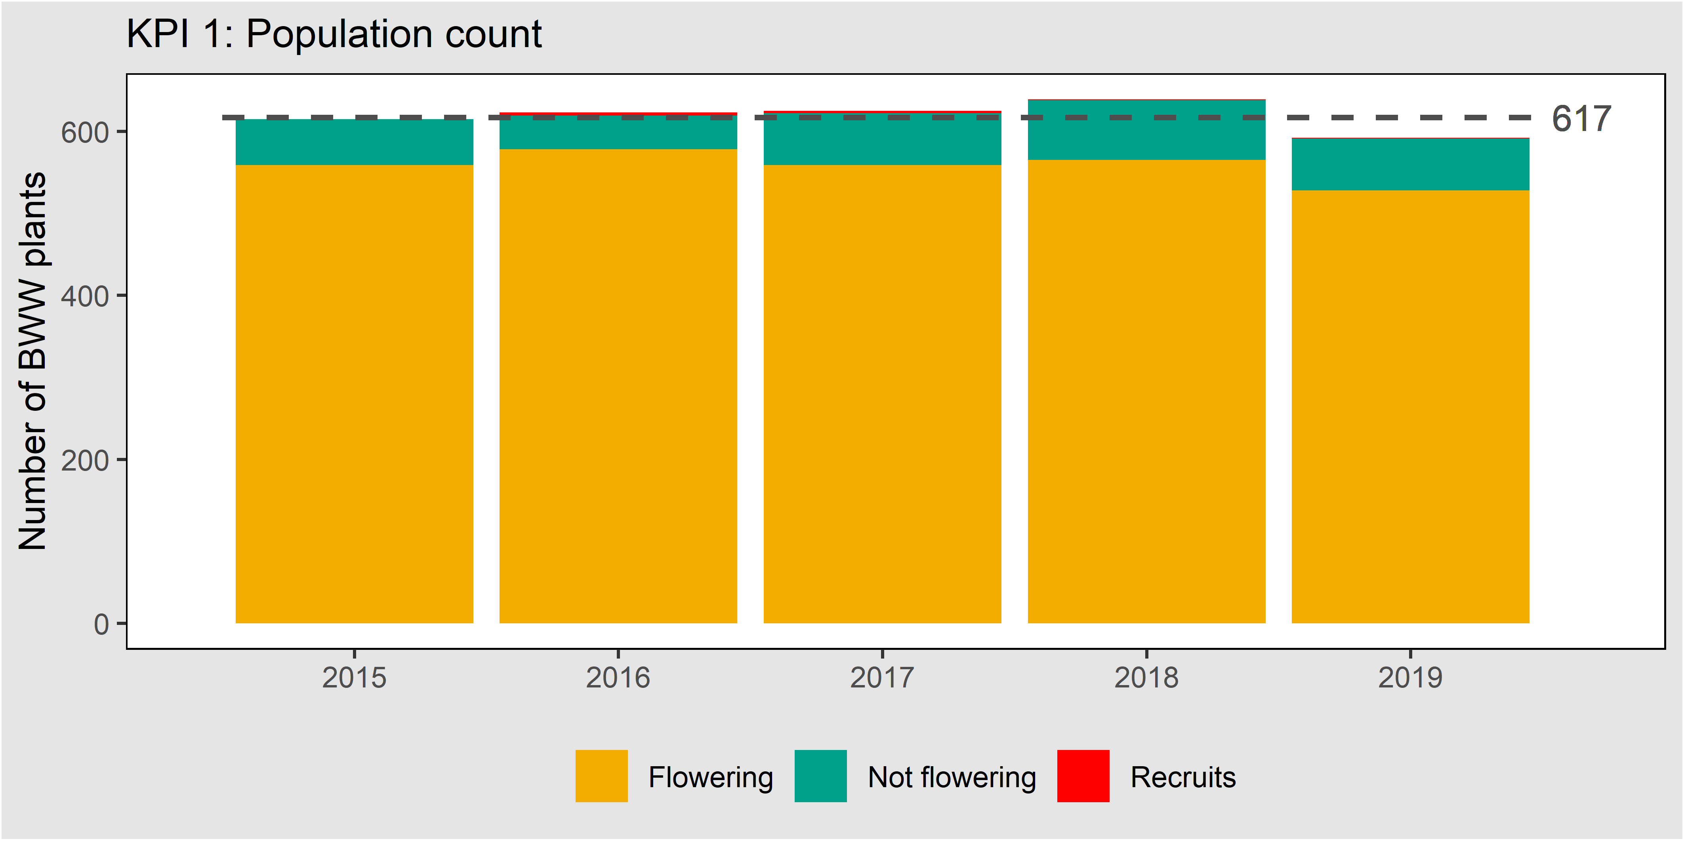
Figure 24. Population count of Button Wrinklewort at Truganina Cemetery, 2015-2019. The dashed line shows the baseline calculated after the first five years of monitoring (n=617).

Results: Other measures

Weeds and bare ground
The data from the point intercept plot (Table 7) show that weed levels remain consistently low in the Button Wrinklewort population (c.f. weed levels in the Natural Temperate Grassland ecosystem more broadly, as explored above). They also show a decline in bare ground between 2015 and 2017, followed by an increase in bare ground in 2018 and 2019 (The site was burnt in April 2019).
Table 7. Percentage cover of bare ground and weeds in Truganina Cemetery.
Attribute | 2015 | 2016 | 2017 | 2018 | 2019
Bare ground | 24 | 16 | 3 | 20 | 35
Perennial weeds | 1 | 2 | 1 | 1 | 5
Annual weeds | <1 | 1 | <1 | 2 | <1

Reproductive effort
The Population Viability Analysis (PVA) model (Regan et al. 2020) that is used to predict the consequences of management for the Button Wrinklewort population requires data representing reproductive output. To this end, the monitoring includes counts of the number of stems, buds, flowers and seed heads on every plant, at least every five years (Table 8).
Table 8. The mean number of stems, stems with flowers and flower heads and seed heads per plant. NA denotes data that were not collected in a given year.
Growth and flowering measurement | 2015 | 2016 | 2017 | 2018 | 2019
Reproductive heads (Bud + Flower + Seed) per plant | NA | NA | NA | NA | 12.5
Stems which flowered | NA | NA | 9.5 | 9.2 | 8.5
Stems in total | 10.3 | 11.6 | 12.8 | 12.5 | 12.6

Previous monitoring data
Button Wrinklewort was monitored at Truganina Cemetery by La Trobe University from 2004 until 2012, providing a valuable longer-term context for the data reported here (J. Morgan, La Trobe University, unpublished data). The population declined from 1,072 plants in 2004, to only 472 plants in 2012. Thus, the results presented here for 2015 to 2018 represent a small recovery and stabilisation, following a substantial decline before 2012.

Changes to the MRF
This section details the ways in which the approach taken here differs from the MRF (DEPI 2015).
- The formulation of baselines and targets was clarified to clearly indicate that the KPI is assessed using a continual improvement model.
- It has been stated that a belt transect delineated by a pair of tapes 3 m apart is the preferred monitoring method. This provides equivalent coverage to the single tape lines described in the MRF (3 m apart, searched 1.5 m either side), but prevents accidental double counting at the margins, because the margins are defined by the tape.
- The ‘other measures’ have been updated to include the number of buds, flower heads and seed heads on every plant, to support the parameterisation of PVA models. Such data should be collected in full at least once every five years.
- The methods have been updated to clarify that the X, Y coordinates from previous years may be used to aid plant searches in subsequent years.

Large-fruit Groundsel

Introduction

The species
Large-fruit Groundsel (Senecio macrocarpus) is listed as Vulnerable (VU) under the EPBC Act{DSE, 2005 #201;Department of the Environment, 2009 #499}. It is a perennial daisy growing to about 40 cm high, with grey foliage and yellow flower heads (Belcher 1983; Hills and Boekel 1996; Walsh 1999). It occurs in grassy woodlands and grasslands, in places free from intense competition from other plants. It is distributed widely across south-eastern Australia. It is shown in Figure 25.

Goals and performance indicators
The Victorian Government has committed to ensuring that there is no substantial negative change to the population of Large-fruit Groundsel within the program area.
Progress towards this goal is measured using a single KPI:
- The five-year mean population count, which must remain above a baseline set by the first five years of counts.

Monitored populations
In 2015, when the MRF was written, only one naturally occurring population of Large-fruit Groundsel was known (in Conservation Area 5). This area has not yet been protected under the MSA and has not been the subject of monitoring.
In 2017, a small, previously unknown wild population was discovered on a parcel of land in the Western Grassland Reserve, known as ‘Little Raven’. Monitoring of this population commenced in 2017.
There are also three introduced populations in the MSA area, which are considered under ‘other measures’:
- In 2012, a population was established on One Tree East (Zamin et al. 2018). This population is reported on as an ‘other measure’.
- In 2012, a small population was established at Mount Cottrell NCR (DELWP 2015a. This population is also reported on as an ‘other measure’.
- A translocated population occurs on Little Raven. This population is monitored under a different project and is not reported on here.

Summary of monitoring methods

Population census
Large-fruit Groundsel is monitored between 1 September and 30 November, when it is flowering. A full population count is taken for each population, with the location of every plant recorded as X, Y co-ordinates on a permanently marked grid. Three-metre wide transects are used to systematically cover the population area. Isolated plants away from the monitoring grid may be recorded with a GPS and marked with stakes if appropriate, but they are included in the population count. The coordinates from previous years may be used to aid plant searches in subsequent years.
Given this species is known to have seeds which disperse on the wind, there will be a five-yearly broad area survey of the broader management unit that supports each population to locate any new or previously undetected plants.
Reproductive plants are also identified and recorded (plants with buds, flowers or seed heads from the current year, being careful to exclude seed heads from previous years, which are sometimes retained). On every plant, the number of stems, buds, flowers and seed heads is recorded (at least once every five years to provide estimates of reproductive output for Population Viability Analysis models).

Other measures
Several habitat parameters relevant to the persistence of Large-fruit Groundsel are monitored: bare ground, perennial and annual weed cover (DELWP 2015a). These parameters are quantified using a single permanent point intercept plot located within each population. Counts of the number of buds, flower heads and seed heads per plant are conducted to support the parameterisation of PVA models (Regan et al 2020). Such data should be collected at least once every five years.
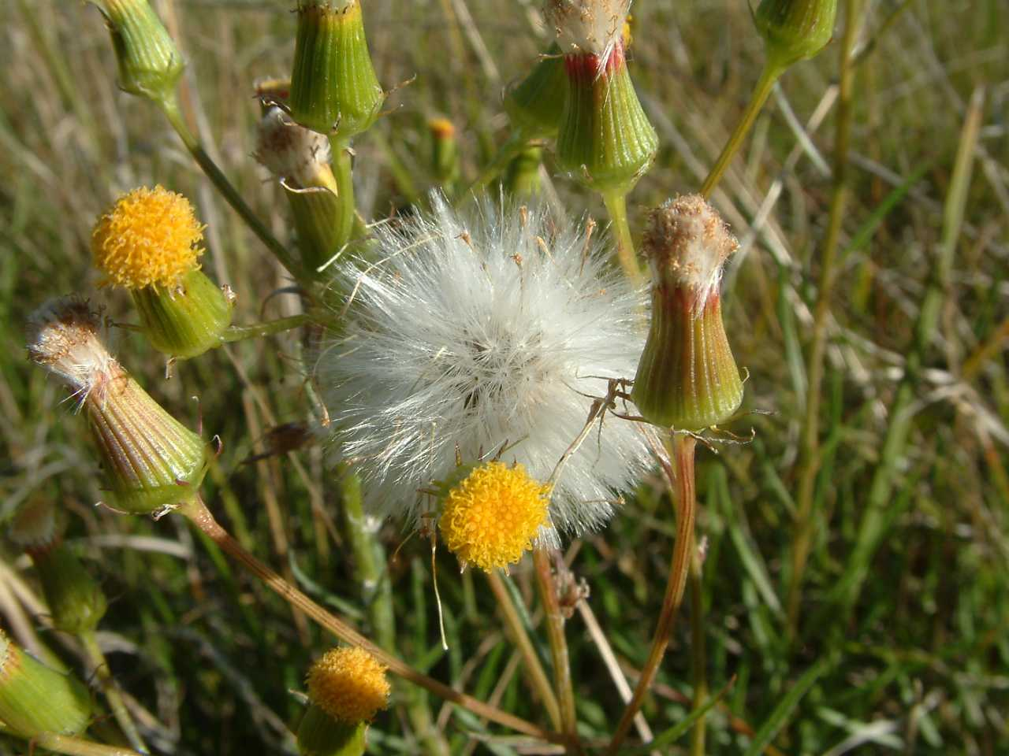
Figure 25. Large-fruit Groundsel.

Results: KPI

KPI 1: Population count
Population count
Little Raven | ◻

The number of Large-fruit Groundsel plants recorded at the Little Raven site is small. In 2019 the number of plants was 12, a slight decrease from previous years (Figure 26). All plants were reproductive. No recruits were noted.
The population in Conservation Area 5 is not yet protected or monitored under the MSA.
It is not yet possible to state whether the KPI has been met, as the baseline will not be set until 2021. This KPI will be assessed using a ‘continuous improvement’ approach, where any increase over the baseline in a five-year reporting period will lead to the calculation of a new baseline for subsequent reporting periods.
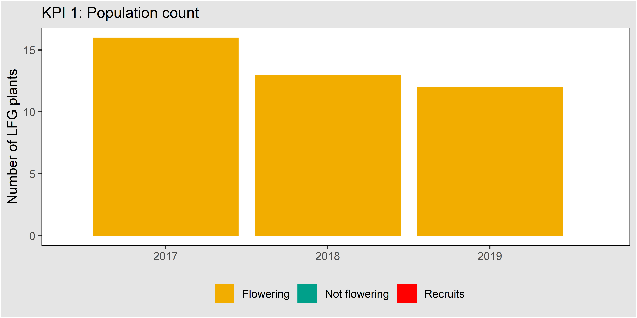
Figure 26. Population count Large-fruit Groundsel at Little Raven, 2017-2019.

Results: Other measures

Cover of bare ground and weeds
Figure 27 shows the cover of bare ground and weeds at the point intercept plot near the wild population.
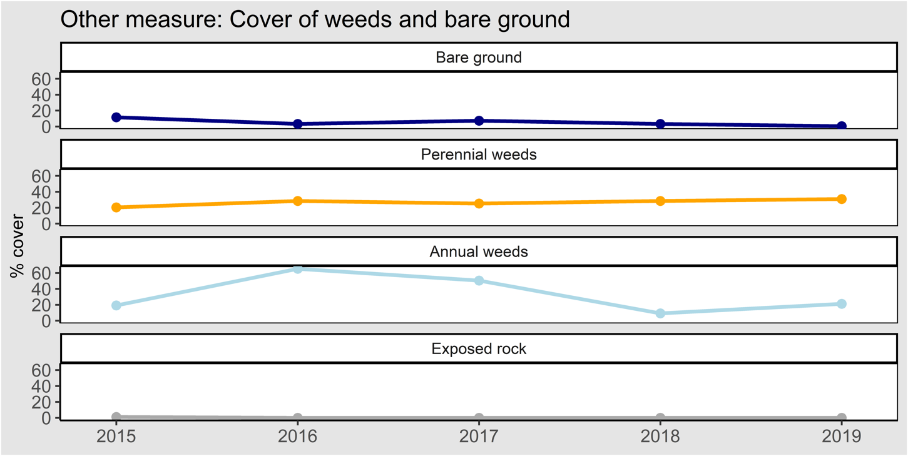
Figure 27. Cover of bare ground and weeds.

Number of stems, flower heads and seed heads per plant
Table 9 shows the number of stems, flower heads and seed heads per plant at the Little Raven population. 2019 was the first year that these attributes were counted.
Table 9. The mean number of stems, stems with flowers and flower heads and seed heads for the Large-fruit Groundselpopulation at Little Raven.
Growth and flowering measurement | 2017 | 2018 | 2019
Reproductive heads (Bud + Flower + Seed) per plant | Not recorded | 45 | 17
Stems which flowered | Not recorded | Not recorded | 8
Stems in total | Not recorded | 16 | 17

Census of re-introduced populations
The number of Large-fruit Groundsel plants at the two re-introduction sites are shown in Table 10. It appears that the population established at One Tree East has declined to extinction. The population at Mount Cottrell NCR is declining.
Table 10. Population count of Large-fruit Groundsel in the two reintroduced populations, 2013 – 2019.
Site | 2013 | 2014 | 2015 | 2016 | 2017 | 2018 | 2019
One Tree East | 5566 | 2426 | 1217 | 726 | 26 | 3 | 0
Mount Cottrell NCR | 25 | - | 25 | - | 10 | 5 | 4

Changes to the MRF
This section details the ways in which the approach taken here differs from the MRF (DEPI 2015).
- The formulation of baselines and targets was clarified to clearly indicate that the KPI is assessed using a continual improvement model.
- It has been stated that a belt transect delineated by a pair of tapes 3 m apart is the preferred monitoring method. This provides equivalent coverage to the single tape lines described in the MRF (3 m apart, searched 1.5 m either side), but prevents accidental double counting at the margins, because the margins are defined by the tape.
- The ‘other measures’ have been updated to include the number of buds, flower heads and seed heads on every plant, to support the parameterisation of PVA models. Such data should be collected at least once every five years.
- The methods have been updated to clarify that the X, Y coordinates from previous years may be used to aid plant searches in subsequent years.
- The methods have been updated to clarify that KPIs are assessed at natural populations, while planted populations are monitored as other measures.

Matted Flax-lily

Introduction

The species
Matted Flax-lily (Dianella amoena) is listed as Endangered (E) under the EPBC Act. It is a perennial lily that forms mats up to ~5 m wide. It has linear grey-green leaves and produces blue or violet star-shaped flowers, followed by purple berries (Carr and Horsfall 1995). It retreats underground during dry periods, making detection problematic. Matted Flax-lily is scattered across Victoria, with a few recently discovered populations in the Canberra region. A patch of this species is shown in Figure 28.

Goals and performance indicators
The Victorian Government has committed to ensuring that there is no substantial negative change to the population of Matted Flax-lily within the program area.
Progress towards this goal is measured using a single KPI, with the following target:
- Annual detection rate of known plants, which must remain above a baseline, set in the first five years of monitoring.
As explained below, this target is different from that included in the published MRF (DELWP 2015a). The MRF will be updated.
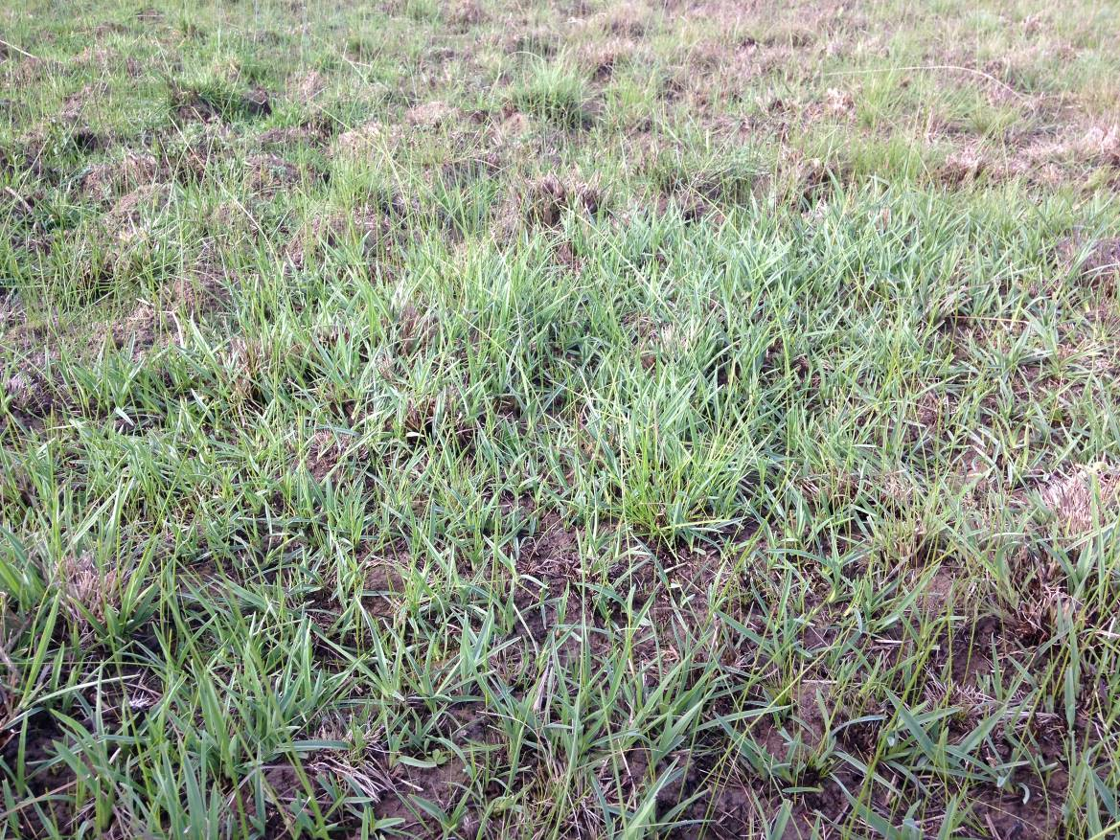
Figure 28. A clump of Matted Flax-lily (foreground).

Monitored populations
Matted Flax-lily is known to occur in at least seven separate Conservation Areas within the program area (DELWP 2015a). Only one of these sites has so far come under management within the MSA program, Conservation Area 24, the Kalkallo Common Grassland. This site has been monitored under the MSA since 2016, following a site inventory to locate known plants in 2015.
At Kalkallo Common Grassland, Matted Flax-lily plants have been translocated into the stony rises. These translocations pre-date the MSA, and these plants are monitored under a different project, funded separately from the MSA. These plants are not included in MSA monitoring, although it is acknowledged that they form part of the Matted Flax-lily population in functional terms (i.e. they likely contribute pollen and seeds to the population).

Summary of monitoring method

KPI: Detection of plants
A database of the locations of known individuals is maintained, and these locations are checked every year. Each individual is recorded as alive, visibly dead or absent above ground.
Every five years, all relevant areas are searched for new plants. Any new plants found during these area searches, or by chance during other field work, are added to the database and checked in all subsequent years.
In each year, as new plants are found, the cumulative count of known plants increases. Each year, all plant locations then known are checked, and a percentage of plants detected is calculated. The value used to monitor Matted Flax-lily is the percentage of known plants found in each year. The baseline is the arithmetic mean of these percentages in years 2-5 (year 1 is omitted because it is necessarily 100%).
Occasionally, it can be difficult to determine whether clumps of Matted Flax-lily represent a single large individual, or several individuals growing nearby. This cannot be definitively addressed without genetic analysis. For practical purposes, any clumps of Matted Flax-lily separated by more than 75 cm are here considered to be separate individuals.

Other measures
Several habitat attributes are recorded at the location of each plant (whether that plant is recorded or not), using visual estimates of the area within a 2.5 m radius around each plant: All native vegetation cover, perennial exotic cover, annual exotic cover, bare ground (including bryophytes) and rocks. Over time, the value of these variables may help explain the detection or mortality of the Matted Flax-lily plants at the locations they describe.
Additional basic demographic measures are also recorded for each plant: The number of flowering stems, and the number of buds, flowers and fruits. These parameters support the PVA model (Regan et al. 2020) used to predict the consequences of management for this species.

Results: KPI

KPI 1: Percentage of plants detected each year
Detection of plants
Kalkallo Common | ◻

In 2015, an initial database of known Matted Flax-lily locations (n=52) was compiled from field searches and the compilation of existing data from Hume City Council, Merri Creek Management Committee (MCMC) and Abzeco. These locations were monitored, commencing in 2016. Each year during monitoring, new plants have been discovered, until by 2019 there are 64 locations included in the database. The percentage of plants detected at known locations was 91% in 2017, 95% in 2018 and 97% in 2019 (Figure 29).
It is not yet possible to state whether the KPI has been met, as the baseline has not yet been set. This KPI will be assessed against a static benchmark, set in 2020.
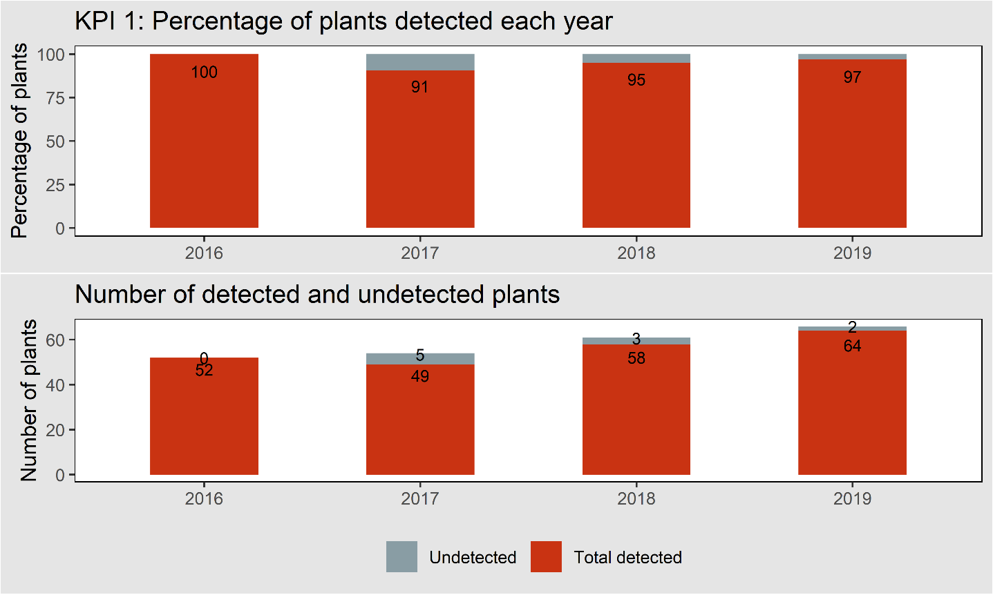
Figure 29. Matted Flax-lily plants detected in the first four years of monitoring at Kalkallo Common, expressed as a percentage of the total number of plants known in each year. Year 1 (2016) shows 100% detection by definition.

Results: Other measures
The covers of native vegetation, exotic annual and perennials, bare ground and rocks were recorded around each plant in each year of monitoring (Figure 30).
The demographic measures were first recorded in 2018. No inflorescences, buds, flowers nor fruit were observed on any of the 61 plants examined in 2018 nor the 64 plants in 2019. These negative results are not shown graphically.

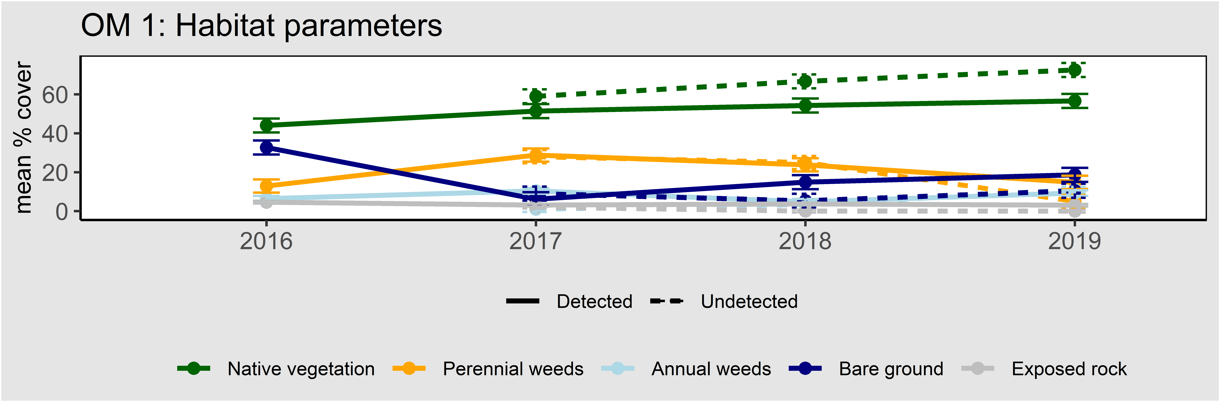
Figure 30. Habitat parameters around Matted Flax-lily plants, expressed as cover.

Changes to the MRF
This section details the ways in which the approach taken here differs from the MRF (DELWP 2015a).
- The formulation of the baseline and target was clarified to clearly indicate that the KPI is assessed using a static baseline.
- The methods have been amended to make it clear that any clumps of Matted Flax-lily separated by more than 75 cm should be considered separate individuals.
- The methods now ensure that other measures include counts of the number of inflorescences, buds, flower heads and fruits per plant, to support the parameterisation of PVA models. Such data should be collected at least once every five years.
- MRF (DELWP 2015a) suggested that the raw counts of plants detected each year are reported, and that the baseline is formed from the mean of the counts in the first five years. This approach has proven problematic due to the continual discovery of new plants (due to the intermittent appearance of plants above ground, and the relatively low detectability of this species). If the baseline is set from the first five years alone, it will be set at a relatively low count, which would be easy to achieve in future years, even if the species was declining. To counter this effect, the MRF has been amended to reflect the monitoring and reporting approach described above.
- For Other measure 1, bare ground and exposed rock are reported separately.
- For Other measure 2, annual and perennial weeds are reported separately.

Small Golden Moths Orchid
Small Golden Moths Orchid (Diuris basaltica) is listed as Endangered (E) under the EPBC Act. It is a perennial orchid growing to 15 cm tall, with a single stem supporting 1-2 small yellow flowers. It retreats to an underground tuber each year in Summer, and at other times when conditions are unfavourable. It is endemic to the Keilor and Werribee Plains (Backhouse and Lester 2010).
The Victorian Government has committed to ensuring that there is no substantial negative change to the population of Small Golden Moths Orchid. Further details of how this commitment is interpreted are provided in the MRF (DELWP 2015a).
The Small Golden Moths Orchid is known from only one location in the MSA area, in Conservation Area 3. This area has not yet been protected, and no monitoring has occurred. The species is not dealt with further here.

Spiny Rice-flower

Introduction

The species
Spiny Rice-flower (Pimelea spinescens subsp. spinescens) is listed as Critically Endangered (CR) under the EPBC Act. It is a small shrub, growing up to 30 cm high. It is endemic to Victoria, occurring on the volcanic plains, in the Wimmera and the northern plains (James and Jordan 2014). The species is shown in Figure 31.

Goals and performance indicators
The Victorian Government has committed to ensuring that there is no substantial negative change to the population of Spiny Rice-flower and the population is self-sustaining within the program area.
Progress towards this goal is measured using two KPIs, with the following targets:
- The five year mean population density, measured in sample plots, which must remain above a baseline set by the first 5 years of survey.
- The occurrence of recruits, which must form over 10% of the MSA-wide population in at least one of the previous 10 years.
As explained below, it is here recommended that KPI 1 is changed, so that “density” is replaced with “count”(as for Button Wrinklewort and Large Fruit Groundsel). The data presented here refer to the updated KPI.

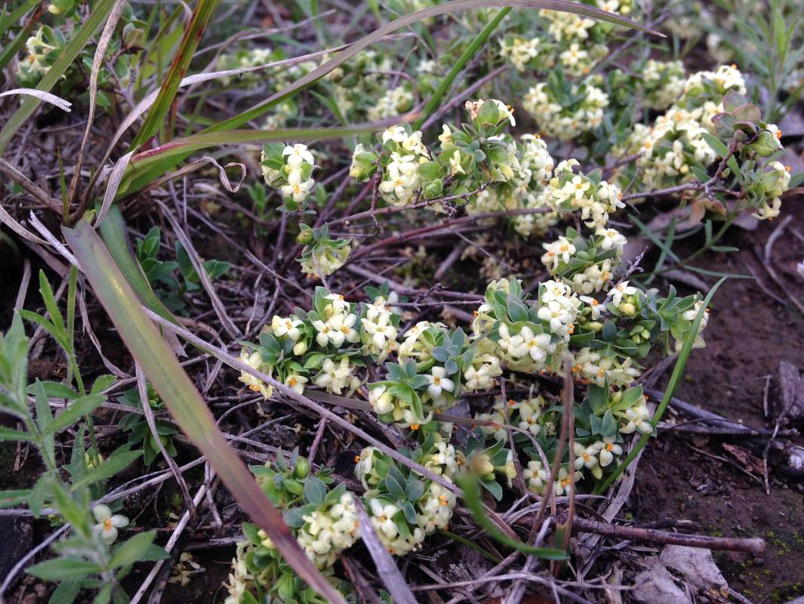
Figure 31. Spiny Rice-flower.

Monitored populations
Spiny Rice-flower occurs naturally in numerous Conservation Areas within the program area (DELWP 2015a). Only four of these sites have so far come under management within the MSA program:
- Truganina Cemetery Grassland (Conservation Area 10).
- Western Grassland Reserve, Mount Cottrell Nature Conservation Reserve (NCR).
- Western Grassland Reserve, Magpie block.
- Western Grassland Reserve, Radio block.
A translocated population has been established on Mount Cottrell NCR, but it is monitored by another project, and is not monitored as part of the MSA.

Monitoring method

Population census
Spatial structure of monitoring
Spiny Rice-flower plants occur in varying spatial arrangements; in clusters of varying extent and density (sometimes numbering 100s of plants and covering 100s of m²), and as isolated small clumps or lone individuals. To ensure that monitoring effort is focussed efficiently on the main centres of population, monitoring is divided into two tiers:
- ‘Clusters’ of plants are monitored every year and contribute to the assessment of KPIs. A cluster is any group of 10 or more plants, where all plants are within 10 m of another plant in the same cluster. An individual plant must be at least 10cm from another plant, otherwise it is not counted as a plant (Spiny-Rice Flower can have multiple stems growing from ground level).
- ‘Scattered plants’ are monitored every five years and are reported every 5 years as an ‘other measure’. These are defined as any plants outside clusters.
It is estimated that >95% of all plants are within clusters, so that the KPI is adequately addressed by the measurement of Clusters only. The previous monitoring method described in the MRF covered a far lower percentage of plants and has been replaced for that reason.
KPIs are reported by site. Some sites may have several clusters and many scattered plants.
Population counts in clusters
Spiny Rice-flower is monitored at any time of year, but optimally in winter when it is flowering. A full count is undertaken for each cluster, with the location of every plant recorded as X, Y co-ordinates on a permanently marked grid. The coordinates from previous years may be used to aid plant searches in subsequent years.
Recruits are identified and recorded (plants not recorded in prior years and with no evidence of previous years’ growth).
Currently, only two MSA properties support clusters of plants:
- Truganina Cemetery Grassland (Conservation Area 10).
- Western Grassland Reserve, Radio block.
Counts of scattered plants
The location of isolated plants is recorded and they are revisited every five years to determine if they remain (Next visit due in 2023). Currently this method is used to record plants on three sites: Mount Cottrell Nature Conservation Reserve, Radio and Magpie, all in the Western Grassland Reserve. Any additional scattered plants located over time are simply added to the total reported.

Vegetation measures
Several habitat parameters relevant to the recruitment and persistence of Spiny Rice-flower are reported for each population: bare ground, cover of all weeds, biomass (cover of all plants), reported per site; and vegetation species composition, reported as the top five most abundant species across all plots (DELWP 2015a). These vegetation measures are all derived from 20 x 20 m point intercept plots undertaken as part of the monitoring for Natural Temperate Grassland. A single plot is located within each cluster. It is assumed that these plots adequately represent the vegetation supporting the populations.

Results: KPIs

KPI 1: Population count
Population count
Radio | ◻
Truganina Cemetery | ◻

The population counts (within clusters) in 2019 were 201 at Radio (in 4 clusters) and 965 at Truganina Cemetery (in 1 cluster) (Figure 32). As this is the first year of monitoring using this method the baseline cannot yet be set.
This KPI will be assessed using a ‘continuous improvement’ approach, where any increase over the baseline in a five-year reporting period will lead to the calculation of a new baseline for subsequent reporting periods.
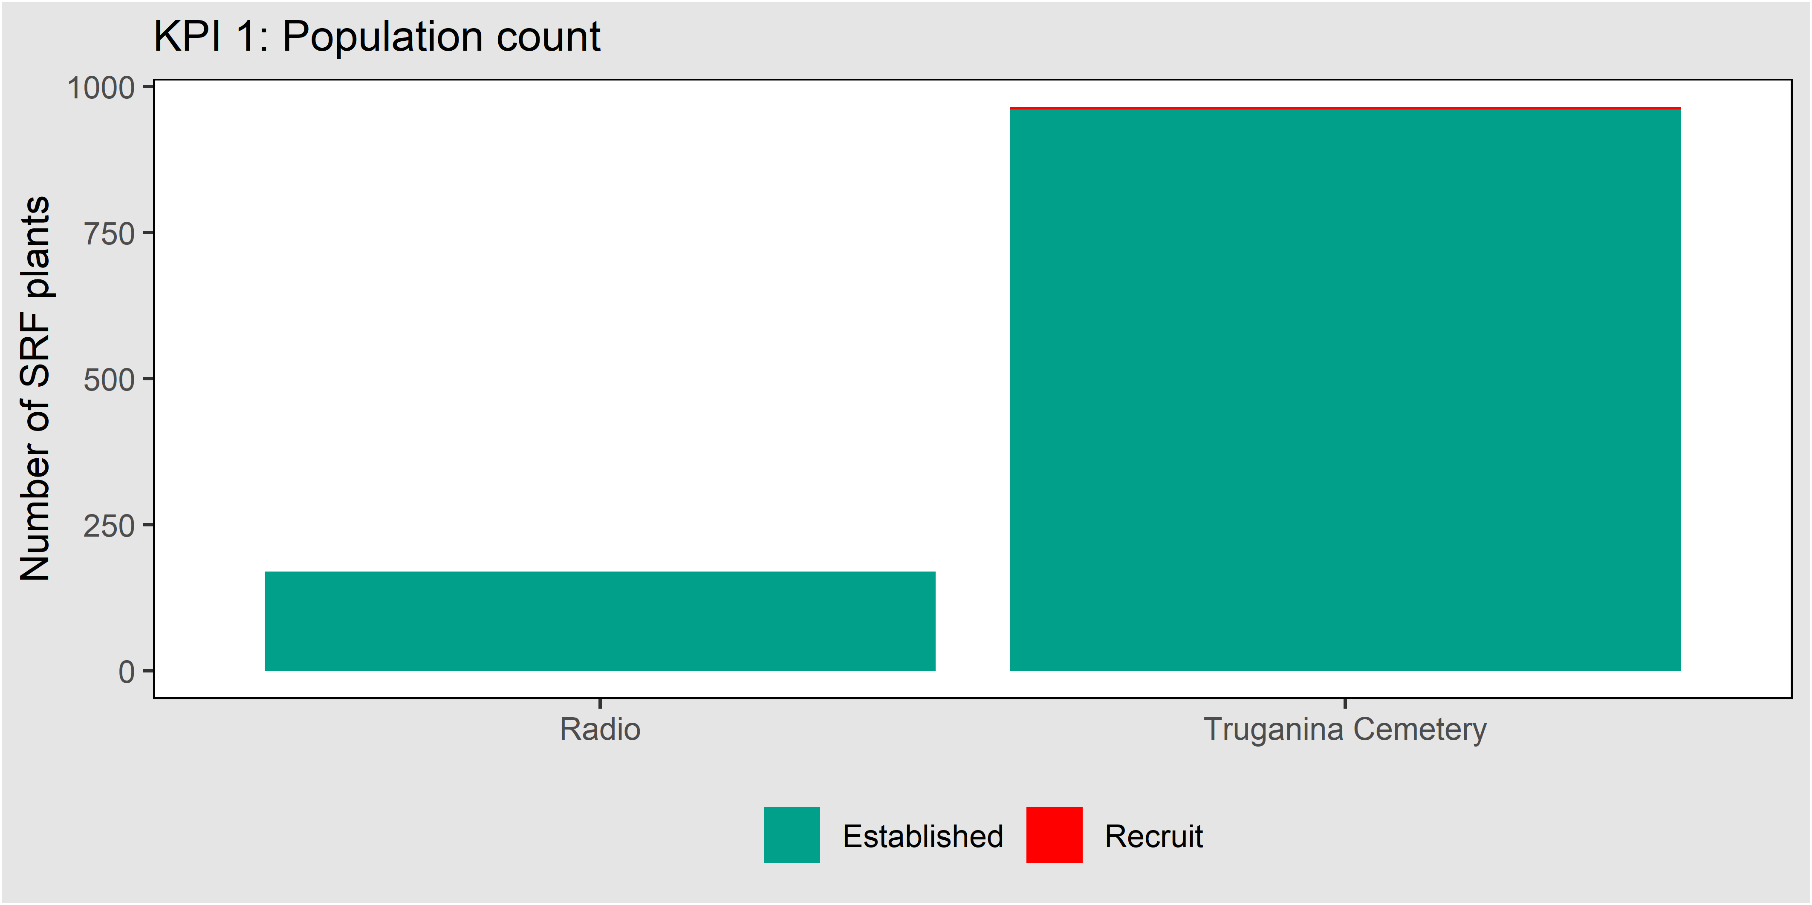
Figure 32. Population count of Spiny Rice-flower at Radio and Truganina Cemetery in 2019.

KPI 2: Number of years that recruits form over 10% of the population over a ten-year period
Number of recruits that form over 10% of the population over a 10-year period
Radio | ◻
Truganina Cemetery | ◻

This KPI measures the proportion of plants that are new recruits to a population. It is expected that recruits form more than 10% of each population at least once every ten years. This KPI is intended to measure the recruitment potential of the population, to ensure that the conditions for recruitment are sustained (periodic bare ground, seed supply), not the fate of recruits, which are not specifically monitored (The overall population trajectory is intended to be covered by KPI 1). Figure 33 shows examples of Spiny Rice-flower recruits.
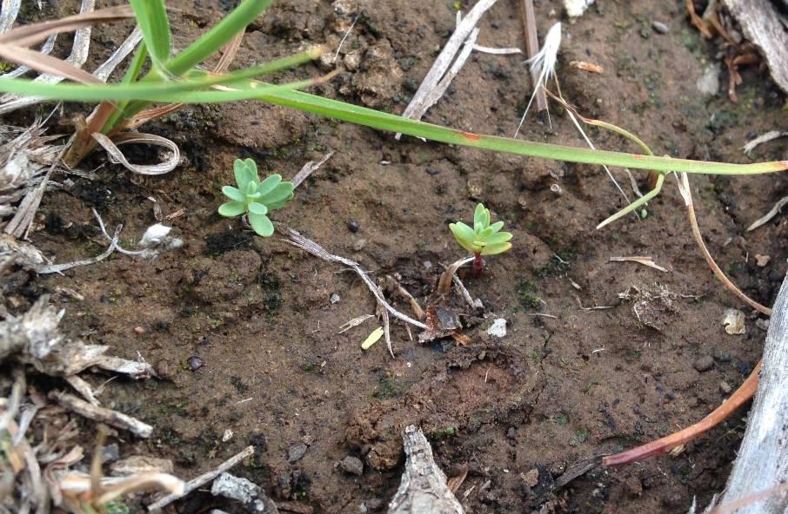
Figure 33. Two Spiny Rice-flower recruits, Truganina Cemetery.
Table 11 shows the percentage of recruits recorded across all currently monitored sites. This is the first year of monitoring using this method. The KPI will be first assessed after ten years of monitoring, in 2029.
This KPI will be assessed against a static baseline (10% of population, one in ten years).
Table 11. Percentage of population formed by recruits. The numbers in brackets show the total numbers of recruits and the total number of plants in the sample plots for that population.
Site | Percentage of population formed by recruits
 | 2019
Truganina Cemetery | (4/965)
Radio (WGR) | 0

Results: Other measures

Scattered plants
The number of known scattered plants is shown in (Table 12). This measure was fully assessed in 2017 and will be re-assessed in 2022. Truganina Cemetery does not have any scattered plants, because all plants form a single large cluster.
Table 12. Counts of scattered plants by block, the number of recruits is shown in parentheses.
Site | Number of scattered plants (additional to clusters)
 | 2017
Mount Cottrell NCR (WGR) | 5 (0)
Magpie (WGR) | 3 (0)
Radio (WGR) | 26 (0)

Vegetation cover
The cover of any plant species (a surrogate of biomass), the cover of bare ground and the of cover weeds are shown for each population in Figure 34. These data are derived from the point intercept plots.
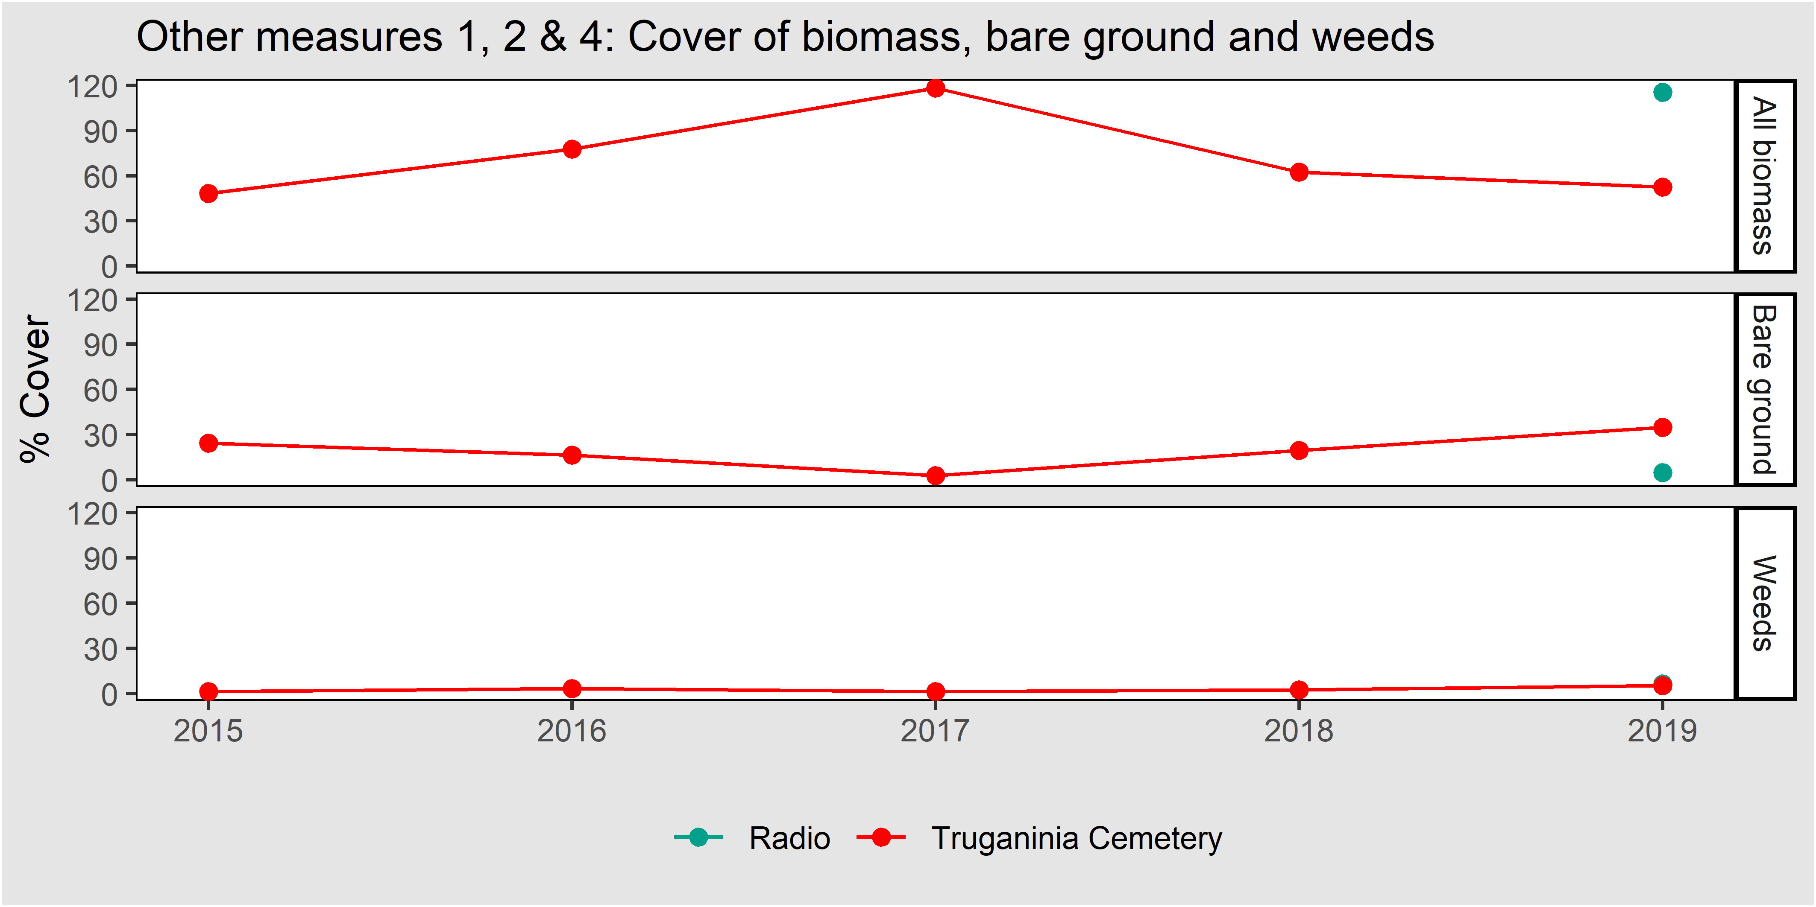
Figure 34. Other measures for the two Spiny Rice-flower clusters. All values are percentage covers.

Identity of associated species
In each plot, in each year, the point intercept data show the identity of the species associated with Spiny Rice-flower. The MRF (DELWP 2015a) requires that the top 5 are reported. The ‘top five’ associated species across all plots are, in descending order: 1) Kangaroo Grass (Themeda triandra; native), 2) Kneed Spear-grass (Austrostipa bigeniculata; native), 3) Onion Grass (Romulea rosea; introduced), 4) Wallaby-grass (Rytidosperma spp.; native), 5) Plantago gaudichaudii (native). This measure will be re-assessed in 2023.

Changes to MRF
The changes implemented for most species and communities involve minor points of clarification. In the case of Spiny Rice-flower, however, substantial changes have been implemented, to better serve the KPIs. This is an acknowledgement that the sampling strategy advocated in the MRF is sub-optimal for dealing with this species. This is apparent from several anecdotal observations:
- The plots in Truganina cemetery which were allocated according to the MRF sampled only ten plants in a population of 965 plants (1%). The monitoring for Button Wrinklewort, at the same location, captures over 600 plants (100% of population), with only ~eight times the survey effort. This shows that the Spiny Rice-flower monitoring approach advocated in the MRF was relatively inefficient.
- In 2016, numerous Spiny Rice-flower recruits were observed outside the plots in Truganina Cemetery, but none in the plots, suggesting that the plot arrangement failed to capture an important phenomenon in the life of this species.
When the MRF was designed, it was assumed that most Spiny Rice-flower populations would be moderate sized clusters of plants, which could be well characterised by 25 m² plots spread across the populations. Instead, detailed surveys have now revealed the varied and uneven spatial arrangements of populations. This actual arrangement of plants is not well served by the current strategy which under-samples large, dense populations, and expends much effort on single plants.
To address this imbalance, the following changes have been implemented:
- The monitoring method has been re-written to align more closely with Button Wrinklewort and Large Fruit Groundsel. Clusters are defined, which include most Spiny Rice-flower plants in the MSA area. These are then monitored using belt transects to allow all plants in the population to be counted, and their positions to be recorded with X, Y co-ordinates.
- The methods have been changed to make it clear that both KPIs apply only to plants within clusters.
- The word ‘density’ has been changed to ‘count’ in KPI 1 (so that KPI 1 now matches Button Wrinklewort). This KPI only applies to plants monitored within Clusters.
- The KPIs are now numbered
- The formulation of the baselines and targets has been clarified to make it clear which KPI is assessed against a static baseline, and which is assessed using a continual improvement model.
- The count of scattered plants has been introduced as an ‘other measure’. Some of the plants previously monitored within the 5 x 5 m plots are now counted as scattered plants.
- The requirement to assign a gender to each plant was removed and replaced with a requirement to estimate the gender ratio among the flowers for each plant at least once every five years (<5% female, 5-39% female, 40-60% female, 61-95% female, >95% female). This change is necessary because it appears that many plants are bisexual, and because making detailed examinations of the many hundreds of plants that occur within the clusters is deemed too labour-intensive.
- The other measure that previously measured the “height of biomass” has been changed to “total cover of biomass” so that it can be calculated directly from the point intercept plots.

Golden Sun Moth

Introduction

The species
Golden Sun Moth (Synemon plana) is listed as Critically Endangered (CE) under the EPBC Act. It is a medium-sized day flying moth with a wingspan of about 3 cm. Golden Sun Moth is found in Victoria, South Australia and NSW. In Victoria it is found extensively on the Victorian Volcanic Plain, including the Werribee Keilor plains to the west of Melbourne (Brown at al. 2012). It is shown in Figure 35.

Goals and performance indicators
The Victorian Government has committed to ensuring that the Golden Sun Moth persists.
Progress towards this goal is measured using a KPI, with the following target:
- The five year mean proportion of monitoring sites occupied must remain above a baseline set by the first five years of survey.

Monitored populations
Golden Sun Moth occurs in numerous Conservation Areas within the MSA area (DELWP 2015a). Four of these sites are currently protected, and contribute to measuring progress towards the goal for this species:
- Truganina South Nature Conservation Reserve (NCR)
- Western Grassland Reserve, Mount Cottrell NCR (eastern half)
- Western Grassland Reserve, One Tree East (Paddock 1 and Paddock 2)
- Western Grassland Reserve, Wilsons Block (Wilsons North and Wilsons South)
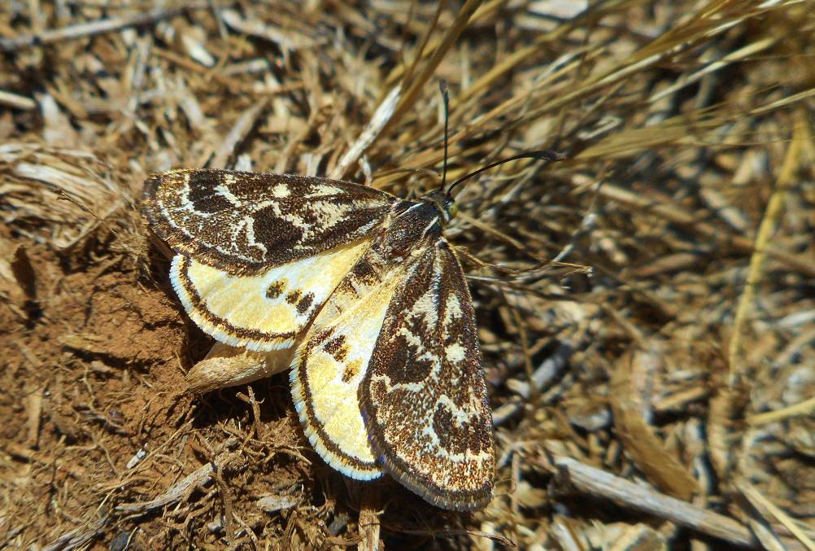
Figure 35. Male Golden Sun Moth in the Western Grassland Reserve.

Monitoring method

KPI 1: Detection of moths
For the purpose of stratifying Golden Sun Moth surveys, the Western Grassland Reserve is divided into 250 ha grids. Within each grid a 400 x 400 m plot is randomly allocated within Natural Temperate Grassland (excluding the states ‘De-rocked grassland’, ‘De-rocked nutrient-enriched pasture’ (Sinclair et al. 2019) which are assumed to be inappropriate habitat for GSM). This plot allocation has resulted in 11 permanent plots being established in the existing protected area, as of 2019. Additional plots will be established in new areas as they are protected.
Surveys are undertaken between November and January in each year, with each plot surveyed once per year. In each plot 21 transects are established (20 m apart) and these transects are walked noting the time to first detection, the total number of moths detected and the total survey time. If all transects are walked with no moth detection the species is recorded as absent from that plot). In cases where the shape of the grassland does not allow a plot to fit, transects are arranged 20 m apart that adequately sample the site (e.g. Truganina South NCR, in this case all native grassland was surveyed via transects 20 m apart). As far as practical, surveys are undertaken during conditions thought to maximise the probability of detection (between 11 am and 3 pm, ambient temperature 20-35 ⁰c, cloud cover < 50% and light winds).
As five years of surveys have been completed in 2019, the baseline for this KPI has now been established. It was calculated as the mean number of plots where moths were detected over these five years (2014-18 inclusive).

Other measures
The weather conditions at the time of survey (ambient temperature, wind speed and direction and cloud cover) are recorded, as these are thought to influence the probability of male moths flying and thus the probability of detection. The mean of these variables for each year is calculated separately for plots in which moths were detected and those in which moths were not detected.
The cover of bare ground and weeds is determined by taking the mean of these variables from all the rapid plots (see Natural Temperate Grassland) that fall in the relevant management unit in a given year. The mean for each year is the grand mean of all relevant management units in that year. The golf ball method (Schultz et al. 2017) provides an estimate of grassland structure and biomass levels, this may be related to habitat suitability for Golden Sun Moth (Brown and Tolsma 2010). It is based on the proportion of golf balls visible in a 1 x 1 m plot where the highest score (18) indicates the highest visibility of balls and thus lowest biomass, a score of zero indicates the highest biomass. The dominant grass species in each plot is taken from the vegetation inventory covering the relevant management unit.

Results: KPI

KPI 1: Proportion of monitoring sites that are occupied
Proportion of monitoring sites that are occupied
All locations | ☑

The baseline for this KPI is calculated as the mean of the first five years of data for all sites monitored within the first five years. Figure 36 shows the proportion of sites occupied for the first six years of the program and the baseline: 89% of sites occupied. In 2019-20 this KPI was met.
This KPI will be assessed against a static baseline.
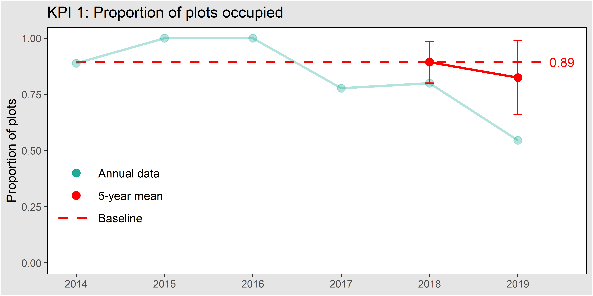
Figure 36. The proportion of plots in which Golden Sun Moth was detected. The five-year mean is shown in red with error bars depicting 95% confidence intervals. The baseline, set after the first five years, is shown as a dashed line.

Results: Other measures

Cover of bare ground, weeds and overall biomass
The cover of weeds may change the species composition of the grass sward that the moth larvae feed in. The cover of bare ground is thought to influence habitat suitability for Golden Sun Moth; higher bare ground may provide greater mating opportunities as it is easier for males to find mates (Brown and Tolsma 2010). Bare ground weed cover and biomass as indicated by the golf ball score are shown in Figure 37.

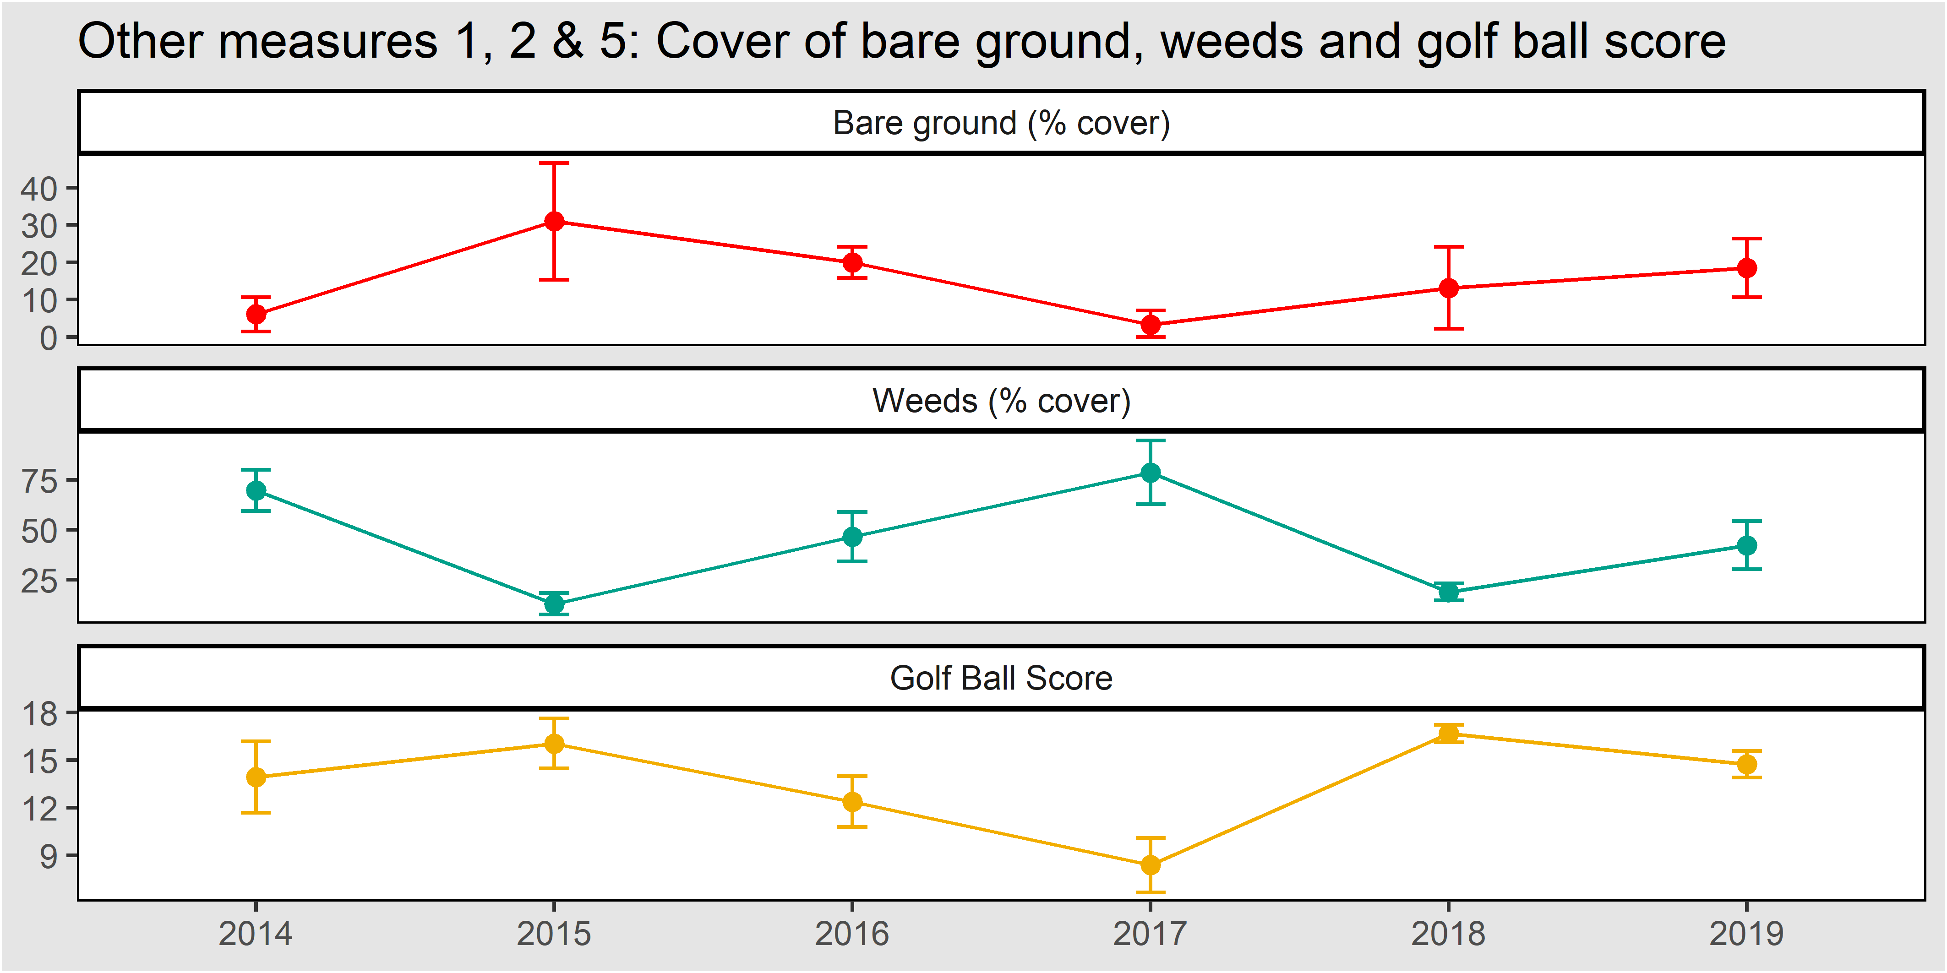
Figure 37. Mean cover of bare ground and weeds in management units where moths were monitored. Error bars are 95% confidence intervals. The golf ball score is a measure of biomass ranging from 0 = high biomass to 18 = low biomass.

Weather conditions during survey
Weather conditions may influence the likelihood that male moths fly, which may in turn influence Golden Sun Moth detectability (Brown et al. 2012). Figure 38 and Table 13 summarise the weather conditions during the Golden Sun Moth surveys, showing under which conditions moths were detected or not detected.
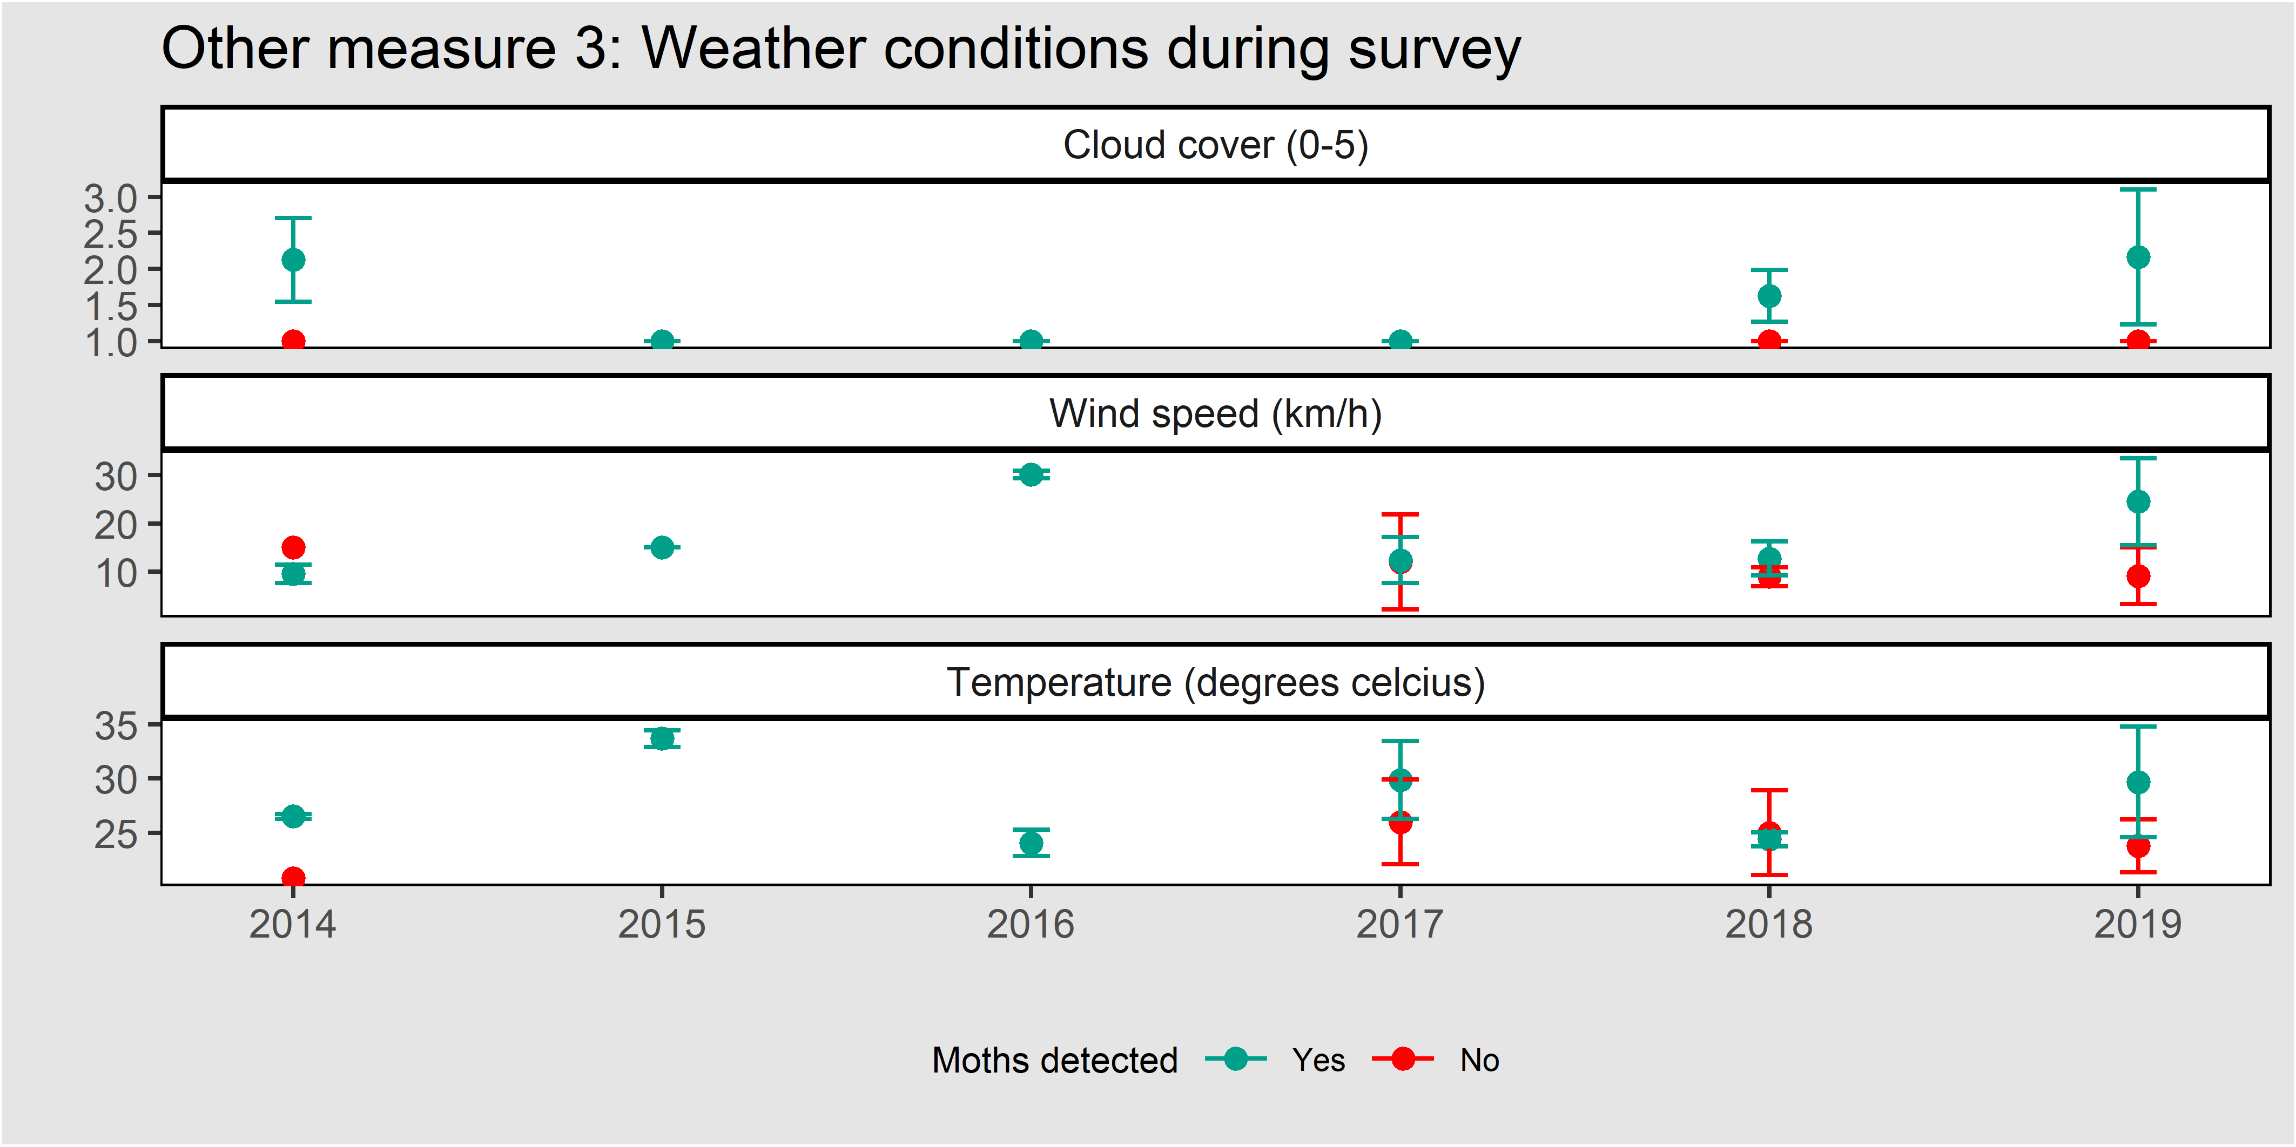
Figure 38. The mean weather conditions at the time of survey for plots where moths were detected and not detected. Cloud cover (upper panel) was recorded in bins (1 = 0-25%, 2 = 26-50%, 3 = 51-75% and 4 = 76-100%). Error bars are 95% confidence intervals.
Table 13. The modal (most common) wind direction at the time of Golden Sun Moth Surveys.
Moths detected | 2014 | 2015 | 2016 | 2017 | 2018 | 2019
Yes | SE | N | N | SSW | SE | WNW
No | S | - | - | NNE | SE | ENE

Cover of C3 and C4 grasses
Figure 39 shows the mean cover of C3 and C4 grasses in each management unit where Golden Sun Moth is monitored.
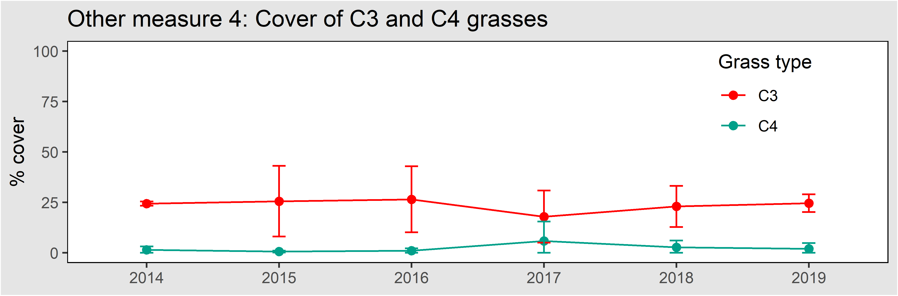
Figure 39. The cover of all (native and exotic) C3 and C4 grasses in management units where Golden Sun Moth was monitored. Error bars are 95% confidence intervals.

Abundance of Golden Sun Moth
Figure 40 shows the mean number of moths detected in each plot. This measure was first recorded in 2017.
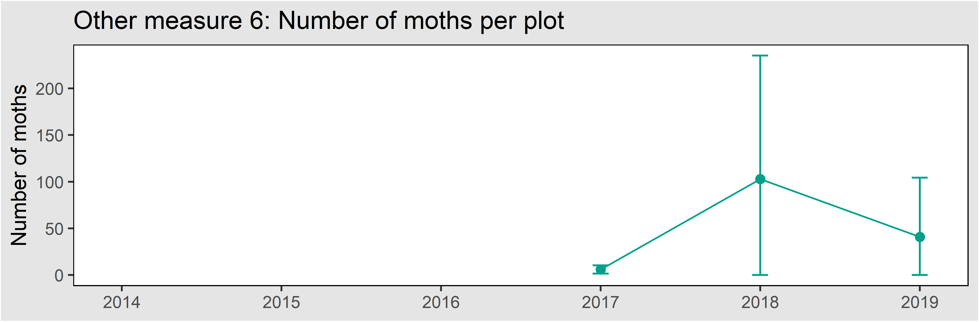
Figure 40. The mean number of Golden Sun Moths detected per plot in each year. Error bars are 95% confidence intervals.

Changes to the MRF
This section details the ways in which the approach taken here differs from the MRF (DELWP 2015a).
- The ‘Other measures’ have been amended to include an estimate of Golden Sun Moth abundance taken from counts of individuals in each plot. This requires a change in the monitoring protocol such that each plot is fully covered, and all detected individuals are recorded. This is now reported as Other measure 6, number of moths per plot.
- The formulation of the baselines and targets has been clarified to make it clear that the KPI is assessed against a static baseline.
- The requirement for other measures to report the cover of all weeds has been removed as this measure includes exotic C3 grasses that might provide habitat for Golden Sun Moth, hence this may be a misleading measure.
- The other measures (Other measure 5) have been amended to include an estimate of biomass as determined by the “golf ball method”, using the NTG rapid plots located within the relevant management unit.
- The requirement for other measures to report the dominant grass in each plot has been removed, and instead the cover of C3 and C4 grasses is reported as other measure 4.
- The recommended survey conditions have been changed such that the recommended cloud cover is up to 50%.
- It is now specified that the other measure of wind direction is reported as the modal (most common) direction recorded at the time of survey for each plot.

Growling Grass Frog

Introduction

The species
Growling Grass Frog (Litoria raniformis) is listed as Vulnerable (V) under the EPBC Act. It is a large, semi-aquatic member of the ‘bell frog group’ (Barker et al. 1995; Heard et al. 2013). It is was formerly distributed widely across lowland south-eastern Australia, including in most regions of Victoria (excluding the Mallee and alpine regions) (Barker at al. 1995; Clemann and Gillespie 2013).

Goals and performance indicators
The Victorian Government has committed to ensuring that the Growling Grass Frog persists within the MSA area. Further details of how this commitment is interpreted are provided in the MRF (DELWP 2015a).

Monitored populations
Growling Grass Frog is known from several locations in the MSA area. Most of these areas are yet to be protected, and no monitoring has occurred under the MSA program. Other projects have monitored some MSA populations in the past, and those data are available to augment future MSA data.

Suggested changes to the MRF
Although monitoring has not commenced, a review of the MRF reveals several areas that can be clarified and improved. These improvements can be informed by recent research on this species (Heard et al. 2013; Rose et al. 2016; Scroggie et al. 2019a), including additional monitoring across northern Melbourne allowing updates to the existing Growling Grass Frog stochastic patch occupancy model (SPOM), and refined estimates of detection probabilities. The suggested changes are outlined below, but will be developed further before monitoring is implemented. Future refinements will:
- Clarify that the KPI is assessed using regularly collected field data, not only using SPOM outputs.
- Clarify that the KPI will be assessed separately for each of the seven Growling Grass Frog corridors.
- Change the performance measure to be ‘the proportion of sites occupied’ in a given year. Occupancy will be determined from periodic monitoring of a set of survey locations. These locations will include a fixed set of core locations but may be varied as new wetlands are constructed. The frequency of monitoring is yet to be determined but should occur at least once every 5 years in each corridor. The monitoring data will be used to estimate occupancy for each corridor in each year during which monitoring is conducted, from the available data, with credible intervals.
- Clarify that the baseline will be set for each corridor based on occupancy estimates from field data. The KPI will be met if the upper 95% credible interval includes the baseline.
- Clarify that the projected (i.e. future predicted) risk of extinction should be calculated every 5 years from the accrued monitoring data and reported as an ‘other measure’.
- Add a requirement to record all variables required by the SPOM at each monitored wetland.

Southern Brown Bandicoot

Introduction

The species
Southern Brown Bandicoot (eastern) (Isoodon obesulus subsp. obesulus) is listed as Endangered (E) under the EPBC Act. It is a marsupial in the family Peramelidae. Males are generally larger than females (Menkhorst 1990). The sub-species is found in Victoria, NSW and South Australia. In Victoria it is primarily in coastal and foothill regions south-east of Melbourne, with isolated populations in western Victoria (Brown and Main 2010; Menkhorst 1990).

Goals and performance indicators
The Victorian Government has committed to ensuring that the Southern Brown Bandicoot persists within the Southern Brown Bandicoot management area. Further details of how this commitment is interpreted are provided in the MRF (DELWP 2015a). Persistence will be assessed by the degree of occupancy of Southern Brown Bandicoots as estimated by remote camera surveys, spread across 100 sites within the management area.

Monitored populations
Southern Brown Bandicoot is monitored on public land throughout the Southern Brown Bandicoot Management Area (DEPI 2014; DELWP 2015a). The management area (Figure 43) covers 59,549 hectares to the south-east of Melbourne, primarily outside the urban growth boundary. Previous research has shown that despite this landscape being heavily modified, bandicoot populations persist (Bryant et. al. 2018; Maclagan et. al. 2018).

Monitoring method

Site selection
A GIS layer was created to define likely Bandicoot habitat within the management area defined in DEPI (2014), by combining:
- the area predicted to have a >56% likelihood of Southern Brown Bandicoot occurrence by the DELWP habitat distribution model, and recent (post 2000) Victorian Biodiversity Atlas records of Southern Brown Bandicoot buffered by 150 metres.
One hundred sampling locations were randomly positioned within the resulting area, with the constraint that all sites must be separated by at least 500 metres. This minimum distance was chosen to limit the likelihood of an individual bandicoot being detected across multiple sites.

These randomly generated sites were examined initially on aerial photographs, and then in the field, to ensure:
- the security of cameras at the site,
- the presence of native vegetation (e.g. not in the middle of a paddock),
- the presence of sufficiently homogenous habitiat to allow two cameras to be installed 50 meters apart, and
- site access was safe and permissible (permission was arranged with private landholders where necessary).
In cases where a randomly generated site did not meet these criteria, the site was moved to a new location within 150 m of the randomised sites. In a minority of cases no nearby site could be found, and entirely new sites were created in the field, based on drive-by assessments of habitat not guided by the randomised points.

Camera setup
Cameras were deployed in four separate periods with one deployment per site in 2019 (February, March/April, May or June/July). Two cameras were deployed at each site, each a different model (Reconyx HP2X Hyperfire 2 Professional Covert IR and Reconyx HC 600). Cameras were deployed between February and July 2019 in four separate deployments. All cameras were deployed for a minimum of 26 days.
Cameras were attached to the nearest suitable tree, approximately 0.5 m from the ground (using a cable lock to prevent theft). Cameras were pointed at a bait station, located ~2.5 m from the camera (the exact distance and angle is determined by the camera’s detection field, dependent on the camera model, and noted in the manufacturer’s instructions). Bait was secured in an inaccessible plastic container. It consisted of a 5:1:2 mixture of rolled oats, golden syrup and peanut butter with 20 ml/kg of truffle oil. To minimise false triggers due to air movement and temperature fluctuation, cameras were directed south and downslope, where possible. The area between the camera and bait station, and 1 m behind the bait station was cleared of vegetation and debris.
All cameras were pre-programmed as follows: five pictures per trigger, Rapidfire, NO Delay, Sensitivity HIGH, DAY & NIGHT. PIR TYPE for HP2X cameras was set to HF Legacy so as the motion detector would function the same as that of the Reconyx HC 600 cameras.
Although the cameras were deployed at 100 sites, only 98 sites yielded data for analysis in 2019; a wildfire in March 2019 (Bunyip complex) destroyed both cameras at two sites and no data could be recovered. These sites should remain as part of the monitoring program in future years. One camera was stolen, but this site was still included in the analysis because the other camera at this site operated without incident.

Data analysis
For Southern Brown Bandicoot the occupancy is estimated using an occupancy model (MacKenzie et al. 2005). Occupancy modelling also provides an estimate of uncertainty (expressed as conficence intervals) which is used to assess whether on not the KPI has been met.
All animals captured on photos were identified by staff experienced in small mammal identification. All photos capturing Southern Brown Bandicoot were tagged to be included in occupancy analysis. Two parameters are estimated in this analysis, the probability of occupancy (the probability of the true presence at a site) and the probability of detection (the probability of detecting a species if it is present at a site). This type of modelling accounts for imperfect detection (where the probability of detection is < 1). This approach is commonly used to analyse data obtained from remote camera surveys (Meek et al. 2014).
Detection histories were compiled in R (R Core Team 2019) using the package camtrapR (Neidballa et al. 2016). Data from both cameras at a site were combined to produce a single daily detection history for each site. For each 24-hour period (midnight to midnight) at each site data was coded as either 1 (SBB detected) or 0 (SBB not detected). Detection histories were produced for 26 consecutive days as this was the minimum amount of time that at least one camera operated per site.
Occupancy analysis was conducted in R using the package unmarked (Fiske and Chandler 2011). The probability of occupancy and detection was computed for a single season (MacKenzie et al 2017) using the “occu” function. Several co-variates were tested for their impact on occupancy and detection (Table 14). The co-variates were habitat type (roadside, reserve or canal side), vegetation type (‘Eucalypt-dominated woodland’ or ‘Treeless scrub and heathland’) and survey month (February, March/April, May or June/July). The best supported model was chosen as having the lowest Akaike information criterion (AIC) value (Akaike 1974), using the “modSel” function.
Table 14. Details of occupancy model covariates and the AIC values for each model. Models with a lower AIC are considered to have more support. The column ΔAIC shows the difference in AIC from the best supported model (model 11, highlighted in bold).
Model number | Occupancy | Detection | AIC | ΔAIC
1 | No covariates | No covariates | 1523.6 | 33.6
2 | Habitat type | No covariates | 1517.3 | 27.3
3 | Vegetation type | No covariates | 1525.0 | 35.0
4 | No covariates | Habitat type | 1504.3 | 14.3
5 | No covariates | Survey month | 1496.3 | 6.3
6 | No covariates | Vegetation type | 1524.8 | 34.8
7 | Habitat type | Habitat type | 1498.1 | 8.1
8 | Vegetation type | Vegetation type | 1526.2 | 36.2
9 | Vegetation type | Habitat type | 1505.7 | 15.7
10 | Vegetation type | Survey month | 1497.7 | 7.7
11 | Habitat type | Survey month | 1490.0 | 0.0
12 | Habitat type | Vegetation type | 1518.5 | 28.5

The fit of the best supported model (the model with the lowest AIC; model 11, Table 14) was tested with 2,000 chi-squared simulations using the “parboot” function. The mean, lower and upper 95% confidence intervals for occupancy and detection probabilities were calculated using the “predict” function.

Results: KPI

KPI 1: Proportion of monitored sites that are occupied
Proportion of monitoring sites that are occupied
SBB Management Area | ◻

The baseline for Southern Brown Bandicoot was calculated from the first survey, using the model to estimate occupancy from the data. The best supported model had occupancy dependent on habitat type and detection dependent on survey month. There was no evidence that this model fitted poorly. The baseline for SBB therefore varies by habitat type; canal 76%, reserve 39% and road 35% of sites occupied (Figure 41). The KPI will be assessed against these baselines in subsequent five-yearly surveys, with the next due in 2024. Bandicoot detections were spread out across the management area, with notable areas of non-detection in the south-western and north-eastern (north of the Princess Hwy) corners of the management area.
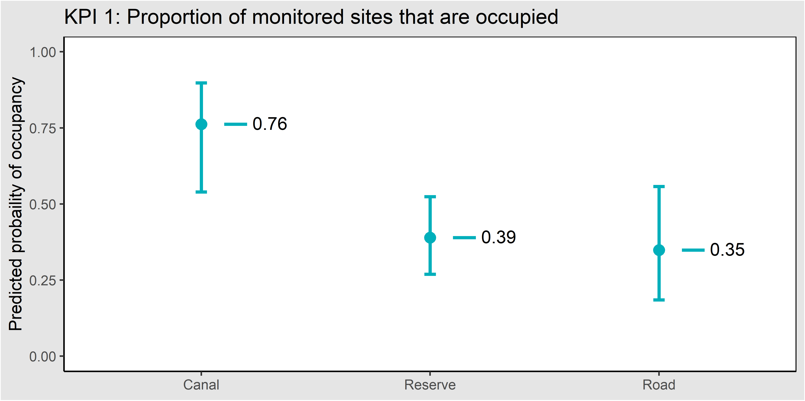
Figure 41. The modelled proportion of sites occupied by Southern Brown Bandicoot and the detection probability for Southern Brown Bandicoot. Error bars are 95% confidence intervals. The horizontal lines show the baseline for each habitat type.

Results: Other measures

Detection probability
Detection probability was influenced by survey month. It was lower during February than the other months (Figure 42). Nevertheless, 26 days was more than sufficient to achieve a cumulative detection probability (the probability of detection of at least one individual given the site is occupied) of over 0.99; which was achieved after 20 days for all deployment periods.
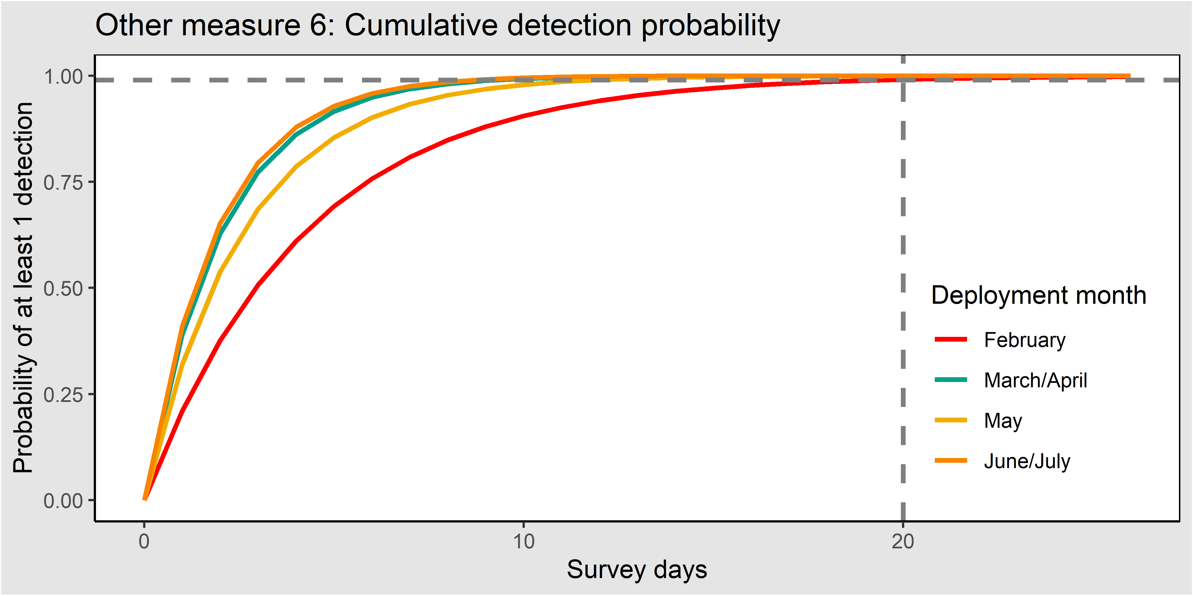
Figure 42. The cumulative detection probability for detection of at least one individual. The dashed lines indicate that a probability of 0.99 was achieved after at most 20 days for all survey months.

Fox occupancy
The percentage of monitoring sites where foxes were detected was 64% (63 out of 98 sites). Foxes were detected throughout the management area, including within Royal Botanic Gardens Cranbourne behind a predator-proof fence. There were 30 sites (31%) where both foxes and bandicoots were detected.

Extent of native vegetation
Figure 43 shows the mapped extent of native vegetation in the SBB management area as at 2005 (the most recent year for which data is available). Native vegetation accounted for 10,035 ha or 16.8% of the management area.
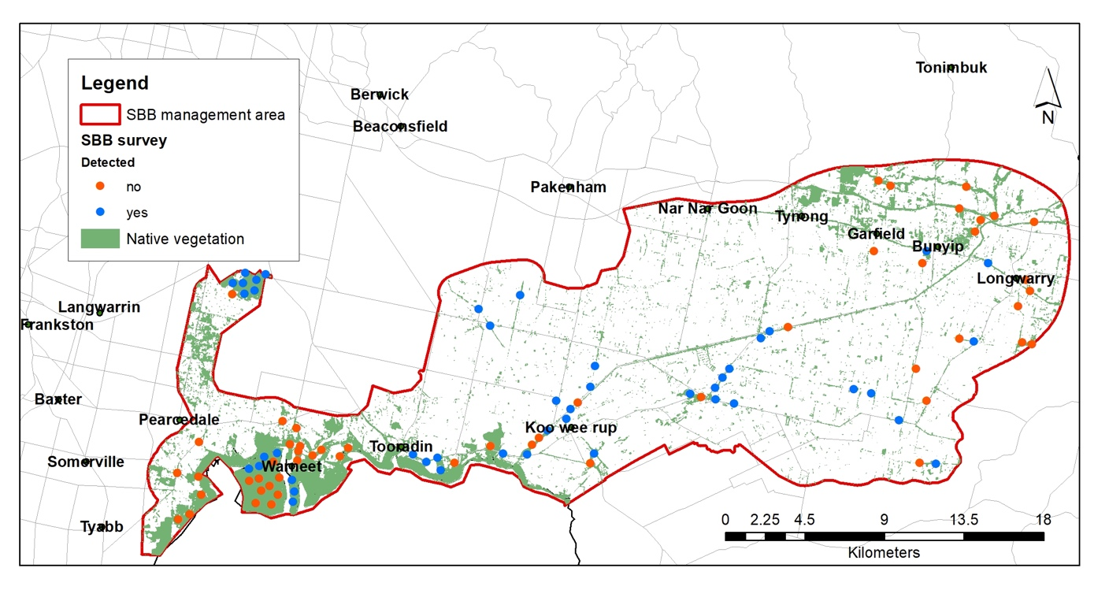
Figure 43. The extent of native vegetation in the Southern Brown Bandicoot management area (2005 data).

Fire history
Figure 44 shows the fire history in and adjacent to the SBB management area for the last five years. In 2019, a large wildfire (Bunyip Complex) burnt part of the north-east, this fire burnt two monitoring locations (and no data was recovered). There were no other recorded fires in the past five years.
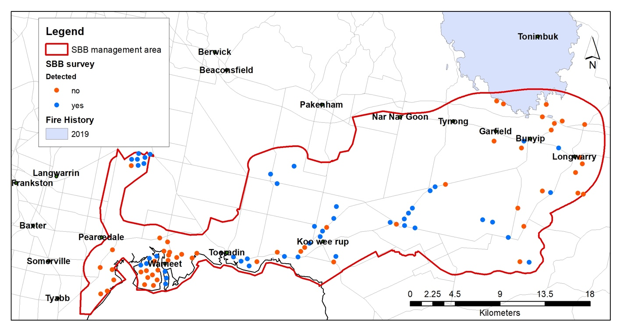
Figure 44. The fire history in the Southern Brown Bandicoot management area (2014-2019).

Changes to the MRF
This section details the ways in which the approach taken here differs from the MRF (DEPI 2015).
- Detection probability has been added to ‘other measures’ so that the adequacy of survey length (number of days) can be adequately demonstrated. Mean deployment length should be such that a cummulative detection probability of 0.99 is achieved, in this case 20 days would have been adequate.
- The source of the other measure “Fox occupancy” has been changed from “Fox bait take” to “the percentage monitoring of sites at which foxes were detected”, so that available data can be utilised. The frequency of this measure has been changed from “As required by the baiting program” to “Five yearly”.
- The KPI and baselines are reported by three habitat types: canal, roadside and reserve.
- The other measure, extent of development has been removed.

Striped Legless Lizard

Introduction

The species
Striped Legless Lizard (Delma impar) is listed as Vulnerable (V) under the EPBC Act. It is a flap-footed lizard. It lacks forelimbs and the hind limbs are reduced to small flaps (Wilson and Swan 2010). The species is found in the ACT, Victoria, NSW and South Australia. The Victorian range has contracted south, with significant populations in the western suburbs of Melbourne (O'Shea 2005). The species is shown in Figure 45.

Goals and performance indicators
The Victorian Government has committed to ensuring that the Striped Legless Lizard persists. Progress towards this goal is measured using a single KPI, with the following target:
- Evidence of Striped Legless Lizard is detected at least once in every five-year period at 100% of permanent monitoring plots (i.e. plots which have previously yielded detections).

Monitored populations
The KPI for Striped Legless Lizard relates to the Western Grassland Reserve and Truganina South NCR. Currently two permanent monitoring locations have been established, at Mount Cottrell NCR.
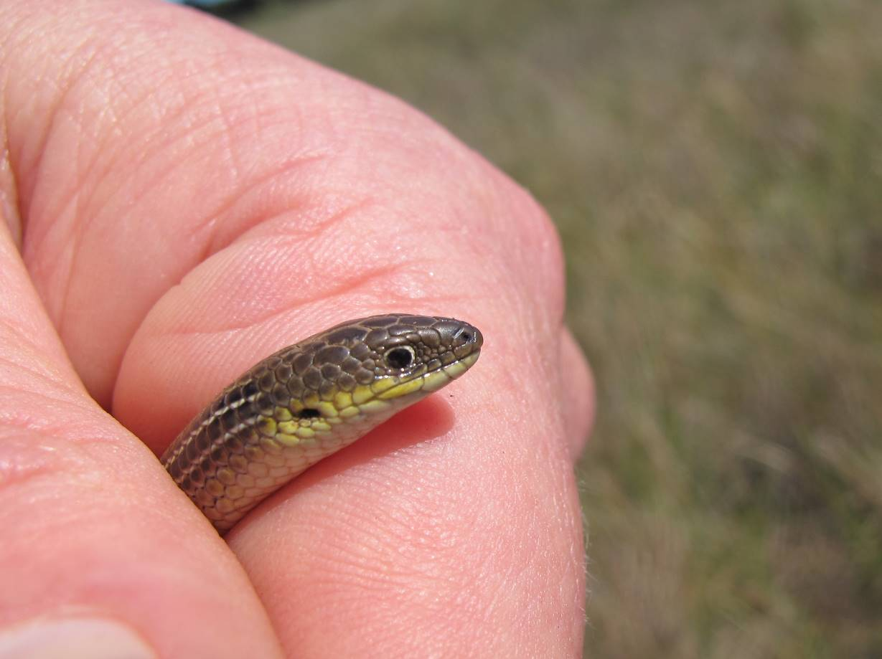
Figure 45. Striped Legless Lizard within the Western Grassland Reserve.

Monitoring method

General protocol
Striped Legless Lizard is surveyed using artificial habitat, which can be routinely inspected. Grids of ceramic roof tiles are used. Each grid is a rectangle of 50 (10 x 5) roof tiles spaced 5 m apart, oriented such that the long axis runs north-south.
The tile grids are surveyed annually. The tile grids are established two months prior to commencing surveys. The locations of the corner tiles are recorded using a hand-held GPS unit.
At each tile grid the sheltered area underneath the tiles is inspected for evidence of Striped Legless Lizards, including sloughed skins. Six repeat tile checks of each grid are conducted each year, with checks at least one week apart. The tiles are checked between 10am and 4pm, when the tile temperature is 18-40°C and the ambient air temperature is between 15-30°C. Tile checks do not occur at the same time of day on each occasion for any given tile grid during the survey period.

Identification of permanent monitoring locations
The Western Grassland Reserve is divided into 250 ha square blocks. Any block already containing one or more permanent monitoring plots (from phase 1) is excluded from this phase. Within each of the remaining blocks, 10 random locations are identified, each at least 50 m from any other grid location. One location (one tile grid per location) is surveyed each year, over ten years, in an effort to detect lizards. Any grid found to contain evidence of Striped Legless Lizard (alive, dead or a lizard slough) becomes a permanent monitoring plot (see phase 3). Phase 2 will cease in a 250-ha block if one or more of the following occurs:
- evidence of Striped Legless Lizard is detected at one of the ten locations;
- evidence of Striped Legless Lizard is detected during Phase 1 inventory surveys on other parcels within the 250-ha block;
- all the grassland is exhausted (i.e. no more plots can fit given the distance rules);
- all 10 random locations have been surveyed.
This is supplemented by the deployment of tile grids as part of the inventory of newly acquired parcels. Grids under which lizards are detected during these surveys may also become monitoring subject to the distance rules outlined below.

Ongoing monitoring of known populations
Any tile grids that have had a Striped Legless Lizard detected become permanent monitoring grids and are monitored for the remainder of the MSA program. At each monitoring location, the original tile grid where the lizard was detected is expanded, via the addition of four additional grids nearby, off each corner of the original grid, to form an X arrangement. These expanded grids are located at least 100 m apart. To ensure this spatial separation the centre point of permanent plots should be at least 282 metres apart (twice the radius of the circle containing the X shaped plot plus 100 m). In the case of two new permanent plots being installed in the same year the distance rule also applies where two plots are too close together, the grid where a lizard was first located becomes the permanent plot (the location of the other plot will be noted). The rule applies regardless of property, parcel or management unit boundaries.

Monitoring to date
Prior to 2019 two permanent monitoring plots have been established for this species. One is on Mt Cottrell NCR, following a detection in 2016. In this case the grid arrangement was altered (from the standard X arrangement) such that the additional grids were placed to the south, west and north of the original location due to a mown fire break and fence directly to the east. On Truganina South NCR the plot is in the standard X arrangement.

Other measures
The weather conditions at the time of survey (ambient temperature, under-tile temperature, wind strength and direction, cloud cover and time of day) are recorded, as these are known or suspected to influence the probability of detecting lizards under tiles (Thompson 2006; Scroggie et al. 2019b). The mean of these variables for each year is reported separately for surveys in which lizards are detected and those in which lizards are not detected.
The cover of bare ground and weeds is determined by taking the mean of these variables from the rapid grassland plots (see Natural Temperate Grassland) in the relevant management unit for that year. The mean for each year is the grand mean of all relevant management units in that year.

Results: KPI

Identification of permanent monitoring locations
In 2019 Striped Legless Lizard was detected at nine new locations that qualify to become permanent plots (Table 15).

KPI 1: Proportion of monitoring sites that are occupied
Proportion of monitoring sites that are occupied
Mount Cottrell NCR | ☑
Truganina South NCR | ☑
All other locations | ◻

Striped Legless Lizard has been detected in all survey years after the establishment of the permanent plot in 2017 on Mount Cottrell NCR. At Truganina South NCR, Striped Legless Lizard was detected in 2019. This KPI has been met for the first five years at both locations (Table 15). At the other locations the assessment of the KPI will begin in 2020.
Table 15. Detections of Striped Legless Lizard at permanent monitoring plots (phase 3) by year. *Indicates first year of detection as part of phase 1 or 2 survey. ^The decision to include Truganina South NCR as part of monitoring was taken in 2019, therefore surveys for were not conducted as per the MRF in 2018.
Location | 2016 | 2017 | 2018 | 2019
Mount Cottrell NCR | Yes* | Yes | Yes | Yes
Truganina South NCR | NA | Yes* | NA^ | Yes
Basalt 6 | NA | NA | NA | Yes*
Werribee River easement | NA | NA | NA | Yes*
Little Pony | NA | NA | NA | Yes*
Caboose 1 | NA | NA | NA | Yes*
Caboose 2 | NA | NA | NA | Yes*
Olive 1 | NA | NA | NA | Yes*
Olive 2 | NA | NA | NA | Yes*
Radio 1 | NA | NA | NA | Yes*
Radio 2 | NA | NA | NA | Yes*

Results: Other measures

Cover of bare ground and weeds
Figure 46 shows the mean cover of bare ground and weeds for the management units in which the permanent plots are located.
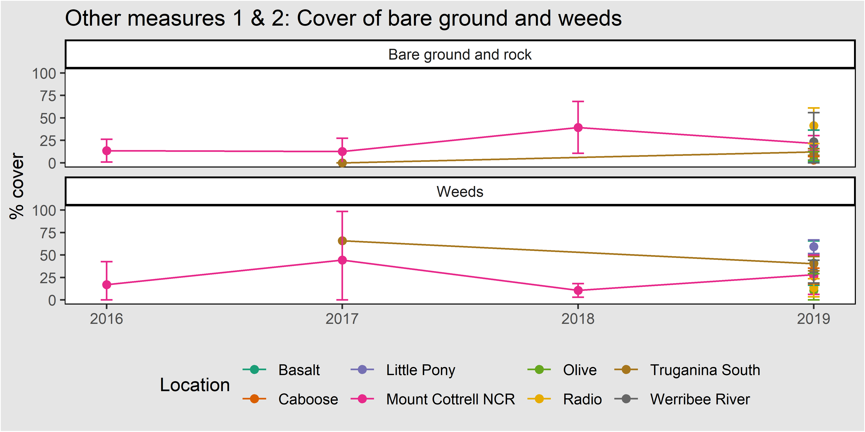
Figure 46. Mean cover of bare ground (inc. rock) and weeds (annual and perennial) in the management units where Striped Legless Lizard has been detected. Error bars are 95% confidence intervals.

Weather conditions during survey
The weather conditions during the surveys may influence Striped Legless Lizard detectability (Thompson 2006). Figure 47 and Table 18 show the weather conditions during all tile surveys, and indicates which surveys resulted in a detection.

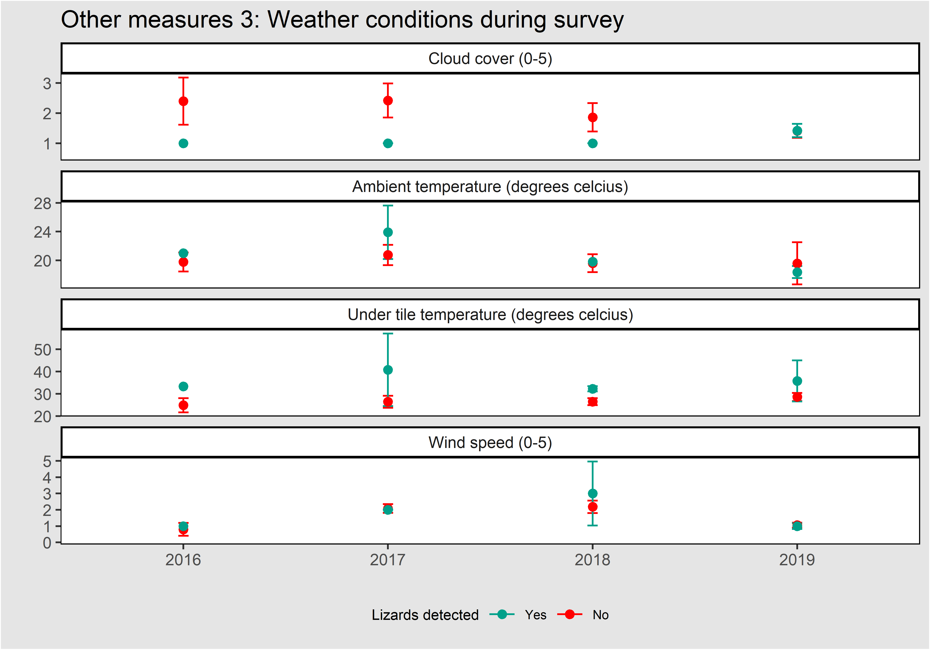
Figure 47. The mean weather conditions at the time of survey where lizards were detected and not detected. Cloud cover (upper panel) was recorded in bins (1 = 0-25%, 2 = 26-50%, 3 = 51-75% and 4 = 76-100%). Wind speed was recorded in bins (1 = still, 2 = breeze, 3 = windy, 4 = string wind, 5 = strong wind with gusts). Error bars are 95% confidence intervals.
Table 18. The modal (most common) wind direction at the time of Striped Legless Lizard surveys.
Lizard detected | 2016 | 2017 | 2018 | 2019
Yes | N | S | N | SSE
No | SSE | SW | N | SSE

Reptiles and frogs detected under tile grids
Table 19 shows the other species of reptiles and frogs detected under Striped Legless Lizard monitoring grids.
Table 19. Reptiles and frogs detected under monitoring grids.
Common Name | Scientific Name
Common Blue-tongue Lizard | Tiliqua scincoides
Tiger Snake | Notechis scutatus
Tussock Skink | Pseudemoia pagenstecheri
Large Striped Skink | Ctenotus spaldingi

Changes to the MRF
This section details the ways in which the approach taken here differs from the MRF (DEPI 2015).
- The stipulation that tiles be removed and stored at the end of each survey period has been removed.
- It is now stipulated that all damaged tiles should be replaced.
- The other measures have been expanded to include all reptiles and frogs detected under permanent tile grids.
- The permissible timing of surveys has been extended to allow tile grids to be checked between 9am and 10am, provided the other optimal survey conditions are met.
- Truganina South NCR has been added to the area considered for monitoring of this species
- The distance rules for the installation of permanent monitoring plots has been amended. The intent is that the edges of permanent plots are at least 100 metres apart. To ensure this, the centre point of new permanent plots should be at least 282 metres from the centre point of an existing plot. In the case of two new permanent plots being installed in the same year this distance rule applies. The rule applies regardless of property, parcel or management unit boundaries.

Acknowledgements
This work was funded through the Melbourne Strategic Assessment program at DELWP. We thank the DELWP MSA team, past and present, particularly Anne Buchan, Adam Muir, Ben Nam, Jessica Kovassy, Renae Measom, Jessica Millet-Riley, Jeremy Aarons and Richard Boekel. We also acknowledge the support of our colleagues at ARI, particularly Kim Lowe, Tim O’Brien, Tracey Regan, Matt White, David Duncan (now University of Melbourne) and Graeme Newell.
The former MSA Technical Advisory Group provided crucial advice on the formulation of KPIs and appropriate monitoring techniques. We thank Vanessa Craigie, John Morgan, Georgia Garrard, David McLaren, Nathan Wong, Josh Dorrough, David Baker-Gabb, Geoff Carr, Damien Cook, Charles Grech, Peter Robertson, Peter Menkhorst, Fiona Smith and the late Alan Yen.
The field monitoring work was undertaken with assistance from many volunteers and DELWP staff, and we thank John Hick, Nicola Prior, Paula Nink, Hayley Sime, Billy Geary, Brad Farmilo, Phoebe Macak, Arn Tolsma, Annette Muir, Geoff Sutter, Geoff Brown, Mel Hardie, Sam Gilbert, Christie Boyle and Leila Brook.
Several groups kindly provided additional data for Matted Flax-lily, and we thank the City of Hume (particularly Amanda Dodd), Abzeco (particularly Geordie Scott-Walker) and Merri Creek Management Committee (particularly Brian Bainbridge).
We thank Parks Victoria, City of Casey, Cardinia Shire, Mornington Peninsula Shire, Baw Baw Shire, Melbourne Water, Bayles Flora and Fauna Reserve, Moonlit Sanctury and Royal Botanic Gardens Cranboune for assisting with site access and management information, notably James Neil, Emma Parker and Mike Forsyth.
We also thank the experts and recovery team members who provided advice about the natural history of the MSA area, including Debbie Reynolds, Steve Mueck, Neville Walsh, Neville Scarlett, Karl Just, Mike Duncan, Karen Lester, Nick Clemann, Garry Peterson, Michael Scroggie, Geoff Heard, Megan O’Shea, Sarah Macalgan, Terry Coates and Daniel Gilmore.
Paul Moloney provided statistical advice and the code for extracting detection histories was adapted from that written by Luke Emerson. Kasey Stamation built the NTG database.
Josepine MacHunter and Michael Scroggie provided helpful feedback on drafts of this report.

References
Akaike H (1974) A new look at the statistical model identification. IEEE Transactions on Automatic Control 19, 716–723.
Backhouse G. and Lester K (2010) National Recovery Plan for the Small Golden Moths Orchid Diuris basaltica. Department of Sustainability and Environment, Melbourne.
Barker J, Grigg G and Tyler MJ (1995) A Field Guide to Australian Frogs. Surrey Beatty, Chipping Norton, NSW.
Bayes E & Cook D (2015) Seasonal Herbaceous Wetlands. Identification and Management Handbook. Goulburn Broken Catchment Management Authority.
Beeton RJ, McGrath C (2009) Developing an approach to the listing of ecological communities to achieve conservation outcomes. The Australasian Journal of Natural Resources Law and Policy, 13 (1), 61-92
Belcher RO (1983) New Australian species of Erechthitoid Senecio (Asteraceae). Muelleria 5, 119-122.
Benton TG, Vickery, JA, Wilson, JD (2003). Farmland biodiversity: is habitat heterogeneity the key?. Trends in Ecology & Evolution, 18, 182-188.
Biggs HC and Rogers KH (2003) An adaptive system to link science, monitoring and management in practice. In: du Toit J, Biggs HC, Rogers KH (2003) The Kruger experience: ecology and management of savannah heterogeneity. Island Press, Washington DC. pp. 59-80.
Brown GW and Main ML (2010) National Recovery Plan for the Southern Brown Bandicoot Isoodon obesulus obesulus Department of Sustainability and Environment, Victoria.
Brown G, Tolsma A, and McNabb E (2012) Ecological aspects of new populations of the threatened Golden sun moth Synemon plana on the Victorian Volcanic Plains. The Victorian Naturalist 129, 77-85.
Brown GW and Tolsma AD (2010) A survey for the Golden Sun Moth Synemon plana on the Victorian Volcanic Plains, 2009. Arthur Rylah Institute for Environmental Research. Department of Sustainability and Environment, Heidelberg, Victoria.
Bryant D, Sinclair S, Geary W, Bruce M and Millen C (2018) The occurrence of the Southern Brown Bandicoot Isoodon obesulus and its habitat on Chinaman Island, Western Port, Victoria. The Victorian Naturalist 135, 128-138.
Casanova MT and Powling IJ (2014). What makes a swamp swampy? Water regime and the botany of endangered wetlands in western Victoria. Australian Journal of Botany 62, 469-480.
Carr GW and Horsfall PF (1995) Studies in Phormiaceae (Liliaceae) 1: New species and combinations in Dianella Lam. Ex Juss. Muelleria 8, 365-378.
Chisholm RA, Menge DNL, Fung T, Williams NSG and Levin SA (2015) The potential for alternative stable states in nutrient-enriched invaded grasslands. Theoretical Ecology 8, 399-417.
Clemann N and Gillespie GR (2013) National Recovery Plan for the Southern Bell Frog Litoria raniformis. Victorian Government Department of Sustainability and Environment, Melbourne.
DELWP (Department of Environment, Land, Water and Planning) (2015a) Monitoring and Reporting Framework: Program Outcomes, for the Melbourne Strategic Assessment. Victorian Government Department of Environment, Land, Water and Planning (DELWP), East Melbourne.
DELWP (Department of Environment, Land, Water and Planning) (2015b) Conservation Area Inventory Guidelines. Melbourne Strategic Assessment. Victorian Government Department of Environment, Land, Water and Planning (DELWP), East Melbourne.
DELWP (Department of Environment, Land, Water and Planning) (2016) Quality assessment metric for ‘Seasonal Herbaceous Wetlands’. Melbourne Strategic Assessment. Victorian Government Department of Environment, Land, Water and Planning (DELWP), East Melbourne.
DELWP (Department of Environment, Land, Water and Planning) (2017) Growling Grass Frog Masterplan for Melbourne’s Growth Corridors. Melbourne Strategic Assessment. Victorian Government Department of Environment, Land, Water and Planning (DELWP), East Melbourne
DEPI (Department of Environment and Primary Industries) (2013a). Biodiversity Conservation Strategy for Melbourne's Growth Corridors. Department of Environment and Primary Industries (DEPI), East Melbourne.
DEPI (Department of Environment and Primary Industries) (2013b) The impact of Melbourne’s growth on ‘seasonal herbaceous wetlands (freshwater) of the temperate lowland plains’. Department of Environment and Primary Industries (DEPI), East Melbourne.
DEPI (Department of Environment and Primary Industries) (2014) Sub-regional Species Strategy for the Southern Brown Bandicoot. Department of Environment and Primary Industries (DEPI), East Melbourne.
Dorrough J and Scroggie MP (2008) Plant responses to agricultural intensification. Journal of Applied Ecology 45, 1274-1283.
DPCD (Department of Planning and Community Development) (2009) Delivering Melbourne’s Newest Sustainable Communities: Program Report. Victorian Government Department of Planning and Community Development, East Melbourne.
DSEWPAC (Department of Sustainability, Environment, Water, Population and Communities) (2011) Nationally Threatened Ecological Communities of the Victorian Volcanic Plain: Natural Temperate Grassland & Grassy Eucalypt Woodland. A guide to the identification, assessment and management of nationally threatened ecological communities Environment Protection and Biodiversity Conservation Act 1999. Department of Sustainability, Environment, Water, Population and Communities. Canberra, ACT.
Duncan DH and Wintle BA (2008) Towards adaptive management of native vegtation in regional landscapes. In: Pettit C, Cartwright W, Bishop I, Lowell K, Pullar D and Duncan D. (eds) Landscape Analysis and Visualisation. Lecture Notes in Geoinformation and Cartography. Springer, Berlin, Heidelberg.
Elzinga CL, Salzer DW, Willoughby JW, Gibbs JP (2001) Monitoring Plant and Animal Populations. Blackwell Science, Inc., Malden, USA.
Fiske I and Chandler R (2011). unmarked: An R Package for Fitting Hierarchical Models of Wildlife Occurrence and Abundance. Journal of Statistical Software, 43, 1-23, http://www.jstatsoft.org/v43/i10/.
Garrard GE, Bekessy SA, McCarthy MA and Wintle BA (2008). When have we looked hard enough? A novel method for setting minimum survey effort protocols for flora surveys. Austral Ecology 33, 986-998.
Garrard G (2009) Dealing with imperfect detectability in biological surveys for native grassland management. PhD thesis, School of Global Studies, Social Science and Planning, RMIT University, Melbourne Australia.
Gibson-Roy P (2010) Reconstructing New Populations of the Endangered 'Rutidosis leptorrhynchoides' (Button Wrinklewort) at Two Sites in South-Western Victoria. Australasian Plant Conservation 19, 13-14.
Godefroid S, Piazza C, Rossi G, Buord S, Stevens A-D, Aguraiuja R, Cowell C, Weekley CW, Vogg G, Iriondo JM, Johnson I, Dixon B, Gordon D, Magnanon S, Valentin B, Bjureke K, Koopman R, Vicens M, Virevaire M and Vanderborght T (2011) How successful are plant species reintroductions? Biological Conservation 144, 672-682.
Heard GW, McCarthy MA, Scroggie MP, Baumgartner JB and Parris KM (2013). A Bayesian model of metapopulation viability, with application to an endangered amphibian. Diversity and Distribution. 19, 555–566.
Hills A, Boekel R (1996) Action statement No. 68. Large-fruit groundsel Senecio macrocarpus. Department of Natural Resources and Environment, Victoria.
James EA, Jordan R (2014) Limited structure and widespread diversity suggest potential buffers to genetic erosion in a threatened grassland shrub Pimelea spinescens (Thymelaeaceae). Conservation Genetics 15, 305-317.
Keeney RL (1992) Identifying and structuring objectives In: Value focused thinking: a path to creative decision making. Harvard University Press. pp. 55-98.
Lee KN (1999) Appraising Adaptive Management. Ecology and Society 3, 3.
Lindenmayer DB, Zammit C, Attwood SJ, Burns E, Shepherd CL, Kay G and Wood J (2012). A novel and cost-effective monitoring approach for outcomes in an Australian biodiversity conservation incentive program. PLoS One 7, e50872.
Lunt ID and Morgan JW (1999) Vegetation changes after 10 years of grazing exclusion and intermittent burning in a Themeda triandra (Poaceae) Grassland Reserve in South-eastern Australia. Australian Journal of Botany 47, 537-552.
McCarthy MA and Possingham HP (2007) Active adaptive management for conservation. Conservation Biology 21, 956-963.
MacKenzie DI, Nichols JD, Royle JA, Pollock, KH and Bailey L (Eds.) (2005) Occupancy Estimation and Modelling: Inferring Patterns and Dynamics of Species Occurrence. Academic Press, Cambridge, Massachusetts.
MacKenzie DI, Nichols JD, Royle JA, Pollock KH, Bailey LL and Hines JE (Eds.) (2017) Occupancy Estimation and Modeling (Second Edition), Academic Press Cambridge, Massachusetts.
Maclagan SJ, Coates T and Ritchie EG (2018) Don’t judge habitat on its novelty: Assessing the value of novel habitats for an endangered mammal in a peri-urban landscape. Biological Conservation 223, 11-18.
Marttunen M, Belton V and Lienert J (2018). Are objectives hierarchy related biases observed in practice? A meta-analysis of environmental and energy applications of Multi-Criteria Decision Analysis. European Journal of Operational Research 265, 178-194.
McIntyre S and Lavorel S (2007) A conceptual model of land use effects on the structure and function of herbaceous vegetation. Agriculture, Ecosystems & Environment 119, 11-21.
McIntyre S (2008) The role of plant leaf attributes in linking land use to ecosystem function in temperate grassy vegetation. Agriculture, Ecosystems & Environment 128, 251-258.
Meek P, Flemming P, Ballard G, Banks P, Claridge A, Sanderson J and Swann D (eds.) (2014) Camera Trapping: Wildlife Management and Research, CSIRO Publishing.
Menkhorst PWS (1990) Distribution and conservation status of bandicoots in Victoria. In: JH Seebeck, PR Brown, RL Wallis and CM Kemper (eds.) Bandicoots and Bilbies, Surrey Beatty & Sons Pty Ltd, Chipping Norton, pp. 51-50.
Moore RM (1970) South-eastern temperate woodlands. In: Moore RM (ed) Australian Grasslands. Australian National University Press, Canberra, Australia, pp. 169-190.
Morgan JW (1997) The effect of grassland gap size on the establishment, growth and flowering of the endangered Rutidosis leptorrhynchoides (Asteraceae). Journal of Applied Ecology 34, 566-576.
Mueck SG (2000) Translocation of Plains Rice-flower (Pimelea spinescens ssp. spinescens), Laverton, Victoria. Ecological Management and Restoration 1, 111-116
Niedballa J, Sollmann R, Courtiol A and Wilting A (2016) camtrapR: an R package for efficient camera trap data management. Methods in Ecology and Evolution 7, 1457-1462.
NSW OEH (Office of Environment and Heritage) (2012) National Recovery Plan for Button Wrinklewort Rutidosis leptorrhynchoides. NSW Office of Environment and Heritage, Hurstville.
O'Shea MB (2005) Methods for Assessment and Techniques for Management of Striped Legless Lizard Delma impar Populations in South-eastern Australia. Ph.D. thesis, Victoria University, St. Albans, Victoria.
Prober SM and Lunt ID (2009). Restoration of Themeda australis swards suppresses soil nitrate and enhances ecological resistance to invasion by exotic annuals. Biological Invasions 11, 171-181.
Prober SM, Thiele KR, Lunt ID and Koen TB (2005) Restoring ecological function in temperate grassy woodlands: manipulating soil nutrients, exotic annuals and native perennial grasses through carbon supplements and spring burns. Journal of Applied Ecology 42, 1073-1085.
Prober SM, Lunt ID and Morgan JW (2009) Rapid internal plant-soil feedbacks lead to alternative stable states in temperate Australian grassy woodlands. New models for ecosystem dynamics and restoration. Island Press, Washington, pp. 156-168.
R Core Team (2019) R: A language and environment for statistical computing. R Foundation for Statistical Computing, Vienna, Austria. https://www.R-project.org/.
Regan TJ, Bruce MJ, Batpurev K, Farmilo B, Scroggie, M, Geary W and Cadenhead N. (2020) Melbourne Strategic Assessment. Population viability analysis models for threatened plants and animals. Version 1.0. Arthur Rylah Institute for Environmental Research Technical Report Series, Department of Environment, Land, Water and Planning, Heidelberg, Victoria.
Rose LE, Heard GW, Chee YE and BA Wintle BA (2016) Cost-effective conservation of an endangered frog under uncertainty. Conservation Biology 30, 350–361.
Schreiber ESG, Bearlin AR, Nicol SJ and Todd CR (2004. Adaptive management: a synthesis of current understanding and effective application. Ecological Management & Restoration 5, 177–182.
Schultz N, Keatley M, Antos M, Wong N, Moxham C, Farmilo B and Morgan JW (2017) The golf ball method for rapid assessment of grassland structure. Ecological Management & Restoration 18, 134-140.
Scroggie MP, Preece K, Nicholson E, McCarthy MA, Parris KM and Heard GW (2019a) Optimising habitat management for amphibian: from simple models to complex decisions. Biological Conservation 236, 60-69.
Scroggie MP, Peterson GNL, Rohr D, Nicholson E and Heard GW (2019b) Disturbance has benefits as well as costs for fragmented populations of a cryptic grassland reptile. Landscape Ecology 34, 1949-1965.
Sinclair SJ, Duncan DH and Bruce MJ (2014) Mortality of native grasses after summer fire in natural temperate grassland suggests ecosystem instability. Ecological Management & Restortion 15, 91-94.
Sinclair SJ, Griffioen P, Duncan DH, Millett-Riley JE and White MD (2015) Quantifying ecosystem quality by modelling multi-attribute expert opinion. Ecological Applications 25, 1463-1477.
Sinclair S, Bruce M, Batpurev K and Bryant D (2019a) Melbourne Strategic Assessment: Ecological trends, Years 1-5. Department of Environment, Land, Water and Planning, Heidelberg.
Sinclair SJ, Zamin T, Gibson-Roy P, Dorrough J, Wong N, Craigie V, Garrard GE and Moore JL (2019b) A state-and-transition model to guide grassland management. Australian Journal of Botany 67, 437-453.
Stuwe J (1986) An assessment of the conservation status of native grasslands on the western plains, Victoria and sites of botanical significance. Arthur Rylah Institute for Environmental Research Technical Report Series No. 48, Conservation Forests & Lands, Fisheries and Wildlife Service, Heidelberg, Victoria.
Stuwe J and Parsons RF (1977) Themeda australis grasslands on the basalt plains, Victoria: Floristics and management effects. Australian Journal of Ecology 2, 467-476.
Sutton CS (1916) A sketch of the Keilor Plains Flora (part 1). Victorian Naturalist 33, 112-124.
Sutton CS (1917) A sketch of the Keilor Plains Flora (part 2). Victorian Naturalist 33, 128-143.
Tews J, Brose U, Grimm V, Tielbörger K, Wichmann MC, Schwager M, Jeltsch F (2004) Animal species diversity driven by habitat heterogeneity/diversity: the importance of keystone structures. Journal of Biogeography, 31, 79-92.
Thompson MJ (2006) The Use of Artificial Refuges to Census Populations of the ‘Threatened’ Striped Legless Lizard, Delma impar in Western Victoria Honours thesis, La Trobe University, Bundoora, Victoria.
Tilman D (1994) Competition and biodiversity in spatially structured habitats. Ecology, 75, 2-16.
Tilman D, Pacala S (1993) The maintenance of species richness in plant communities. Species diversity in ecological communities, 13-25.
TSSC (Threatened Species Scientific Committee ) (2008) Advice to the Minister for the Environment, Heritage and the Arts from the Threatened Species Scientific Committee (the Committee) on Amendment to the list of Threatened Ecological Communities under the Environment Protection and Biodiversity Conservation Act 1999 (EPBC Act): Natural Temperate Grassland of the Victorian Volcanic Plain. Threatened Species Scientific Committee. Canberra, ACT.
TSSC (Threatened Species Scientific Committee ) (2012) Advice to the Minister for the Environment, Heritage and the Arts from the Threatened Species Scientific Committee (the Committee) on Amendment to the list of Threatened Ecological Communities under the Environment Protection and Biodiversity Conservation Act 1999 (EPBC Act): Seasonal Herbaceous Wetlands (Freshwater) of the Temperate Lowland Plains. Threatened Species Scientific Committee. Canberra, ACT.
Vos P, Meelis E and Ter Keurs WJ (2000) A framework for the design of ecological monitoring programs as a tool for environmental and nature management. Environmental monitoring and assessment 61, 317-344.
Walsh NG (1999) Senecio. In: NG Walsh and TJ Entwisle (Eds.) Flora of Victoria vol 4: Dicotyledons Cornaceae to Asteraceae. Inkata Press, Melbourne.
Walters, C. J. 1986. Adaptive Management of Renewable Resources. Macmillan, New York.
Wilson JB (2011). Cover plus: ways of measuring plant canopies and the terms used for them. Journal of Vegetation Science, 22, 197-206.
Wilson SK and Swan G (2010) A Complete Guide to the Reptiles of Australia. New Holland Publishers (Australia) Pty Ltd, Chatswood.

delwp.vic.gov.au

