delwp.vic.gov.au

|  |
| --- |
| Salvage Protocol for Melbourne's Growth Corridors 2018  Melbourne Strategic Assessment |

|  |  |
| --- | --- |
|  |  |

Photo credits

Arthur Rylah Institute for Environmental Research

|  |
| --- |
| © The State of Victoria Department of Environment, Land, Water and Planning 2018  LogoThis work is licensed under a Creative Commons Attribution 4.0 International licence. You are free to re-use the work under that licence, on the condition that you credit the State of Victoria as author. The licence does not apply to any images, photographs or branding, including the Victorian Coat of Arms, the Victorian Government logo and the Department of Environment, Land, Water and Planning (DELWP) logo. To view a copy of this licence, visit <http://creativecommons.org/licenses/by/4.0/>  ISBN 978-1-76047-150-7 (pdf)  Disclaimer  This publication may be of assistance to you but the State of Victoria and its employees do not guarantee that the publication is without flaw of any kind or is wholly appropriate for your particular purposes and therefore disclaims all liability for any error, loss or other consequence which may arise from you relying on any information in this publication.  Accessibility  If you would like to receive this publication in an alternative format, please telephone the DELWP Customer Service Centre on 136186, email [customer.service@delwp.vic.gov.au](mailto:customer.service@delwp.vic.gov.au), or via the National Relay Service on 133 677 [www.relayservice.com.au](http://www.relayservice.com.au). This document is also available on the internet at [www.delwp.vic.gov.au](http://www.delwp.vic.gov.au). |

Contents

Introduction 2

MSA Restoration Program 3

Flora salvage under the MSA 3

Flora salvage outside Melbourne’s Growth Corridors 3

Flora salvage within Melbourne’s Growth Corridors 4

Requirements under this protocol 5

Step 1: Check NVIM 5

Step 2: Permit holder provides completed salvage form to DELWP 6

Step 3: DELWP makes decision regarding access for salvage requirements 6

Step 4: DELWP notifies the permit holder of access for salvage requirements 6

Step 5: Access for salvage provided 6

Introduction

The Melbourne Strategic Assessment (MSA) assessed the impacts of the Victorian Government’s urban development program for Melbourne on matters of national environmental significance (MNES) listed under the *Environment Protection and Biodiversity Conservation Act 1999* (EPBC Act). The program commits the Victorian Government to a range of conservation outcomes to mitigate the impacts of this development including improving the composition, structure and function of key ecological communities and maintaining the persistence of key species or ensuring populations of key species are self-sustaining. These outcomes will be delivered through the protection and management of a range of conservation areas for MNES within and external to the Urban Growth Boundary.

The MSA conservation outcomes will be achieved through implementing a range of management actions and some of these actions, such as revegetation or supplementary planting and buffer areas, require a source of plant material. The Biodiversity Conservation Strategy for Melbourne’s Growth Corridors (BCS) (Department of Environment and Primary Industries, 2013), specifies that salvage of flora may be required to support restoration programs for the Western Grassland Reserve, the Grassy Eucalypt Woodland Reserve and the larger conservation areas within the growth corridors as appropriate. This document outlines the protocol to determine where salvage obligations may apply across the Melbourne growth corridors.

# MSA Restoration Program

MSA conservation outcomes for key ecological communities and species will be delivered through the protection and management of the Western Grassland Reserve, the Grassy Eucalypt Woodland Reserve and network of conservation areas within the UGB.

There are considered to be four active ways in which management of conservation areas will achieve the outcome commitments;

* The implementation or alteration of management actions much as grazing regimes, ecological burning, weed control, etc.
* Enhancement through supplementary planting. Restoration may be required to re-introduce organisms important for the composition, structure and function of threatened ecosystems, where natural establishment may be unlikely (or very slow) due to an absence of source material. For instance, grazing sensitive species may no longer be present in areas of previously grazed grasslands and be unlikely to re-establish without re-introduction of seed.
* Revegetation of areas of non-native vegetation in strategic locations to create habitat or buffer existing populations of key species or high-quality areas of vegetation communities.
* Supplementary planting to augment populations of key species at risk of decline to ensure conservation outcomes (persistence of the species within conservation areas) are met.

# Flora salvage under the MSA

Restoration programs must consider the provenance of their source material, namely the geographic location from which the plant or plant material is sourced from. Loss of habitat and fragmentation around Melbourne has resulted in small isolated populations at risk of inbreeding depression. These small isolated populations are a key consideration for restoration where they exist within conservation areas, and for determining suitable sites for collecting plant material.

In order to increase the robustness of small isolated populations the MSA restoration program will collect source material from a broad geographic range aiming to collect material of a broad genetic diversity.

Augmenting or restoring populations using plant material with a larger genetic diversity (i.e. collected from a larger geographic area) increases the possibility of adaptation to environmental selection pressures, such as climate change. Collecting seed from a broader geographic range also provides more options for seed collection locations, especially for rare plants and as such, helps to reduce negative impacts on source populations, and is likely to enable collection from larger more genetically diverse populations. Seed collected from larger populations is likely to provide more genetic diversity and higher quality seed, maximising the adaptive potential of restored populations and seed germination and survival rates. With specific consideration of the ecosystems relevant to the MSA program, many grassland species are wind-pollinated meaning seed is often spread considerable distances from the parent plant.

## Flora salvage outside Melbourne’s Growth Corridors

Given the MSA’s approach to sourcing plant material of a broad provenance area a large portion of material for restoration programs will be sourced from outside the Urban Growth Boundary. Plant material will be sourced from across the Werribee / Keilor plains (i.e. any areas on recent volcanic soils between Geelong, Bacchus Marsh, Sunbury, Broadmeadows, Melbourne CBD and the coast). A strategic approach for collecting seed across this area for restoration programs will be developed.

## Flora salvage within Melbourne’s Growth Corridors

While restoration programs for the MSA will focus on collecting material from a broad geographic area, a proportion of effort will focus on salvaging material from larger populations of the key species within Melbourne’s growth corridors. This aims to ensure a considerable representation of the genetic variance is collected from these areas that would otherwise be lost.

A condition on planning permits issued for subdivision or works within any area covered by the BCS will require this salvage protocol to be implemented to the satisfaction of DELWP, prior to the removal of native vegetation or habitat. The area the protocol applies to includes:

* The four growth corridors in the expanded 2010 Urban Growth Boundary
* 16 of the existing 28 urban precincts in the 2005 Urban Growth Boundary, as listed in the BCS
* The Outer Metropolitan Ring Transport Corridor / E6 Road Reservation
* The Truganina Employment Area and part of the Greenvale South precinct, as depicted in the BCS.

This protocol does not apply to the Regional Rail Link corridor between Werribee and Deer Park (Section 2) or to 12 of the existing 28 urban precincts within the 2005 Urban Growth Boundary (being those precincts with a planning scheme amendment to introduce a precinct structure plan approved before 1 March 2012). Nor does it apply to Diggers Rest Precinct Structure Plan properties 3, 4, 6, 7 and 9 in the north-western growth corridor.

Under this protocol, salvage may be required for the following threatened species listed under the Commonwealth *Environment Protection and Biodiversity Conservation Act 1999* (EPBC Act) and the Victorian *Flora and Fauna Guarantee Act 1988* (FFG Act):

* Spiny Rice-flower (*Pimelea spinescens* subsp. *spinescens*)
* Matted Flax-lily (*Dianella amoena*).

Salvage may also be required for other threatened, rare or common grassland, grassy woodland or wetland flora species in conjunction with the salvage of Spiny Rice-flower or Matted Flax-lily. For most plant species, seed only will be salvaged and then ‘bulked up’ in seed orchards before being planted as part of the restoration programs.

# Requirements under this protocol

## Step 1: Check NVIM

The Native Vegetation Information Management System (NVIM) provides a map of where DELWP may require access to conduct salvage operations. The map will be updated as required to meet the needs of the restoration program. This mapped information can be accessed at the website *nvim.delwp.vic.gov.au*.

If the land occurs within any of area that is **not** labelled **‘Potential salvage operations’** then DELWP will provide written confirmation (upon request) that no access for salvage is required and that the relevant planning permit condition has been met.

Salvage may be required in areas labelled **‘Potential salvage operations’**.In addition to the salvage of Spiny Rice-flower and Matted Flax-lily, DELWP may require access to salvage other native grassland, grassy woodland and/or wetland species at these sites to assist with restoration programs.

To meet the requirements of the relevant planning permit condition for land in this area the following steps apply:

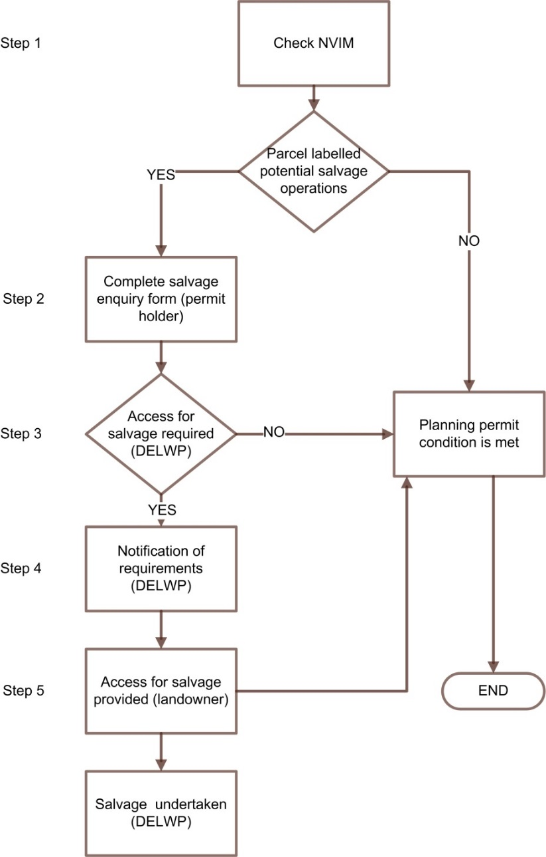

Figure : Salvage protocol decision process

## Step 2: Permit holder provides completed salvage form to DELWP

The salvage enquiry form is available on NVIM and requires the following information:

* planning permit number (if already issued)
* parcel location details
* whether the parcel is within the area labelled as **‘Potential salvage operations’** in NVIM
* if parcel is labelled **‘Potential salvage operations’**, the proposed timing of removal of vegetation and/or habitat (i.e. when will works start, over what period, details of any staging).

## Step 3: DELWP makes decision regarding access for salvage requirements

DELWP will decide whether salvage of Spiny Rice-flower, Matted Flax-lily and/or other flora species is required taking into account:

* The need for additional material for restoration programs, taking into account other flora material already available to DELWP,
* The likelihood of required flora species occurring on the land based on analysis of existing spatial and survey data,
* The size of the population and likely genetic characteristics of Spiny Rice-flower or Matted Flax-lily potentially occurring on the relevant land based on existing data where available or modelled habitat distribution data for the species.

## Step 4: DELWP notifies the permit holder of access for salvage requirements

**DELWP will inform the permit holder of the requirement to provide access for salvage operations no later than 10 business days after receipt of the completed salvage enquiry form.**

If access is not required, DELWP will provide written confirmation (upon request) that no access for salvage is required and that the relevant planning permit condition has been met.

DELWP’s notification of the requirement to provide access for salvage will include specification of the following:

* The timing of the salvage. This may be immediate or may be deferred to the optimal time of year. This will be determined in accordance with the permit holder’s proposed development timing for the relevant land, taking into consideration the recommended timing for salvage of Spiny Rice-flower, Matted Flax-lily or relevant species,
* The relative time that DELWP or its agents will spend salvaging different flora species and whether repeat visits are required to check seed collection bags on target plants,
* The target area for the salvage operations and requirements limiting the use of that area prior to completion of the salvage operations (e.g. temporary fencing, avoidance of the area etc.).

## Step 5: Access for salvage provided

On receipt of notification from DELWP, the Permit Holder will provide:

* permission for DELWP to access the relevant land to undertake any required salvage
* contact details of the site manager to arrange access and any site access requirements.

When the permit holder responds providing permission for DELWP to undertake the salvage operations, the salvage planning permit condition has been met. If requested, DELWP will respond to any written request to confirm this within ten (10) business days.