Nature fencing requirements

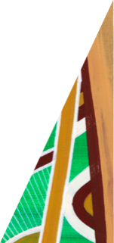
deeca.vic.gov.au

Background 2
Requirements 3
1. Fence styles and specifications 3
2. Secure and safely located access gates for land and emergency management activities 3
Specifications and number of access gates 4
Location along roads 4
Safety provisions 5
Ease of access 5
3. Boundary delineation and associated considerations 5
Placement 5
Wildlife friendly 6
4. Public access 7
Further information 8
Appendix 9

The installation of permanent boundary fencing is an interface requirement for conservation areas and must be delivered to the satisfaction of the Department of Energy, Environment and Climate Action (DEECA).

Background
The Biodiversity Conservation Strategy for Melbourne’s Growth Corridors (BCS) identifies 36 conservation areas that must be protected and managed for conservation purposes in perpetuity. The BCS assigns each conservation area with a management category of ‘growling grass frog (GGF)’ or ‘nature’ conservation.
Conservation areas are located in Melbourne’s growth areas and are being established progressively as new urban precincts are created. Coordinated and consistent requirements for the planning and establishment of conservation areas is necessary to ensure consistency in function, management, visual character, and amenity.
The provision of permanent boundary fencing is required for development to be generally in accordance with the Precinct Structure Plan applying to the land. Planning and delivery of permanent fencing in accordance with a fencing plan is a mandatory planning permit condition for any subdivision of land containing a conservation area.
This document sets out the permanent boundary fencing requirements for nature conservation area land. The purpose of this fencing is to clearly delineate the conservation area boundary, provide protection from unauthorised vehicular access, and support land management activities without compromising the movement of wildlife.
Due to the varying location and features of nature conservation areas, minor variations to the fencing requirements may be considered by DEECA. These will be considered on a case-by-case basis in consultation with the land manager and the relevant council. This document covers key fencing requirements and is not intended to be exhaustive. Nature conservation areas may be subject to additional requirements where necessary.
This document may be updated periodically to reflect current best practice in nature conservation area management and lessons learnt. Access to the most contemporary version is provided at https://www.msa.vic.gov.au/conservation-actions/western-grassland-reserve/bcs-conservation-areas (under ‘Key documents’).

Requirements

1. Fence styles and specifications
The fencing styles for nature conservation areas and the required detail drawings are listed below and provided in the Appendix of this word document version as images (please refer to pdf version of this document for printing drawings to scale). The fence style and associated post/rail material (selected from the options in the specifications) will be determined by DEECA, in consultation with the land manager and council.

Post and cable (two strand)
DEECA – MSA Nature Conservation Area Fencing Details, drawings L2.1 & L2.3.

Post, rail, and cable (two strand)
DEECA – MSA Nature Conservation Area Fencing Details, drawings L2.2 – L2.3.

Post, rail, and cable (single strand)
DEECA – MSA Nature Conservation Area Fencing Details, drawings L2.2 – L2.3 (the single strand details are provided as a notation on the drawing).

DEECA’s detail drawings should be applied to nature conservation areas. The land manger or council may propose variations to these styles and specifications to accommodate site specific features or management needs.
DEECA will consider these proposals on a case-by-case basis, in consultation with the land manager and council. Any approved variations to these fence specifications must be recorded in a new detail drawing, the preparation of which will be coordinated by the requesting party and it must be reviewed and approved by DEECA prior to construction.
Where overhead power lines are present on site, the relevant energy company’s standards for earthing must be considered and integrated into the fence design.

2. Secure and safely located access gates for land and emergency management activities
Nature conservation areas will require ongoing land and asset management, and access for emergency services. Fencing must provide secure access for management personnel to access these areas safely and easily with various management vehicles, trailers, and machinery. Forest Fire Management Victoria (FFMVic) will be responsible for fire management, prevention and suppression activities on certain nature conservation areas and access must meet its requirements.
An access gate location must ensure the following:
- safe access for management vehicles and machinery
- conservation area values are not negatively impacted
- easy access.

Specifications and number of access gates
Access gates must be heavy-duty style with a dual locking mechanism. The required detail drawings are identified below and provided in the Appendix of this word document version as images (please refer to pdf version of this document for printing drawings to scale).

Heavy-duty, dual locking access gate
DEECA – MSA Nature Conservation Area Access Gate Details, drawings L2.4.- L2.5.

The width of all access gates must be a minimum of 4.12-metres clear horizontal open to accommodate management vehicles and machinery, and to be in accordance with FFMVic access requirements. The access location must also provide at least 4.2-metres of clear vertical space for emergency management vehicles (Figure 1).
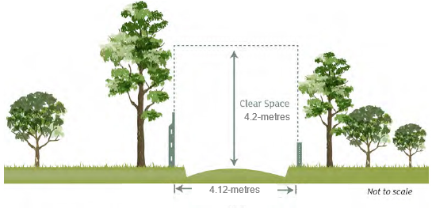
Figure 1: Clear horizontal and vertical space required at nature conservation area access gates (Source: adapted from CFA Access Requirements: Bushfire Management Overlay, August 2014).
Consultation with DEECA and council is required to determine whether land and emergency management access requirements (i.e. the number and location of access points) are satisfied in a proposed fence plan.

Location along roads
The location of access gates along roads must consider the existing and planned road conditions, including traffic volume, speed, and existing/planned infrastructure (e.g. future upgrades/duplications, traffic lights, clearways, pedestrian crossings, intersections, and public transport stops) to ensure safe access.
Access gate locations must avoid:
- Being located on road corners or other locations that obscure the clear view of approaching traffic in either direction.
- Structures/features on the road reserve that may impede visibility, approach and/or access, such as light poles, signposts, above ground services, trees, etc.
Access gates should only be located along minor roads (i.e. access street level 1 and level 2, and connector street) where practical.

Safety provisions
The position of access gates located along roads must enable vehicles with trailers and machinery operators to safely do the following:
- leave the vehicle/machine to unlock and lock the gate, and
- exit and enter traffic on the road.
All access gate locations must demonstrate safe access for management vehicles and machinery to the satisfaction of the relevant authority responsible for road safety.

Ease of access
Access gate locations must provide easy access in accordance with the following:
- A heavy-duty vehicle crossover must be provided at all access gates along roads to enable vehicles and machinery to move safely between the conservation area and the road. The dimensions of the crossover must suit the width of the gate and not be narrower than 4.12-metres in width at any point. It must also smoothly transition to the natural ground surface level if it extends past the gate into the conservation area.
- Where an access point will require crossing of a shared path/pedestrian path, the relevant section of path must also be designed to withstand heavy vehicle use.
- Access gate locations must consider the topography of the conservation area (e.g. avoid directing passage on to a steep incline/decline or area that is not traversable due to rock) and avoid directing passage into sensitive areas (e.g. cultural heritage sites, tree protection zones, high biodiversity areas, wet areas).
- Access gates must provide access in all conditions, considering seasonal variation. For example, an area may be prone to having persistent soft ground during the wetter months, particularly if it is located at the bottom of a slope, making it unsuitable for an access location. Where unavoidable, suitable stabilisation works (subject to DEECA approval) may be required.
- The location of an access gate should allow for vehicles to enter from a relatively straight path of travel, rather than vehicles using turning movements to enter the access gate. This is particularly important for large heavy/rigid vehicles involved in management and fire and emergency activities.
- Access gates must open into the conservation area and must not be located where paths intersect. They must also not open across any path. Paths to be constructed in the conservation area that run parallel to an access gate, should be aligned at this point to avoid conflicting with the access gate when it is in an open position.

3. Boundary delineation and associated considerations
The permanent fence must be constructed on the conservation area boundary and will become the responsibility of the land manager. If a conservation area contains an asset managed by another public authority (e.g. a drainage asset including any maintenance access paths associated with the asset), any fencing required for that asset alone will be the responsibility of the relevant public authority with agreement of the land manager.

Placement
Nature conservation areas will be surrounded by an urban landscape with a variety of interfacing land uses. The placement of fencing needs to consider the surrounding landscape and the conservation area as a whole. An example of this is illustrated in Figure 2.
Fencing may not be required on boundaries:
- where there are existing natural or man-made features that clearly demarcate the conservation area boundary (e.g. garden beds, tree line, existing boundary fencing from adjoining land, etc.)
- that are adjacent to public open space or infrastructure (e.g. parkland, sporting fields, drainage, etc.).
The requirement for fencing on such boundaries will be determined by DEECA on a case-by-case basis, as fencing to prevent unauthorised vehicular access and delineate management boundaries may still be necessary. Different boundary treatments (e.g. a series of bollards) may be used to delineate boundaries between conservation area land and other public land or infrastructure where this boundary is not at risk from unauthorised vehicle access. Natural or sustainable materials should be utilised along such boundaries.
Installations on the road reserve (Figure 3) or other locations near the conservation area may influence the need for boundary fencing. If these provide an effective barrier to vehicles, boundary fencing may not be required. DEECA, the land manager, and council will determine the final outcome in these situations on a case-by-case basis.
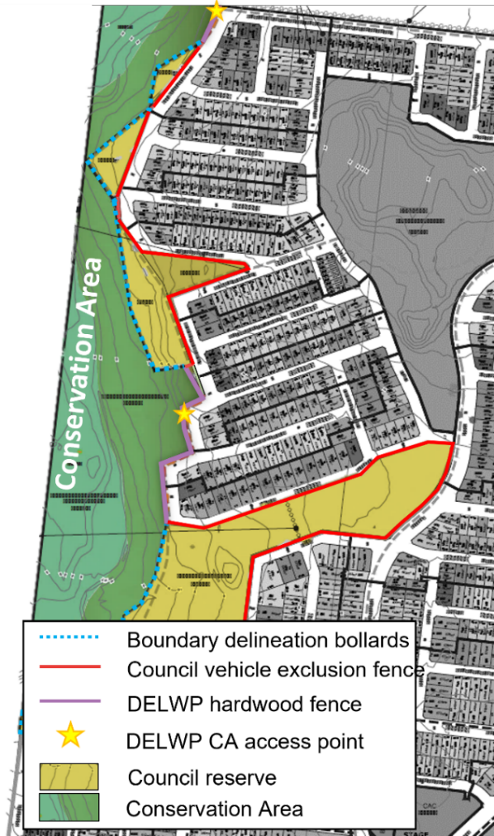  Figure 2: Example of different boundary treatments for road and public open space interfaces (Credit: Villawood Properties). | 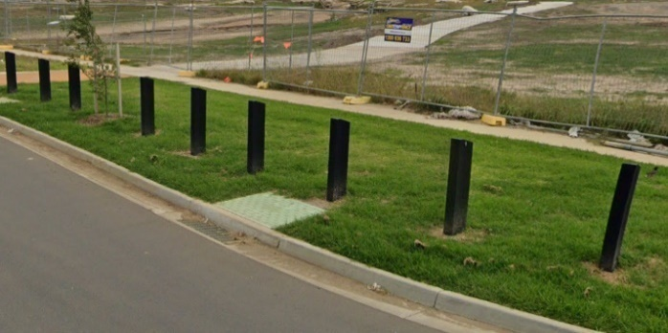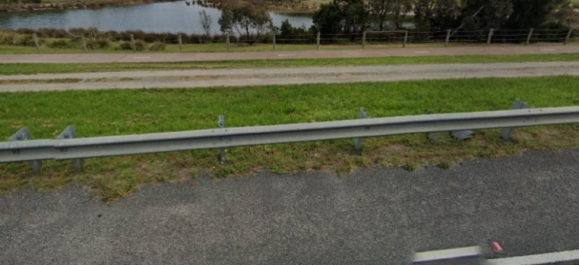  Figure 3: Examples of road reserve installations that may influence the need for boundary fencing if they are near the conservation area. A bollard streetscaping treatment (top), and a road barrier (bottom). (Source: Image capture © 2021 Google).

Wildlife friendly
Fencing around conservation areas must consider the movement of wildlife across the landscape. The fencing must not isolate wildlife populations by preventing their movement in or out of a conservation area. Fencing materials and designs must not create a risk of injury to wildlife.

4. Public access
The primary purpose of nature conservation areas is for conservation. However, where ecological values allow, conservation areas will be accessible to the public to encourage connection to and appreciation of the natural environment. Public access should be encouraged at designated entry/exit points that are linked to existing and planned paths (Figure 4) and in consideration of the urban design of the surrounding area.
Access openings in the fence must suit the width of the path it is connecting to. Generally, these are:
- 1.5-metres for pedestrian only paths
- 3-metres for shared paths.
Access to the conservation area overall must demonstrate compliance with the Disability Discrimination Act 1992 to enable all abilities access, as well as facilitate pram and bicycle use.
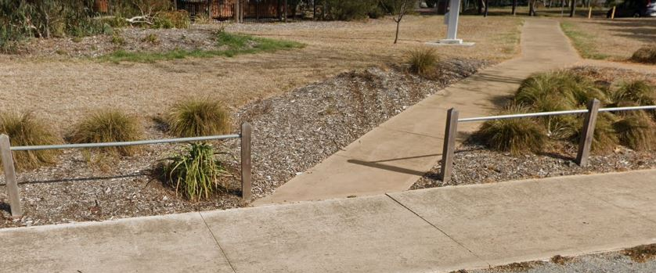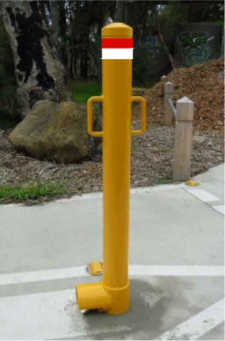
Figure 4: Public access point linked to a pedestrian path (Source: Image capture © 2021 Google). | Figure 5: A high visibility, dual locking bollard (Credit: Melbourne Water).
For access openings associated with shared paths, the installation of a high visibility, dual locking bollard (Figure 5) or similar, is required to prevent unauthorised vehicle access into the conservation area. The bollard must form part of the shared path asset and be included in the path construction.
For high-risk locations, public access points may need to include structures such as a pedestrian gate, corral, bollards, etc. (Figure 6) to deter inappropriate activity in the conservation area. This will need to be determined in consultation with DEECA, the land manager, and council.
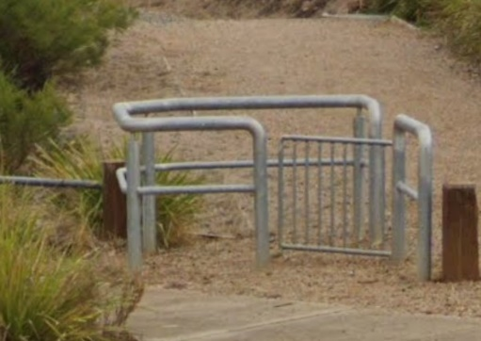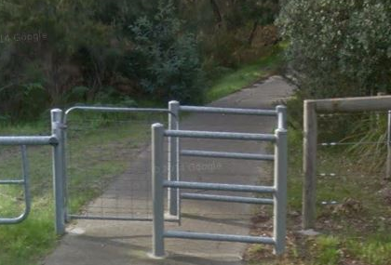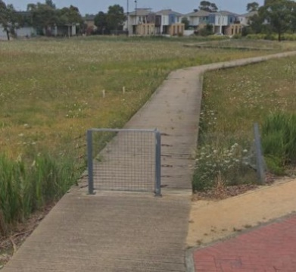
Figure 6: Examples of pedestrian corrals (left, middle) and a pedestrian gate (right). (Source: Image capture © 2021 Google).

Further information
For further information on the requirements for permanent fencing around nature conservation areas, please contact the MSA program at msa.bioconservation@delwp.vic.gov.au.
For further information on the MSA program, please visit the DEECA web page at https://www.msa.vic.gov.au.
We acknowledge Victorian Traditional Owners and their Elders past and present as the original custodians of Victoria’s land and waters and commit to genuinely partnering with them and Victoria’s Aboriginal community to progress their aspirations.
© The State of Victoria Department of Energy, Environment and Climate Action July 2023.
Creative Commons
This work is licensed under a Creative Commons Attribution 4.0 International licence, visit the Creative Commons website (http://creativecommons.org/licenses/by/4.0/).
You are free to re-use the work under that licence, on the condition that you credit the State of Victoria as author. The licence does not apply to any images, photographs or branding, including the Victorian Coat of Arms, and the Victorian Government and Department logos.
ISBN 978-1-76136-328-3 (pdf/online/MS word)
Disclaimer
This publication may be of assistance to you but the State of Victoria and its employees do not guarantee that the publication is without flaw of any kind or is wholly appropriate for your particular purposes and therefore disclaims all liability for any error, loss or other consequence which may arise from you relying on any information in this publication.
Accessibility
To receive this document in an alternative format, phone the Customer Service Centre on 136 186, email customer.service@delwp.vic.gov.au, or contact National Relay Service on 133 677. Available at DEECA website (www.deeca.vic.gov.au).

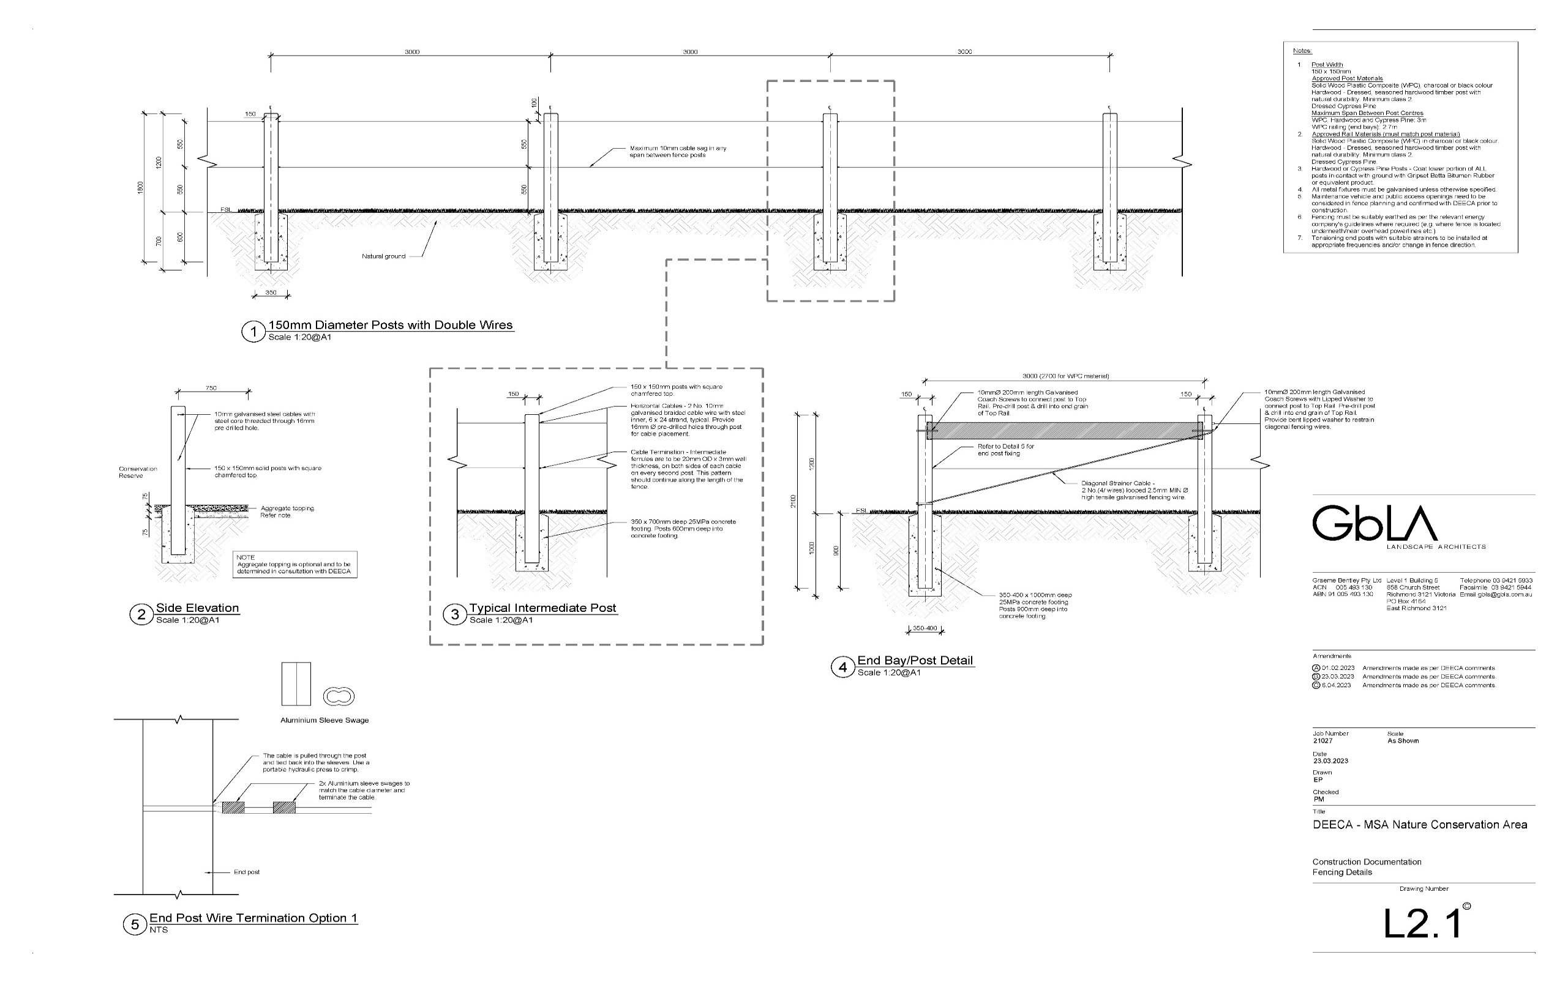
Appendix

