Victorian Grassland Earless Dragon Prescription Frequently Asked Questions
Information for landowners and developers in the Melbourne Strategic Assessment area
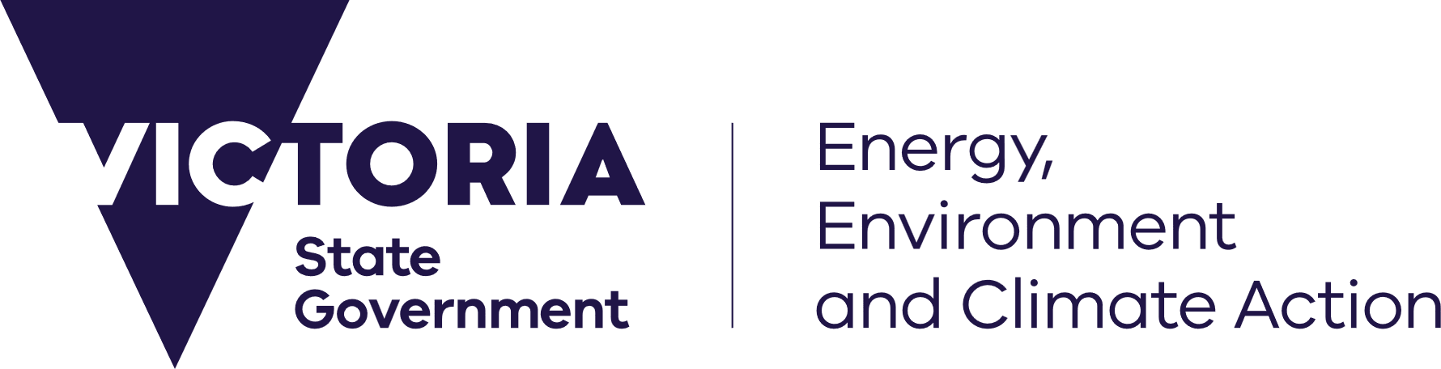





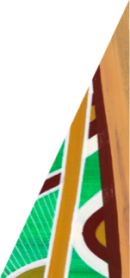
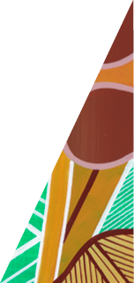

deeca.vic.gov.au

Q.
What is the Victorian grassland earless dragon?
A.
The Victorian Grassland Earless Dragon (VGED) is a small lizard (reptile) measuring just 15 centimetres from head to tail when fully grown. Unlike most lizards, it does not have external ear openings. The VGED is likely an annual species, maturing within one year and living for less than two. This makes it vulnerable to population fluctuations following poor conditions or significant disturbance.
Thought to be extinct, the Victorian grassland earless dragon (VGED) was rediscovered west of Melbourne in 2023. The VGED is a Matter of National Environmental Significance (MNES) under the Environment Protection and Biodiversity Conservation Act 1999 (EPBC Act) and is regulated by the Commonwealth Government. The species is also protected under the Victorian Flora and Fauna Guarantee Act 1988.
Q.
What is the Melbourne Strategic Assessment Program?
A.
The Melbourne Strategic Assessment (MSA) Program is one of Australia’s largest urban conservation programs. Delivered through the Department of Energy, Environment and Climate Action (DEECA), the program was developed to balance the need for housing in Melbourne’s growth areas with protection of our most threatened species and ecosystems.
A State and Commonwealth Government agreement under EPBC Act, the program ensures that development in Melbourne’s growth corridors follows strict Victorian and Commonwealth environmental laws. It streamlines the approvals process for developers who must follow certain requirements including paying the MSA levy, as required under the MSA (Environment Mitigation Levy) Act 2020. The levy goes towards funding the creation and management of conservation areas and programs for vulnerable species.
The MSA Program provides regulatory certainty and clarity for developers while supporting the delivery of the Victorian Government’s Housing Statement in Melbourne’s growth areas.
In all, the Program will establish more than 20,000 hectares of conservation areas and reserves in Melbourne’s newest suburbs and support a range of threatened species such as the southern brown bandicoot, growling grass frog, golden sun moth, matted flax-lily and spiny rice-flower. For more on the MSA Program and the areas it covers, see msa.vic.gov.au.

Q.
How does the MSA Program address the rediscovery of VGED?
A.
The Commonwealth has approved a Prescription under the Melbourne Strategic Assessment (MSA) Program, to address the rediscovery of VGED and to avoid and mitigate impacts to the species from urban development in the MSA Program area.
The VGED Prescription guides how the MSA Program will manage any impacts to the VGED and provides clear information for developers about VGED conservation activities, including habitat assessments and targeted surveying, that will be carried out by the Victorian Government.
The Prescription ensures:
- protection and management of VGED habitat within MSA Conservation Areas and reserves (Western Grassland Reserve, Grassy Eucalypt Woodland Protected Area, and any areas secured to deliver conservation outcomes for golden sun moth, matted flax-lily and spiny rice-flower)
- habitat assessments and targeted surveys to identify any VGED populations in areas modelled as VGED habitat in the MSA Program area
- potential in-situ management and relocation activities if VGED are found.
More than 13,000 hectares of potential VGED habitat will be protected in MSA Conservation Areas, the Western Grassland Reserve and Grassy Eucalypt Woodland Protected Area, and additional areas are to be secured to achieve conservation outcomes for golden sun moth, matted flax-lily and spiny rice-flower.
Q.
What does the VGED Prescription mean for developers and landowners in the MSA Program area?
A.
The VGED Prescription commits the Victorian Government to conducting habitat assessments and surveys to avoid and mitigate impacts to the species in the MSA area. Habitat assessments and surveys will be undertaken based on a 3-tiered approach (see VGED fact sheet) considering the planning and development status of the land:
- Scenario 1: Precinct Structure Plan (PSP) not yet complete (Victorian Planning Authority-led)
- Scenario 2: PSP complete, planning permit not yet issued (MSA-led)
- Scenario 3: PSP complete, planning permit already issued (MSA-led)
DEECA will work with the Department of Transport and Planning (Victorian Planning Authority) to deliver VGED surveys. Targeted surveys will only be conducted where modelled, potential habitat is confirmed on-ground through an initial habitat assessment. Surveys will be timed to avoid disrupting planning and construction schedules to the extent possible.
Where planning permits have already been issued, planning permit conditions will not apply retrospectively. If VGED are found, they will be relocated with no ongoing in-situ management required.
By supporting access to land, developers and landowners can confirm the absence of VGED early on and continue with their projects under MSA approvals.

Q.
What happens if VGED are found?
A.
The chances of discovering VGED are very low. In the unlikely event VGED are found in Land Status Scenarios 1 and 2, the Victorian Government will develop a Conservation Management Plan to be approved by the Commonwealth Government, which may involve activities such as in-situ management and/or relocation.
Any VGED found in Land Status Scenario 3 will be relocated and guided by the Rediscovery response protocol for a listed GED as detailed in the National Recovery Plan. If VGED are not identified through any targeted surveying, there are no further implications for future development.
Q.
Who will carry out the VGED habitat assessments and targeted surveys and how will they be funded?
A.
VGED habitat assessments and targeted surveys undertaken by the Victorian Government will be funded by the MSA Program (from the Environment Mitigation Levy). In some cases, landowners may choose to do their own surveys following current, published advice on survey approach for VGED and to DEECA’s satisfaction.
Q.
How will the VGED habitat distribution model (HDM) support the planning system?
A.
The VGED HDM is one of several tools to help planners, developers and decision-makers identify potential location of VGEDs and consider the potential impacts of land use changes on the species.
Environmental assessments are prepared based on field surveys and analysis of environmental data. When environmental assessments are undertaken in locations of potential habitat, they should include consideration of VGED within their scope. The Commonwealth Department of Climate Change, Energy, the Environment and Water (DCCEEW) has published survey guidance for VGED to support field surveys available here: Survey guidelines for Four Grassland Earless Dragons (Tympanocryptis spp.) of Southeast Australia and any VGED surveys should also follow a survey approach approved by DEECA.
The VGED HDM will help target effort in environmental assessments, providing greater confidence and clarity to the planning and development sectors. Please visit the Victorian Grassland Earless Dragon Habitat Distribution Model web page for information about the HDM, and access to a map of the HDM and spatial data.
Q.
Are planning rezoning approvals (including PSPs) impacted by the rediscovery of the VGED?
A.
The rezoning approvals process (including PSPs) is not impacted by the rediscovery of the VGED as there are existing processes in place to identify and manage VGED (as a MNES) within PSP areas.
The VGED habitat distribution model will assist the Victorian Planning Authority (VPA) and councils to deliver planning rezoning proposals (including PSPs) by informing VGED identification, conservation and recovery efforts. DEECA will continue to support councils and the VPA to meet these requirements.

Q.
What is required for developers and landowners outside the MSA Program area?
A.
Outside of the area covered by the MSA Program, standard regulatory environmental approval requirements apply.
Proposals to rezone and develop land must continue to comply with the existing requirements under the EPBC Act to assess if a development may have an impact on ‘protected matters’ including VGED and consider how proposals may impact the environment as required in the Victorian planning system.
These processes may include conducting field surveys and self-assessing whether a referral to the Commonwealth Government is necessary under the EPBC Act. See dcceew.gov.au/environment/epbc/approvals#decide -whether-to-submit-a-referral.
Planning authorities including councils and the VPA have always needed to consider biodiversity impacts under the Planning and Environment Act 1987 (Victorian Government), the EPBC Act (Commonwealth Government) and the FFG Act (Victorian Government) in the strategic planning phase of proposed urban growth areas and in preparation of rezoning proposals (including PSPs). These matters are also relevant to the planning permit process. Field survey results may be used to support a proposal to use and develop land. For more information on planning requirements, see planning.vic.gov.au.
The VGED habitat distribution model (HDM) will assist the VPA and councils to deliver PSPs by identifying areas of potential VGED habitat and informing VGED identification, conservation and recovery efforts. To view the VGED HDM, see environment.vic.gov.au/conserving-threatened-species/victorian-grassland-earless-dragon-habitat-distribution-model.
For more information on landowner and developer obligations outside the MSA area, see vpa.vic.gov.au/planning-in-areas-that-include-potential-victorian-grassland-earless-dragon-habitat/.
Q.
What else is the Victorian Government doing to protect the VGED?
A.
The Victorian Government is working with a range of partners and stakeholders as part of a VGED Recovery Team to support VGED conservation efforts. Chaired by Zoos Victoria, the VGED Recovery Team includes representation from species experts, geneticists, husbandry and ex-situ breeding experts, wildlife ecologists, and both the Victorian and Commonwealth Governments.
DEECA has prepared a VGED action statement as required under the Flora and Fauna Guarantee Act 1988, which is available on DEECA’s website. This will sit alongside the Commonwealth’s National Recovery Plan for Four Grassland Earless Dragons of Southeast Australia. Both documents will outline management actions to support species conservation and recovery. Victoria has provided input into the Commonwealth’s National Recovery Plan.
DEECA also supports the successful conservation breeding program established by Zoos Victoria which is focused on ensuring the ongoing survival of the VGED and preparing populations for reintroduction and release in the future.

