Meeting the condition: Security of conservation land
  - MSA Planning Guidance Note 1
April 2023

This guidance note provides advice about the condition ‘security of conservation land’ applying to any subdivision of land in the Melbourne Strategic Assessment program area that contains a conservation area as identified in the relevant Precinct Structure Plan.

About
Landowners who subdivide land containing a ‘conservation area’ identified in the relevant Precinct Structure Plan (PSP) are required to meet the ‘security of conservation land’ planning permit condition (see Box 2).
The condition to secure conservation area land has been updated through planning scheme amendment VC213 to achieve a more consistent and streamlined conservation land security process. The need to secure conservation area land is consistent with the requirements of the Biodiversity Conservation Strategy for Melbourne’s Growth Corridors, DEPI 2013 (BCS) under the Melbourne Strategic Assessment Program (MSA).
This document provides guidance on the options for landowners to meet the requirements of the condition and ensure that the conservation area land is protected and secured for conservation purposes in perpetuity.
Box 1. Key steps to meet the condition requirements.

Key Steps:
- Create conservation area lot as part of the plan of subdivision or plan of subdivision for the first stage of subdivision in the case of any staged subdivision.
- Enter into the relevant agreement (s 173 or s 69) drafted using DEECA's standard templates (prior to SoC for the subdivision/first stage of subdivision).
- Cause the agreement to be registered on title (prior to lodgement of the plan of subdivision /first stage plan of subdivision for registration).
- Fulfill requirements of relevant agreement:
  - s 173 Agreement: Meet land condition requirements and transfer conservation area land to the Minister at the trigger nominated in the agreement (e.g. part of the final stage of subdivision).
  - s 69 Agreement: Protect and manage conservation area land in perpetuity in accordance with the Conservation Management Plan prepared for and detailed in the agreement.

Background
The BCS identifies 36 conservation areas throughout Melbourne’s Growth corridors that are to be secured for conservation purposes in perpetuity.
Implementation of the BCS including the protection and securing of the conservation areas is a condition of Commonwealth approvals under the Environment Protection and Biodiversity Conservation Act 1999 (EPBC Act) for the urban development of Melbourne’s Growth Corridors.
Securing conservation areas in practice is achieved through the transfer or vesting of conservation area land (and associated management requirements) to the Minster for Environment (Minister). The land will then be surrendered to the Crown where it is reserved for conservation purposes. The land will be managed for conservation purposes in perpetuity by the nominated Crown land manager.
Alternatively, where landowners wish to retain ownership of the land, conservation areas can be secured by entering into an on-title Land Management Cooperative Agreement (LMCA). The agreement will restrict future changes to the land and include requirements to manage the land for conservation outcomes at the landowner’s cost, in perpetuity.
The BCS requirement to secure conservation areas is implemented through the planning scheme by the inclusion of the condition ‘security of conservation land’ in relevant Urban Growth Zone schedules.
Box 2. Wording of condition.
Condition – Security of conservation land
The owner of the land must, as part of the plan of subdivision (or the first plan of subdivision submitted for registration, in the case of any staged subdivision), create the 'conservation area' as a separate lot or reserve. The boundaries of the lot or reserve on the plan of subdivision are subject to the prior satisfaction of the Secretary to the Department of Environment, Land, Water and Planning as constituted under Part 2 of the Conservation, Forests and Lands Act 1987 (Secretary). The owner must further secure the conservation area, by causing that lot or reserve to be vested, transferred, or protected in perpetuity in one of the following ways:
- Prior to a statement of compliance being issued for the plan of subdivision (or, in the case of a staged subdivision, the plan of subdivision or masterplan which implements the first stage of the subdivision), enter into an agreement under section 173 of the Planning and Environment Act 1987 by which the owner agrees to transfer ownership of the conservation area to, or to vest the conservation area in, the Minister responsible for section 5 of the Crown Land (Reserves) Act 1978, the Council or Melbourne Water. The transfer or vesting must either be for no or nominal consideration. The Secretary and the person or body to whom the land is to be transferred or vested must also be a party to the agreement. The terms of the agreement must include that the owner pays the reasonable costs of the other parties to the agreement that were incurred for the preparation, execution, and registration of the agreement. The owner must cause the agreement to be registered prior to lodgement of the plan of subdivision for registration; or
- Prior to a statement of compliance being issued for the plan of subdivision (or, in the case of a staged subdivision, the plan of subdivision or masterplan which implements the first stage of the subdivision), enter into an agreement with the Secretary under section 69 of the Conservation, Forests and Lands Act 1987, which provides for the conservation and management of the conservation area by or on behalf of the owner in perpetuity. The terms of the agreement must include that the owner pays the reasonable costs of the Secretary incurred for the preparation, execution, and registration of the agreement. The owner must cause the agreement to be registered prior to lodgement of the plan of subdivision for registration.
The requirement to include the above condition does not apply if the permit applicant provides the responsible authority with a statement in writing from the Secretary, as constituted under Part 2 of the Conservation, Forests and Lands Act 1987, that the condition is not required because the Secretary is satisfied that either:
- the land containing the conservation area is expected to be further subdivided and a further planning permit will be required for that subdivision (to which the above condition requirement will apply); or
- the conservation area has been or will be otherwise secured in perpetuity.

When land security obligations are triggered, and the condition is applied
The formal trigger for securing the conservation areas is any subdivision of land containing a conservation area. Under the relevant Urban Growth Zone schedules a permit to subdivide land containing a ‘conservation area’ as shown in the relevant precinct structure plan must include the condition ‘security of conservation land.’
You can check if part of your property includes a conservation area by visiting https://mapshare.vic.gov.au/msa/ and searching for your property address or by viewing your property on the map.
Be sure to have the ‘MSA Conservation Area’ layer turned on under the ‘Layers’ tab:
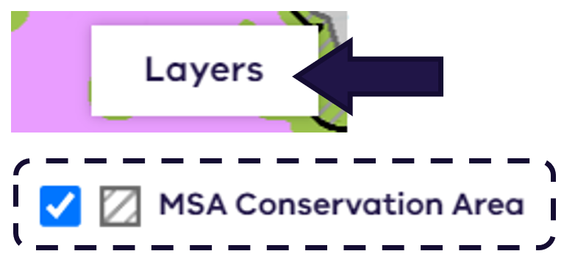
Example of a property containing conservation area land as shown on the MSA Mapshare tool:
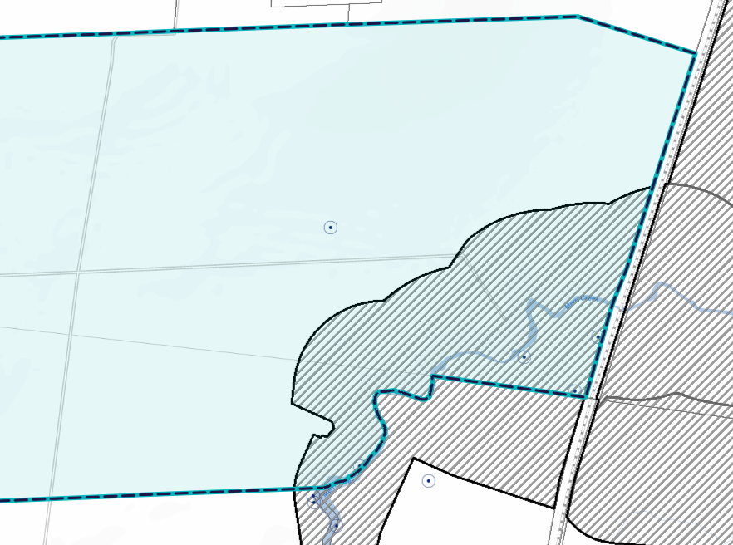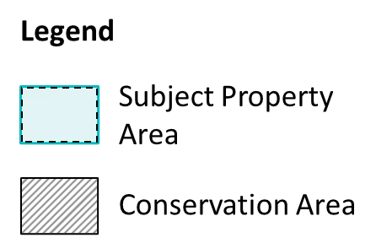

What must be done to meet the condition
A plan of subdivision must create the 'conservation area' as a separate lot or reserve. For a staged subdivision this must be done on the first plan of subdivision submitted for registration.
The boundaries of the conservation area lot on the plan of subdivision must be consistent with the current conservation area boundary as defined by dataset ‘MSA_BCS_CONS_AREA’ available at DATA VIC (https://discover.data.vic.gov.au/dataset/conservation-areas-in-the-biodiversity-conservation-strategy).
The owner must further secure the conservation area, by causing that lot or reserve to be transferred or vested to the Minister, or protected in perpetuity in one of the following two ways:

Option 1 – Secure through the section 173 (P&E Act) Agreement pathway
A landowner may enter into a section 173 agreement under the Planning and Environment Act 1987 (P&E Act) which allows the transfer or vesting of the conservation area to the Minister under section 5 of the Crown Land (Reserves) Act 1978.
A s 173 agreement must be entered into prior to statement of compliance (SoC) for the first plan of subdivision being issued. The agreement must then be registered on title prior to lodgement of the plan of subdivision for registration with the Titles Office.
Meeting the condition Option 1: Once the s 173 agreement has been registered on title the ‘security of conservation land’ condition can be considered met for the purposes of issuing statement of compliance for the subdivision/first stage of subdivision.
The point at which the landowner must transfer or vest the conservation area land will be specified in the s 173 agreement. The transfer or vesting will be required as part of an agreed stage of the subdivision where all development adjacent to the conservation area is complete.
All land condition requirements must be met prior to the vesting or transfer of the conservation area. For guidance on land condition requirements please refer to DEECA requirements for conservation area land security under the Melbourne Strategic Assessment.
The method of transfer or vesting specified in the s 173 agreement will be consistent with the options outlined within Table 1. For more information on the vesting and transfer process contact msa.bioconservationareas@delwp.vic.gov.au.
Table 1. Land transfer options
Conservation Area Type | Transfer options
Growling Grass Frog Conservation Areas | - Vesting in or transferring of the land to the Minister or relevant public authority for nominal consideration ($1, if demanded).
Nature Conservation Areas | - Land purchased by the Minister at market value at the time of transfer.  - Vesting in or transferring of the land to the Minister or relevant public authority for no or nominal consideration ($1, if demanded). This option may be undertaken if the landowner does not wish to go through the valuation process.  - Transfer to the Crown for reduction of MSA Levies equal to the market value of the conservation area.
Regional Parks | - Acquired through the Metropolitan Park processes.

Option 1 (cont.) – Facilitating transfer of the land via the agreement

Preparing the s 173 agreement
DEECA will provide a s 173 agreement template that will be used to draft the conditions for the transfer of ownership and management requirements of a conservation area to the Minister. For a copy of the agreement template please contact DEECA’s MSA Conservation Planning team at msa.planning@delwp.vic.gov.au.

Preparing the Plan of Subdivision and transferring the Conservation Area
To facilitate transfer of conservation area land, the s 173 agreement requires that a plan of subdivision is prepared that:
- Shows the boundaries of the conservation area lot to be transferred to the Minister.
- Shows the agreed boundaries of any lots, reserves, or roads within the conservation area. These should be shown as separate lots/reserves to the conservation area lot to be transferred to the Minister. This may apply where DEECA has approved assets and infrastructure to the located within the conservation area. This could include reserves for:
  - stormwater assets
  - passive recreations spaces
  - existing or future roads
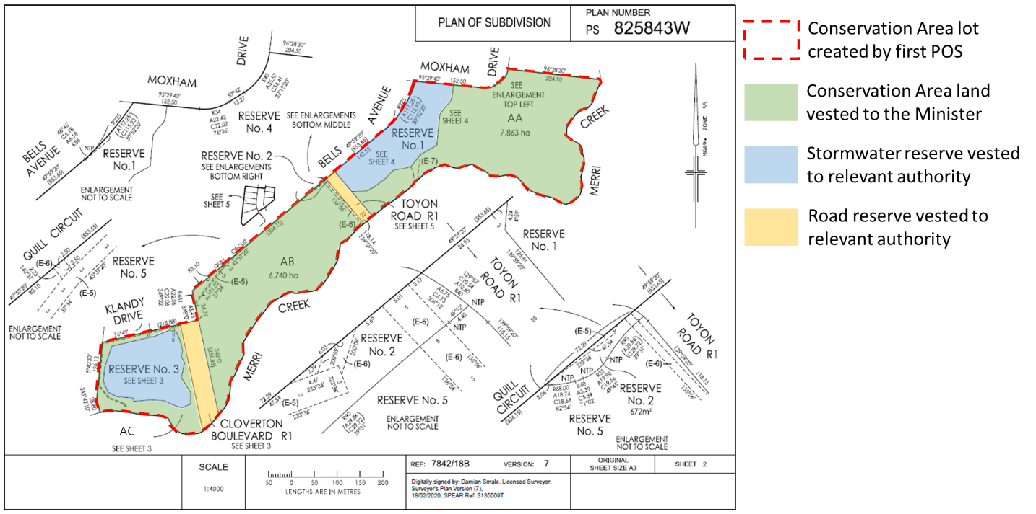
Figure 1. Example POS showing conservation area lot to be vested to the Minister and other approved reserves within the conservation area to be vested to the relevant authorities.

- Vests the conservation area lot to the “Minister for Environment”, and any reserve to the relevant public authority.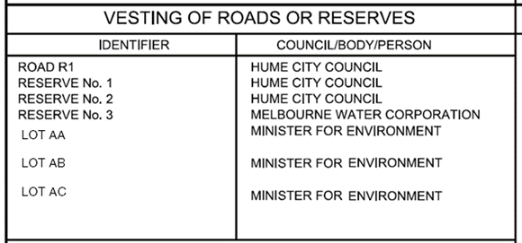
- The plan of subdivision must be submitted to DEECA for review and endorsement. Any requested amendments must be made to the plan of subdivision.

Transferring the conservation land
Once the plan of subdivision required by the s 173 agreement has been drafted the following steps should be taken to facilitate transfer of the conservation land:
- Written confirmation must be obtained from DEECA that the land condition requirements detailed in the DEECA requirements for conservation area land security under the Melbourne Strategic Assessment have been met.
- The owner must then do all things reasonably necessary for the Registrar of Titles to update the Certificate of Title for the Land to record the Minister as the registered proprietor. This includes submitting the endorsed plan of subdivision for registration to the Titles Office.
These actions must be undertaken prior to the nominated timeframe in the agreement (e.g. prior to certification of the final stage of subdivision for the permit) or within 5 years of the commencement of the agreement.
The process for securing the conservation area via a s 173 agreement is detailed in Appendix 1.

Option 2 – Secure through the section 69 (CFL Act) Agreement pathway
A landowner may enter into a Land Management Co-operative Agreement (LMCA) under section 69 of the Conservation, Forests and Lands Act 1987 (CFL Act) that will be registered against the title of conservation area.
The agreement must be entered into prior to SoC for the first plan of subdivision being issued. It must then be registered on title prior to lodgement of the plan of subdivision for registration with the Titles Office.
The LMCA will require that the landowner manages and maintains, at their own cost, the conservation area for conservation purposes in-perpetuity. Management of the conservation area will be in accordance with a Conservation Management Plan (CMP) prepared for the site by a suitably qualified ecologist/conservation land management consultant. The CMP must be to the satisfaction of DEECA and will form a schedule to the agreement.
The agreement will restrict any further works, uses, or development on the conservation area land that is inconsistent with the CMP or conservation objectives of the MSA program. Landowners will be required to monitor and regularly report to DEECA on the implementation of the agreement.
The requirements of the agreement will commence once the agreement has been registered to the title and will apply in-perpetuity or until such a time that the landowner may opt to transfer or vest the land to the Minister via voluntary processes.
Meeting the condition Option 2: Once the s 69 agreement has been registered on title the ‘security of conservation land’ condition can be considered met for the purposes of issuing statement of compliance for the subdivision/first stage of subdivision.
The pathway for securing the conservation area via a s 69 agreement is detailed in Appendix 1.

Preparing the s69 agreement
DEECA will use a standard LMCA template to draft the agreement for the subject land. The draft agreement will be provided to the landowner for review.
To request a copy of the template or for more information on entering into a s 69 agreement and required details, including the process to prepare the agreement and the conservation management requirements, contact DEECA’s Biodiversity Conservation Areas team at msa.bioconservation@delwp.

When this condition is not required:
In some limited instances DEECA will not require the security of conservation land condition. Specifically, the condition may not be required if the Secretary is satisfied that either:
- the land containing the conservation area is expected to be further subdivided and a further planning permit will be required for that subdivision (to which the security of conservation area land will apply). This applies to cases where a significant portion of developable land will remain on the same title as the conservation area following the proposed subdivision; or
- the conservation area has been or will be otherwise secured in perpetuity. For example, through a separate voluntary transfer process.
For further information on meeting the condition contact msa.planning@delwp.vic.gov.au

Keep all content above this instruction text line. Delete only when document formatting is complete.

Appendix 1 – Conservation Area Land Security Process Flow Chart

Typical process for securing the conservation area land via either s173 agreement under the P&E Act or s69 agreement under the CFL Act.
Option 2:
s 69 Agreement Pathway
Option 1: s 173 Agreement Pathway
Land condition requirements met
Certification and SoC for subsequent stage(s) of subdivision
Enter into s69 agreement to secure and manage conservation area land
Conservation area land protected and managed in perpetuity by land owner as per the Conservation Management Plan.
Agreement registered on CA lot title
SoC for first stage of subdivision
Enter into s173 agreement to secure conservation area land
Planning Permit application for subdivision of land containing a conservation area
SOC for last stage of subdivision (or other trigger as specified in the s.173 Agreement)
POS creating separate lot for conservation area
Land reserved for conservation and managed by the nominated public land manager.
CA land vested to Crown (under s.5 of the CLR Act) at point in the development process as nominated in s.173 agreement
Agreement registered on CA lot title
SoC for first stage of subdivision
Certification for first stage of subdivision

Planning Permit issued with ‘Security of conservation land condition

