Meeting the condition: Fencing of conservation areas
MSA Planning Guidance Note 2
October 2023
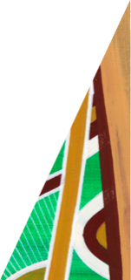
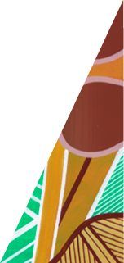
This guidance note advises on preparing a Fencing Plan to meet the condition ‘Fencing of conservation areas.’
deeca.vic.gov.au

About
This document provides guidance on Fencing Plan preparation to meet the planning permit condition ‘fencing of conservation areas.’ Fencing plans ensure that conservation area land is properly fenced for protection during development and on-going management as a conservation reserve.
Landowners who subdivide land, construct a building, or carry out works on land containing or abutting a ‘conservation area’ under the Department of Energy, Environment and Climate Action (DEECA)’s Melbourne Strategic Assessment (MSA) program must meet the condition. Conservation areas are identified in the relevant Precinct Structure Plan (PSP) or via the MSA Mapshare.
Box 1. Key steps to meet the condition requirements

Key Steps:
- Prepare a fencing plan that is consistent with the guidance provided in this document and:
  - DEECA Requirements for Growling Grass Frog Conservation Area Permanent Fencing, or
  - DEECA Requirements for Nature Conservation Area Permanent Fencing
- Submit the plan to DEECA’s MSA Conservation Planning Team for review and approval.
- Implement the plan as part of the development permit.
  - Ensure temporary protective fencing requirements are incorporated into the relevant Construction Environment Management Plans.
  - Ensure ultimate fencing and access requirements are translated to relevant Functional Layout Plans and Landscape Plans for construction and delivery.
  - Inspections will be undertaken by DEECA to confirm fencing requirements have been installed satisfactorily.

Background
An important part of protecting conservation area land is through appropriate fencing– guided and coordinated by the fencing plan.
The Biodiversity Conservation Strategy identifies 36 conservation areas throughout Melbourne’s Growth corridors that are to be secured for conservation purposes in perpetuity.
Implementation of the BCS including the protection and securing of the conservation areas is a condition of Commonwealth approvals under the Environment Protection and Biodiversity Conservation Act 1999 (EPBC Act) for the urban development of Melbourne’s Growth Corridors.

What must be done to meet the condition
The relevant permit holder must prepare a fencing plan that coordinates the implementation and delivery of fencing to ensure the protection and management of conservation area land. The fencing plan must be submitted to DEECA for review and approval. The approved plan will form part of the permit and must be implemented to the satisfaction of DEECA and the responsible authority.
Box 2. Wording of condition
Condition – Fencing of conservation areas
Prior to the commencement of development, a conservation area fencing plan must be submitted to and approved by the Secretary to the Department of Environment, Land, Water and Planning (as constituted under Part 2 of the Conservation, Forests and Lands Act 1987) (Secretary) to ensure the conservation area is adequately protected. The fencing plan must contain the following:
- The boundaries of any conservation area, and the location of any scattered tree and the boundaries of any patch of native vegetation within the conservation area.
- The location and alignment of temporary protection fencing showing the following minimum distance from the element to be protected:
Element | Distance
Conservation area | 0.5 metres
Scattered tree | 12 x diameter at a height of 1.3 metres
Patch of native vegetation | 2 metres
- The timing of installation and removal of temporary protection fencing.
- The timing of installation of permanent fencing.
- Location and details of ongoing maintenance vehicle access points.
- The type of temporary and permanent fencing including materials, heights and spacing of uprights.
- Frequency of inspections and rectification works for temporary protection fencing.
Once approved the plan will form part of the permit and must be implemented to the satisfaction of the Secretary to the Department of Environment, Land, Water and Planning and the responsible authority.
Stockpiles, fill, machinery, vehicle parking, excavation and construction activity of any kind must not be bought into, or be undertaken within, the area to be fenced, except with the prior written consent from the Secretary.
Typically fencing should be considered in two phases:
- Semi-permanent protective fencing installed prior to works to protect the conservation area during the development period.
- Permanent fencing installed through the development process to ensure on-going protection of the conservation area.
The alignment of boundary fencing must be consistent with the current conservation area boundary as defined by the dataset ‘Conservation Areas in the Biodiversity Conservation Strategy’ available at DATA VIC or viewable via the MSA Mapshare.
What to show on a Fencing Plan
The Fencing Plan must detail the specifications and designs of all fencing and gates to be installed as required by the plan. This includes for:
- Semi-permanent temporary fencing
- Permanent fencing
- Maintenance access gates
- Any temporary farm style or other internal boundary fencing/ maintenance delineation treatment.
The Fencing Plan should include a site plan that shows the alignment of all relevant fencing through the life of the development. The plan must show the locations of permanent maintenance access locations.
To determine if maintenance access locations are appropriate and meet future management needs of the conservation area, additional details and features must also be shown on the plan.
Specific details to be shown on a site plan(s) as part of the Fencing Plan are detailed in Table 1. Appendix 1 shows an example fencing plan layout.
Table 1. Specific details that must be shown on a Fencing Plan site plan.
Semi-permanent temporary fence alignment | Specifications consistent with Item 5 of the DELWP Requirements for CEMPs
Permanent fence alignment | Specifications consistent with the DEECA Fencing Requirements
Internal reserve delineation | Through bollards, landscaping, shared paths etc. (e.g. for a stormwater reserve in the conservation area)
Maintenance access gate locations | This must include the requirement for a heavy-duty vehicle crossover
Road network | From the endorsed subdivision plan
Conservation area contours | Data available from Data Vic
Native vegetation patches, significant flora records within the conservation area | Timestamped data available from Data Vic
Growling Grass Frog Areas of Strategic Importance | Data available from Data Vic
Any obstacles or barriers to movement into and within the conservation area | This could include:  - Existing wind break trees  - Drainage lines (incl. future constructed waterways)  - Future infrastructure (roads, bridges, paths, stormwater wetlands etc.)  - Steep embankments or other landscape features (e.g. stony knolls)
Any future ‘way’ easements | To allow maintenance access through land managed by other authorities

Additional Fencing Plan details
Timing
The fencing plan must detail the timing of installation for both the semi-permanent protective fencing and the ultimate interface fencing/treatment.
Timing of fencing installation should consider the following principles:
Semi-permanent protective fencing
- Installation must be prior to any works occurring on or within 50 metres of the conservation area.
- Installation can be for the entire boundary of the conservation area or staged with the progression of adjacent works (note, works for each stage must not commence until semi-permanent protective fencing has been installed).
- Installation timing should consider any wildlife movement requirements under an endorsed Kangaroo Management Plan.
- Removal must be staged and coordinated with the installation of the ultimate fencing to ensure the conservation is at no time unprotected.
Ultimate permanent fencing/interface delineation treatment
- Maintenance access crossovers into the conservation area must be delivered as part of the road and drainage civil works for relevant adjacent stages of development.
- Installation of the permanent fencing/interface delineation must be delivered with the landscaping for relevant adjacent stages of development or open space.
It will be the responsibility of the developer to manage the permanent fence and interface whilst they remain the owner of the conservation area land. Prior to transfer of the land any defects with the fencing must be rectified.

Safe access considerations
When nominating maintenance access locations in the Fencing Plan the following principles should be considered:
- Ensure clear lines of site (including future streetscape landscaping).
- Avoid access from the end of T intersections.
- Avoid access from main thoroughfare/high traffic roads (e.g. arterial roads).
- Avoid access which may intersect with a shared trail.
- Avoid access locations into steep sections, obstacles, or barriers.
Where the road network is elevated above the natural surface level of the conservation area it may be necessary to ensure the Fencing Plan considers the need for a stabilised access ramp. Example specifications are:
- Ramp should be stabilised by stripping top soil and replacing with a 100mm crushed rock with some clay, and then compacted.
- Ramp top coat to be 100mm of 20mm crushed rock with 3% stabiliser.
Additional Fencing Plan details (cont.)
- Where there is potential for surface cross flows, drainage should be provided, e.g. 150mm pipe with 2 x concrete headwalls. Pipe to be backfilled with 20mm crushed rock and compacted as per MWC standard drawing 7251/08/419.
- Concrete crest to be equal to top of road curb and channel.
- Ramp grade/ angle to be typically 6 degrees.
- Ramp width to be minimum 4 metres wide.
Example details:

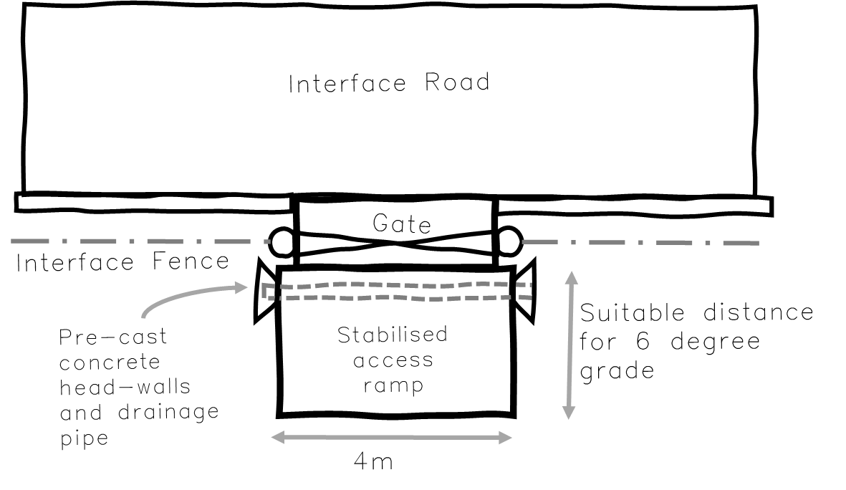
Figure 1. Access ramp plan view

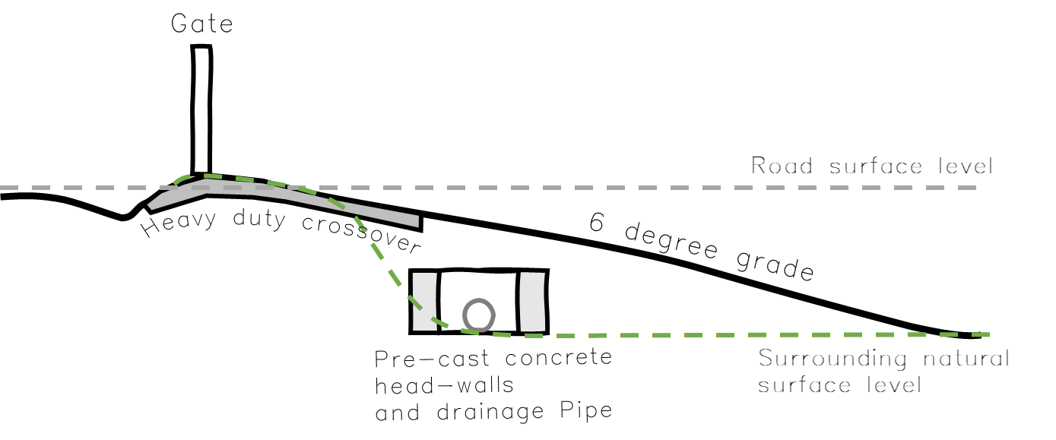
Figure 2. Access ramp cross-section

Additional Fencing Plan details (cont.)

Plans informed by the Fencing Plan

The Fencing Plan must specify the requirement to inform as relevant:
- Any Construction Environment Management Plan for works covered by the Fencing Plan (Semi-permanent protection fencing requirements).
- Any civil road and drainage plan for development stages included in the Fencing Plan (maintenance access requirements).
- Any landscape/streetscape plan for development stages included in the Fencing Plan (permanent fencing requirements).
- Any civil and landscape plan for open space reserves included in the fencing plan (maintenance access and delineation requirements).
- Any plan of subdivision creating a reserve, other than for the conservation area, through which maintenance access is required (‘way’ easement requirements).

Additional fencing installation considerations
- In accordance with the condition ‘Correct alignment of protective fencing:’
  - Works must not commence until the semi-permanent fencing has been installed.
  - Alignment of the installed fence must be confirmed by a suitably qualified land surveyor.
- The verge of the road reserve should allow sufficient space to install permanent fencing. Installation must ensure no machinery, tools, equipment, or stockpiles within the conservation area.
- Utility plans should provide suitable separation between any services or utilities within the road reserve and the semi-permanent and permanent fencing.
- Gates must open into the conservation area, not out onto the road.

Further information

For further information or clarification of fencing plan requirements contact the MSA Conservation Planning Team at msa.planning@delwp.vic.gov.au.

We acknowledge Victorian Traditional Owners and their Elders past and present as the original custodians of Victoria’s land and waters and commit to genuinely partnering with them and Victoria’s Aboriginal community to progress their aspirations.
© The State of Victoria Department of Energy, Environment and Climate Action August 2023.
Disclaimer: This publication may be of assistance to you but the State of Victoria and its employees do not guarantee that the publication is without flaw of any kind or is wholly appropriate for your particular purposes and therefore disclaims all liability for any error, loss or other consequence which may arise from you relying on any information in this publication.
Accessibility
To receive this document in an alternative format, phone the Customer Service Centre on 136 186, email customer.service@delwp.vic.gov.au, or contact National Relay Service on 133 677. Available at DEECA website (www.deeca.vic.gov.au).

Appendix 1 – Example Fencing Plan Layout

[PAGE INTENTIONALLY BLANK]
